
XC Reports



Sutron Corporation
21300 Ridgetop Circle
Sterling, Virginia 20166
TEL: (703) 406-2800
FAX: (703) 406-2801
WEB: http://www.sutron.com/
Table Of Contents
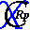 Welcome to XC Reports 1
Using XC Reports 3
Moving around in XC Reports 3
The Menu Bar 4
The XC Reports Toolbar 5
The following tools are provided: 5
Report Manager 5
Report Viewer 5
Report Properties 6
Report Summary 6
Report Statistics 6
Report Settings 6
The Status Bar 6
Changing the database source 7
Toggling between the Report Manager and the Report Viewer 8
Report Manager 8
Report Viewer 9
Running a Report 9
Exporting reports 10
Adding a new Report 10
Report Setup Parameters 12
Removing a Report 13
Status messages 14
Viewing Sensor Data or Post-Processed data 15
Report Descriptions 17
001 Station Details 17
002 Station Details for Selected Stations 19
003 Station List for Satellite System 21
004 Station List for Conventional System 22
005 Stations Not Reporting Today 23
006 Stations Not Reporting in 5 Days 24
007 Stations Last Update 25
008 Stations Reporting Today 26
009 Stations Not Reporting Since Selected Time 27
010 System Sensor Details 28
011 Sensor Details for Selected Stations 30
012 Last Reported Battery Value 32
012 Last Reported Sensor Value 34
020 All Data 36
021 Data for Selected Stations 37
022 Data for Selected Stations-Sensors 38
023 Data for Selected Time Range-Stations-Sensors 39
024 Data For Today 40
025 Data For Yesterday 41
026 Delta Value for Selected Time Range-Stations-Sensors 42
030 Satellite Quality Data 44
031 Satellite Quality Data For Selected Stations 46
032 Satellite Quality Data For Selected Stations For Today 48
033 Satellite Quality Data For Selected Stations For Yesterday 50
034 All Satellite Quality Data For Today 52
035 All Satellite Quality Data For Yesterday 54
036 Satellite Performance Analysis 56
037 Satellite Performance Analysis For Yesterday 58
036 Satellite Performance Analysis For Today 60
039 Satellite Performance Analysis For Random Channel 62
040 Satellite Performance Analysis For Random Channel Today 64
037 Satellite Performance Analysis For Random Channel Yesterday 66
042 Satellite Performance Analysis (QC Only) 68
044 Rtu Performance Analysis For Today 70
044 Rtu Performance Analysis For Today 72
045 Rtu Performance Analysis For Yesterday 74
046 Rtu Poll Summary 76
047 Rtu Poll Summary For Today 78
047 Rtu Poll Summary For Yesterday 80
037 Satellite Performance Analysis Time Range 82
050 Data Analysis 1 84
051 Data Analysis 2 85
052 Data Analysis 1 For Selected Time Range 86
053 Rtu Channel Summary 87
054 Rtu Channel Summary for Today 89
054 Rtu Channel Summary for Today 91
057 Rtu Quality Data For Selected Time Range-Stations 93
056 Rtu Quality Data For Selected Stations 95
060 Bad Data For Today 97
061 Bad Data For Yesterday 99
062 Bad Data For Selected Time Range 101
063 Bad Data For Selected Time Range-Stations-Sensors 103
Troubleshooting 105
Troubleshooting tips 105
Error Messages 105
Error 8: Invalid License Key. Please verify XConnect is properly installed. 105
Error 9: Invalid License Key. Exiting now... 105
Error 1200: Unable to connect to database. 105
Error 1201: Crystal Reports file does not exist. 105
Error 1202: Report file xxx is not enabled. 106
Error 1203: Unable to set Crystal Reports run parameters. 106
Error 1204: Unable to save new report information. 106
Error 1205: Report Title can not be empty. Please try again. 106
Error 1206: Crystal Reports file not selected. 106
Error 1207: xxx.rpt does not exist. 106
Error 1208: Invalid report category selected. 107
Error 1209: Data operation error. Unable to read from database. 107
Error 1210: Filter file not selected. 107
Error 1211: Unable to load filter file. 107
Error 1212: Unable to update report information. 107
Error 1213: Unable to add category - category file. 108
Error 1214: Unable to add Crystal Reports file xxx into list view. 108
Error 1215: Unable to remove the xxx from XC Reports. 108
Error 1216: Unable to load/refresh report properties. 108
Error 1217: Unable to run/generate report. 109
Error 1218: Failed to get SQL string from Crystal Reports. 109
Error 1219: The starting time must be earlier than the ending time. 109
Index 111

Table of Figures
Figure 1. XC Reports main window 3
Figure 2. Login window 7
Figure 3. Report Manager view 8
Figure 4. Report Viewer view 9
Figure 5. Export selection window 10
Figure 6. Register Report welcome window 11
Figure 7. Register report setup window 11
Figure 8. Register report summary window 12
Figure 9. 001 Station Details report 18
Figure 10. 002 Station Details for Selected Station report 20
Figure 11. 003 Station List for Satellite System report 21
Figure 12. 004 Station List for Conventional System report 22
Figure 13. 005 Stations Not Reporting Today report 23
Figure 14. 006 Stations Not Reporting in 5 Days report 24
Figure 15. 007 Stations Last Update report 25
Figure 16. 008 Stations Reporting Today report 26
Figure 17. 009 Stations Not Reporting Since Selected Time report 27
Figure 18. 010 System Sensor Details report 29
Figure 19. 011 Sensor Details for Selected Stations report 31
Figure 20. 012 Last Reported Battery Value report 33
Figure 21. 012 Last Reported Sensor Value report 35
Figure 22. 020 All Data report 36
Figure 23. 021 Data for Selected Stations report 37
Figure 24. 022 Data for Selected Stations-Sensors report 38
Figure 25. 023 Data for Selected Time Range-Stations-Sensors report 39
Figure 26. 024 Data For Today report 40
Figure 27. 025 Data For Yesterday report 41
Figure 28. 026 Delta Value for Selected Time Range-Stations-Sensors report 43
Figure 29. 030 Satellite Quality Data report 45
Figure 30. 031 Satellite Quality Data For Selected Stations report 47
Figure 31. 032 Satellite Quality Data For Selected Stations For Today report 49
Figure 32. 033 Satellite Quality Data For Selected Stations For Yesterday report 51
Figure 33. 034 All Satellite Quality Data For Today report 53
Figure 34. 035 All Satellite Quality Data For Yesterday report 55
Figure 35. 036 Satellite Performance Analysis report 57
Figure 36. 037 Satellite Performance Analysis For Yesterday report 59
Figure 37. 036 Satellite Performance Analysis For Today report 61
Figure 38. 039 Satellite Performance Analysis For Random Channel report 63
Figure 39. 040 Satellite Performance Analysis For Random Channel Today report 65
Figure 40. 037 Satellite Performance Analysis For Random Channel Yesterday report 67
Figure 41. 042 Satellite Performance Analysis (QC Only) report 69
Figure 42. 044 Rtu Performance Analysis For Today report 71
Figure 43. 044 Rtu Performance Analysis For Today report 73
Figure 44. 045 Rtu Performance Analysis For Yesterday report 75
Figure 45. 046 Rtu Poll Summary report 77
Figure 46. 047 Rtu Poll Summary For Today report 79
Figure 47. 047 Rtu Poll Summary For Yesterday report 81
Figure 48. 037 Satellite Performance Analysis Time Range report 83
Figure 49. 050 Data Analysis 1 report 84
Figure 50. 051 Data Analysis 2 85
Figure 51. 052 Data Analysis 1 For Selected Time Range report 86
Figure 52. 053 Rtu Channel Summary report 88
Figure 53. 054 Rtu Channel Summary for Today report 90
Figure 54. 054 Rtu Channel Summary for Today report 92
Figure 55. 057 Rtu Quality Data For Selected Time Range-Stations report 94
Figure 56. 056 Rtu Quality Data For Selected Stations report 96
Figure 57. 060 Bad Data For Today report 98
Figure 58. 061 Bad Data For Yesterday report 100
Figure 59. 062 Bad Data For Selected Time Range report 102
Figure 60. 063 Bad Data For Selected Time Range-Stations-Sensors report 104

Welcome to XC Reports
XConnect is Sutron Corporation's latest data collection, data processing and data storage software. Built on the strong principles of PcBase2, XConnect is compliant with today's 32-bit Windows operating systems and provides new tools and options for the user.
XConnect is a collection of executables designed to provide a complete solution for data collection, data handling, data viewing and data storage
The XC Reports is a viewer/container for reports created by Crystal Reports. Crystal Reports is a popular report generation tool used widely throughout the world. Once the report is created in Crystal Reports, it can be added to the report library and accessed by XC Reports.
XConnect is installed with an array of reports displaying system, data and diagnostic data. XC Reports is designed for the database storage option in XConnect. Using the power of Crystal Reports to generate new reports, XConnect now has the mechanism to add new reports easily to its library to fill the demands of changing customer requirements.

Using XC Reports

Moving around in XC Reports
The XC Reports application consists of these main areas:
- The Menu Bar provides access to all user-controllable functions within the application.
- The Toolbar provides one-click access to important functions.
- The main report area holds the Report Manager/Report Viewer:
  - The Report Manager
  - The Report Viewer
- The Report Properties panel displays information about the report; when and who created it and their comments.

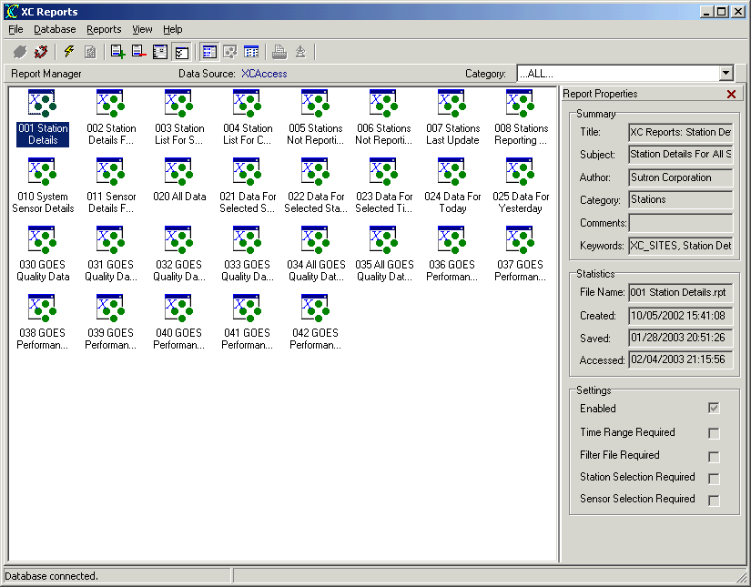
Figure 1. XC Reports main window

The Menu Bar
The Menu Bar provides access to the following menus:
File | - Print Setup -- opens Windows print setup dialog box.  - Print -- prints current report.  - Export -- opens export dialog box.  - Exit -- terminates the application.
Database | - Connect -- opens a dialog box to select database source as defined in Data Sources (ODBC) control applet.  - Disconnect -- disconnects from current database source.
Reports | - Run Report -- runs the currently selected/highlighted report.  - Reload Last Report -- re-runs last report and refreshes with latest data.  - Register Report -- starts report wizard to add another report to the Report Manager.  - Remove Report -- removes the currently selected/highlighted report from the Report Manager.  - Report Setup -- allows user to modify setup parameters of currently selected/highlighted report.  - Report Properties -- allows user to toggle display of Report Properties panel.  - Search for Reports -- searches for reports on hard disk.
View | - Report Manager -- shows Report Manager view which displays available reports.  - Crystal Report Viewer -- shows Report Viewer view which displays current report.
Help | - XC Reports Help -- access this help system an defaults to Index tab.  - XC Reports Contents -- access this help system an defaults to Contents  - About -- get version information for this application.

The XC Reports Toolbar
The toolbar area allows you to quickly access various XC Reports functions.

The following tools are provided:
 | Open dialog box to select database source as defined in Data Sources (ODBC) control applet.
 | Disconnect from current database source.
 | Run the currently selected/highlighted report.
 | Re-run last report and refresh with latest data.
 | Start report wizard to add another report to the Report Manager.
 | Remove the currently selected/highlighted report from the Report Manager.
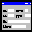 | Edit report setup parameters.
 | Toggle display of Report Properties panel.
 | Show Report Manager view.
 | Show Report Viewer view.
 | Select view options (display items using as large icons, small icons, list or detail list).
 | Print current report.
 | Export current report.
 | Open the on-line help (this document).

Report Manager
The Report Manager displays all the reports available in XC Reports in a Windows Explorer style view. Reports can be displayed as large icons, small icons or as Details. The user can easily toggle between the Report Manager and the Report Viewer views. The ease and power of Crystal Reports allows new reports to be added to XC Reports.

Report Viewer
The Report Viewer view will contain the results of the report. When the user runs a report, XC Reports will display the final report in the Report Viewer. The user can easily toggle between the Report Manager () and the Report Viewer views ().

Report Properties
The Report Properties panel displays information and properties of a highlighted report. The panel is has 3 groups of information: Summary, Statistics and Settings. The panel can be closed by click in the on the upper right hand corner. To display the panel after it has been closed, from the main menu select Report|Report Properties or click the on the toolbar.

Report Summary
The Report summary displays the document properties. Upon creating the report, the user can, optionally, complete the document summary information. Selecting properties in Windows Explorer will also display summary information on a document/file.
- Title - Title of document/report.
- Subject - Subject of document/report.
- Author - Author of document/report.
- Category - Category of document/report
- Comments - Author comments regarding document/report.
- Keywords - Keywords associated with this document/report.

Report Statistics
- File Name - Disk file name of document/report.
- Created - Creation date of document/report.
- Saved - Last saved date of document/report.
- Accessed - Last access date of document/report.

Report Settings
- Enabled - This flag, if checked, indicates the report is active and can be run. A report must be enabled to be run.
- Time Range Required - This flag indicates whether a time range selection is required to run the report.
- Filter File Required - This flag indicates whether a filter file is required to run the report.
- Station Selection Required - This flag indicates whether a station selection is required to run the report.
- Sensor Selection Required - This flag indicates whether a sensor selection is required to run the report.

The Status Bar
The Status Bar is divided in two sections. The left-hand panel displays status messages. The right-hand panel displays parameter hints.

Changing the database source
XC Reports displays data from a database. Easily the database can be changed, as long as it is defined in the Data Sources (ODBC) control applet. To change data sources:
- Start XC Reports from the Start Menu or from a desktop icon.
- From the Database menu, select Disconnect or from the toolbar click on the icon to disconnect from the current data source.
- Next, from the Database menu, select Connect or from the toolbar click on the icon to select a new data source.
- The XC Report Database Login window will appear.
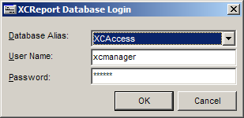
Figure 2. Login window
- Click on the Database Alias list box to select the new data source.
- Enter User Name and Password for data source and click OK.
- XC Reports will attempt to connect to selected data source using the user name and password entered.

Toggling between the Report Manager and the Report Viewer
XC Reports provides to main views: Report Manager and Report Viewer. The user can easily toggle between the two views using easy access toolbar buttons: Report Manager () or the Report Viewer ().

Report Manager
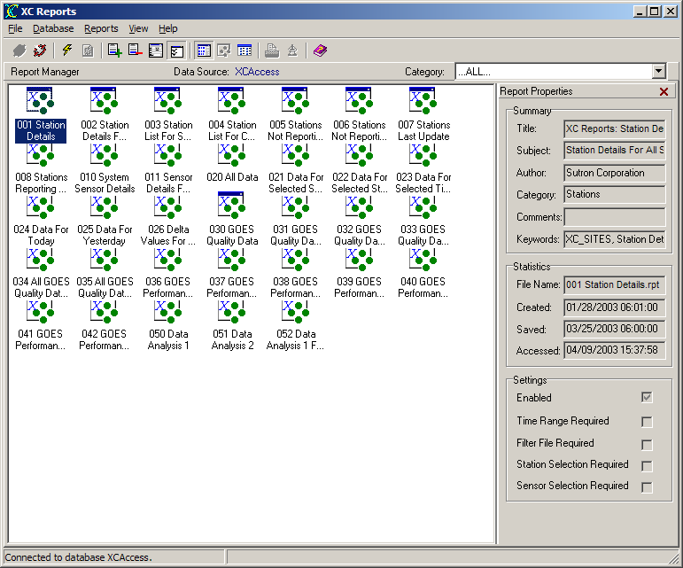
Figure 3. Report Manager view

Report Viewer
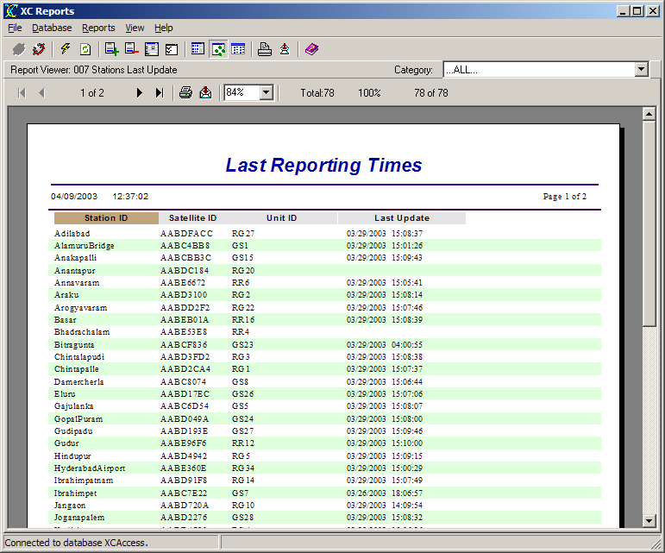
Figure 4. Report Viewer view

Running a Report
Running a report in XC Report is as simple as double-clicking on the file in the Report Library, or from the Reports main menu, select the Run Report or from the toolbar click on the icon.

Exporting reports
XC Reports can conveniently export the reports in a variety of formats. This provides a flexible method to exchange and transport the reports. To export a report:
- Start XC Reports from the Start Menu or from a desktop icon.
- Select a report and select Run Report from the Reports main menu or from the toolbar click on the icon.
- The report will be displayed in the Report Viewer.
- From the File main menu, select Export or from the Report Viewer panel click the icon.
- The Export selection window will appear.
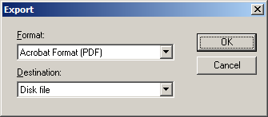
Figure 5. Export selection window
- Select the desired options on the next several windows including the name of the exported file.

Adding a new Report
New reports can easily be added to the Report Manager. New reports must be created in Crystal Reports. Crystal Reports must be purchased separately. The user will design a new report (.RPT) in the Crystal Reports development environment and test it. Once the report has been successfully tested, then it can be added and distributed as an available report in XC Reports.
XC Reports is only a report viewer. Adding a report just takes a few steps and a simple wizard assist the user in this task. To add a report:
- Start XC Reports from the Start Menu or from a desktop icon.
- From the Reports menu, select Register Report or from the toolbar click on the icon.
- The Welcome wizard window will appear. Click Next to advance to the next step.
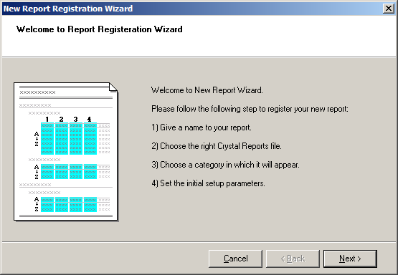
Figure 6. Register Report welcome window
- The Report Setup window appears next to allow selection and configuration of the new report.
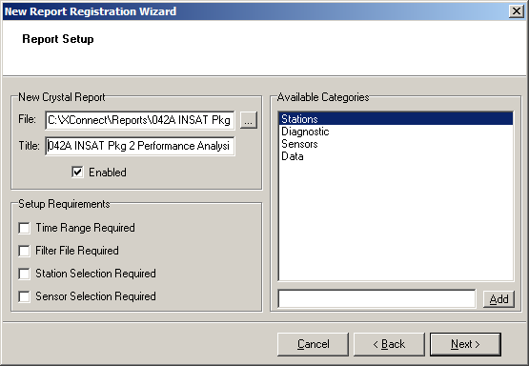
Figure 7. Register report setup window
- Complete the report setup parameters and click Next.
- The final setup window will appear. Review the report setup parameters and click Finish to complete adding the report.
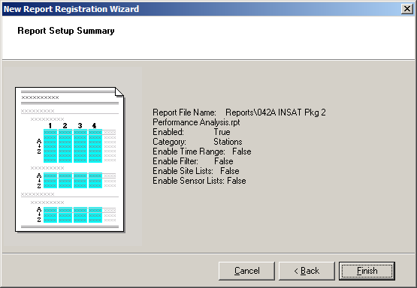
Figure 8. Register report summary window

Report Setup Parameters
- New Crystal Report
  - File - Name of new Crystal Report file (.RPT) located on hard disk.
  - Title - Title for new report. This will be the title displayed in the Report Manager view.
  - Enabled - Check to activate the report. Reports cannot run unless they are enabled.
- Setup Requirements
  - Time Range Required - Check this box if the report requires the user to select a time range to run.
  - Filter File Required - Check this box if the report requires the user to select a filter file to run.
  - Station Selection Required - Check this box if the report requires the user to select a station(s) to run.
  - Sensor Selection Required - Check this box if the report requires the user to select a sensor(s) to run.
Note: Required flags should be set to correspond with the Crystal Report file. If the designer intended the report to require station or sensor selection, then the appropriate boxes should be checked. If properly checked, XC Reports will open an intuitive wizard to assist the use in their selection. If incorrectly checked, then the wizard will appear when not required or the default Crystal Reports prompt will appear which is not as intuitive as the wizard.
- Available Categories
To help organize the many reports, they can be categorized. Afterwards, selecting a category from the Report Manager will then only display files designated in that category. Four default categories are provided.
- Category List - Select a category, if desired, for the report.
- Add - Enter a new category in the edit box next to the Add button. Click Add to add the new category to the Category List

Removing a Report
Reports can be removed from the Report Manager list. This does not delete the report file (.RPT) from the hard disk. To remove a report:
- Start XC Reports from the Start Menu or from a desktop icon.
- From the Reports menu, select Remove Report or from the toolbar click on the icon.
- Finally, the user will be asked to confirm to remove the file from the report list.

Status messages
Below are the status messages XC Decode will display in the decoding status window as it decodes data from the raw files:
- Are you sure you want to remove xxx from XC Reports?
XC Reports confirms the user would like to remove the report title from the Report Manager list. The report file is not deleted from the hard disk. The report may be added back at any time.
- Are you sure you would like to disconnect from current ODBC source?
XC Reports confirms the user would like to disconnect from the current database source. Disconnecting from a data source prevents any reports from being run.
- Click Apply button to filter file. Then click Next.
In the Report Wizard, if a filter file was selected, the user is reminded to apply the filter by clicking the Apply button.
- Connecting to database...
XC Reports is attempting to connect to the database (ODBC) source.
- Connected to database ODBC source.
XC Reports has successfully connected to the user selected database (ODBC) source.
- Disconnected from database.
XC Reports has disconnect from the current database (ODBC) source.
- Database NOT connected.
All raw files have been checked for new satellite messages and decoded.
- Reading xxx.XFG.
XC Reports is reading the default configuration file which contains user's last program settings.
- Startup parameters loaded.
XC Report has complete reading and applying all the startup parameters and is ready to generate reports.
- Running... Please wait...
XC Report is in the process of running the report. Some reports may take some time to complete based on the amount of data requested.
- Report completed.
The Crystal Report has completed and is ready for viewing.

Viewing Sensor Data or Post-Processed data
XC Reports, by default, will retrieve data from the sensor data table (XC_DATA1). However, as part of the XConnect database schema, data is also stored in the post processing data table (XC_PPDATA1). XC_PPDATA1 will have data only if you are using XC PostProc. XC PostProc is used to perform some post-processing calculations on the sensor data. Typically, daily or monthly averages, minimums or maximums are examples of post processed data. To graph or list this data, XC Reports needs to switch focus from the sensor data table, XC_DATA1, to the post-processed data table, XC_PPDATA1.
To retrieve data from XC_PPDATA1,
- From the Select menu, select Post Processed Data (XC_PPDATA1) option. XC Reports will update the Report Manager with the available post-processing reports.
- Continue with normal sensor selection and viewing.

To return to view sensor data from XC_DATA1,
- From the Select menu, select Sensor Data (XC_DATA1) option. XC Reports will update the Report Manager with the available standard reports.
- Continue with normal sensor selection and viewing.

Report Descriptions

001 Station Details
The Station Details Report displays a report showing the station database details for all stations in the system (one page per station). This reports does not require any user inputs.
The SQL query used by the report is:
SELECT XC_SITES.STATION_ID, XC_SITES.ENABLED, XC_SITES.UNIT_ID, XC_SITES.SITE_COMMENT, XC_SITES.SATELLITE_ID, XC_SITES.DISTRICT, XC_SITES.CITY, XC_SITES.COUNTRY, XC_SITES.COUNTY, XC_SITES.STATE, XC_SITES.LATITUDE, XC_SITES.LONGITUDE, XC_SITES.ELEVATION, XC_SITES.WEIGHTING_FACTOR, XC_SITES.PRIMARY_CHANNEL, XC_SITES.RANDOM_CHANNEL, XC_SITES.REPORTING_TIME, XC_SITES.BASIN, XC_SITES.AGENCY, XC_SITES.TZONE_CODE, XC_SITES.GMT_OFFSET`, XC_SITES.SHEF_ID, XC_SITES.INSTALLATION_DATE, XC_SITES.LAST_UPDATE, XC_SITES.ALTERNATE_CHAR_ID_1, XC_SITES.GPNUMBER1, XC_SITES.GPSTRING1, XC_SITES.ALTERNATE_CHAR_ID_2, XC_SITES.GPSTRING2, XC_SITES.GPNUMBER2, XC_SITES.SETUP_FILE_NAME, XC_SITES.PICTURE_FILE_NAME, XC_SITES.REPORTING_INTERVAL, XC_SITES.COEFFICIENT1, XC_SITES.COEFFICIENT2, XC_SITES.COEFFICIENT3
FROM XC_SITES
ORDER BY `XC_SITES`.`STATION_ID`

The example report below was generated on 14 February 2006.

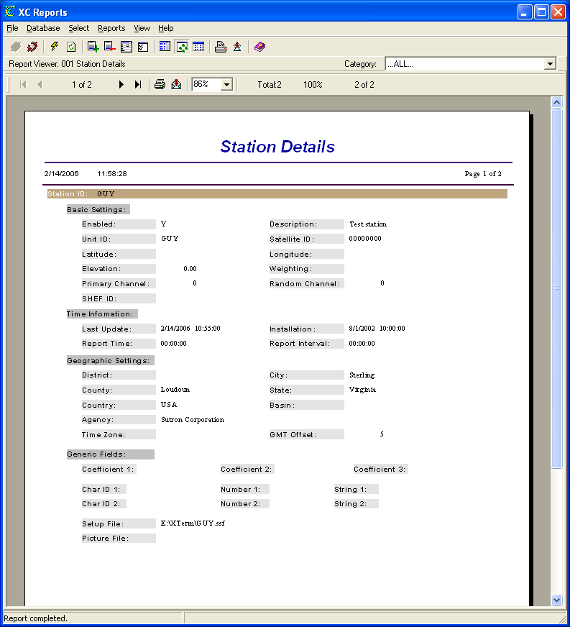
Figure 9. 001 Station Details report

002 Station Details for Selected Stations
The Station Details Report displays a report showing the station database details for user-selected stations in the system (one page per station). The user will be guided by the Report Wizard to select the desired stations.
The SQL query used by the report is:
SELECT XC_SITES.STATION_ID, XC_SITES.ENABLED, XC_SITES.UNIT_ID, XC_SITES.SITE_COMMENT, XC_SITES.SATELLITE_ID, XC_SITES.DISTRICT, XC_SITES.CITY, XC_SITES.COUNTRY, XC_SITES.COUNTY, XC_SITES.STATE, XC_SITES.LATITUDE, XC_SITES.LONGITUDE, XC_SITES.ELEVATION, XC_SITES.WEIGHTING_FACTOR, XC_SITES.PRIMARY_CHANNEL, XC_SITES.RANDOM_CHANNEL, XC_SITES.REPORTING_TIME, XC_SITES.BASIN, XC_SITES.AGENCY, XC_SITES.TZONE_CODE, XC_SITES.GMT_OFFSET, XC_SITES.SHEF_ID, XC_SITES.INSTALLATION_DATE, XC_SITES.LAST_UPDATE, XC_SITES.ALTERNATE_CHAR_ID_1, XC_SITES.GPNUMBER1, XC_SITES.GPSTRING1, XC_SITES.ALTERNATE_CHAR_ID_2, XC_SITES.GPSTRING2, XC_SITES.GPNUMBER2, XC_SITES.SETUP_FILE_NAME, XC_SITES.PICTURE_FILE_NAME, XC_SITES.REPORTING_INTERVAL, XC_SITES.COEFFICIENT1, XC_SITES.COEFFICIENT2, XC_SITES.COEFFICIENT3
FROM XC_SITES
WHERE XC_SITES.STATION_ID`='GUY'
ORDER BY XC_SITES.STATION_ID`

The example report below was generated on 14 February 2006.

Figure 10. 002 Station Details for Selected Station report

003 Station List for Satellite System
The Station List for Satellite System Report displays a report showing the stations in the database that have a non-blank or non-zero SATELLITE ID. This reports does not require any user inputs.
The SQL query used by the report is:
SELECT XC_SITES.STATION_ID, XC_SITES.ENABLED, XC_SITES.SATELLITE_ID, XC_SITES.PRIMARY_CHANNEL, XC_SITES.RANDOM_CHANNEL, XC_SITES.REPORTING_TIME, XC_SITES.REPORTING_INTERVAL, XC_SITES.SITE_COMMENT
FROM XC_SITES
WHERE (XC_SITES.SATELLITE_ID IS NOT NULL) AND NOT (XC_SITES.SATELLITE_ID=' ' OR XC_SITES.SATELLITE_ID='00000000')
ORDER BY XC_SITES.STATION_ID

The example report below was generated on 14 February 2006.

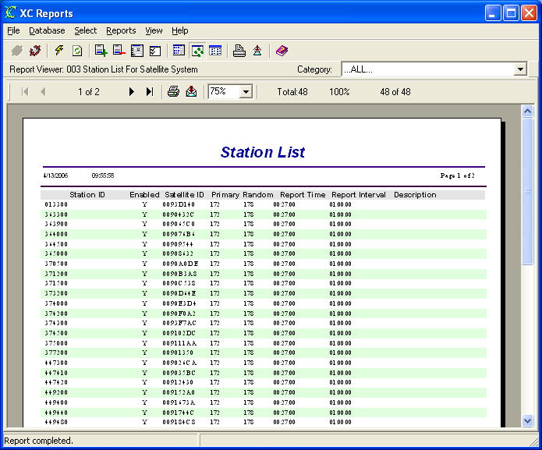
Figure 11. 003 Station List for Satellite System report

004 Station List for Conventional System
The Station List for Conventional System Report displays a report showing the stations in the database that have a non-blank UNIT ID. This reports does not require any user inputs.
The SQL query used by the report is:
SELECT XC_SITES.STATION_ID, XC_SITES.ENABLED, XC_SITES.SITE_COMMENT, XC_SITES.UNIT_ID, XC_SITES.LATITUDE, XC_SITES.LONGITUDE
FROM XC_SITES
WHERE XC_SITES.UNIT_ID IS NOT NULL AND XC_SITES.UNIT_ID<>' '
ORDER BY XC_SITES.STATION_ID

The example report below was generated on 14 February 2006.

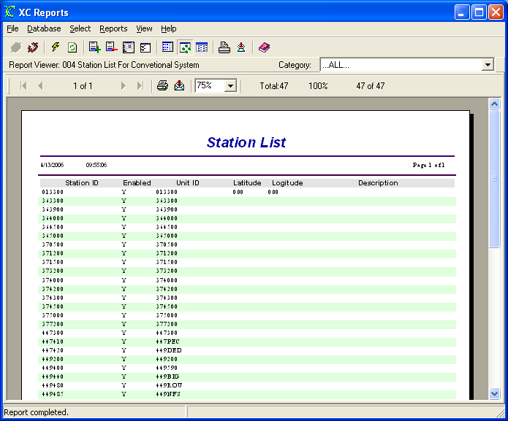
Figure 12. 004 Station List for Conventional System report

005 Stations Not Reporting Today
The Stations Not Reporting Today Report displays a report showing the enabled stations that do not have data (Last Update) of the current day. This reports does not require any user inputs.
The SQL query used by the report is:
SELECT XC_SITES.STATION_ID, XC_SITES.SATELLITE_ID, XC_SITES.UNIT_ID, XC_SITES.BASIN, XC_SITES.ENABLED, XC_SITES.LAST_UPDATE
FROM XC_SITES
WHERE XC_SITES.ENABLED='Y' AND (XC_SITES.LAST_UPDATE IS NULL OR XC_SITES.LAST_UPDATE<{ts '2006-02-14 00:00:00'})
ORDER BY XC_SITES.STATION_ID

The example report below was generated on 14 February 2006.

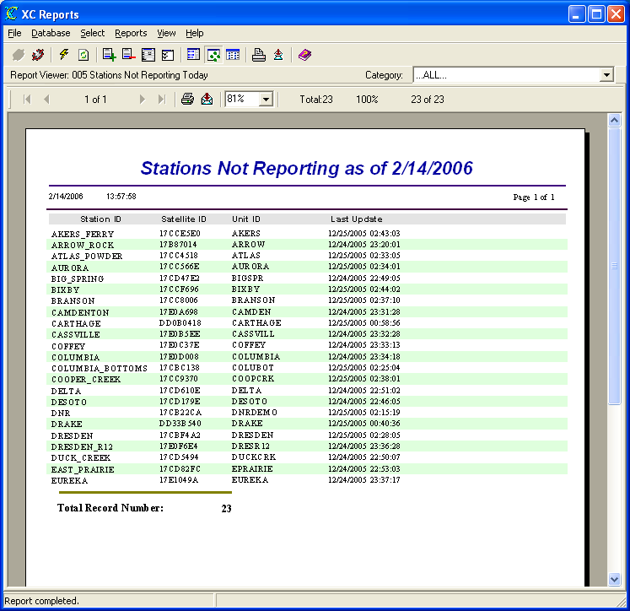
Figure 13. 005 Stations Not Reporting Today report

006 Stations Not Reporting in 5 Days
The Stations Not Reporting in 5 Days Report displays a report showing the enabled stations that do not have data (Last Update) in the last 5 days. In the sql query below, the report was run on 14 Feb 2006. The report query for dates before 10 Feb 2006. This reports does not require any user inputs.
The SQL query used by the report is:
SELECT XC_SITES.STATION_ID, XC_SITES.SATELLITE_ID, XC_SITES.UNIT_ID, XC_SITES.BASIN, XC_SITES.ENABLED, XC_SITES.LAST_UPDATE
FROM XC_SITES
WHERE XC_SITES.ENABLED='Y' AND (XC_SITES.LAST_UPDATE IS NULL OR XC_SITES.LAST_UPDATE<{ts '2006-02-10 00:00:00'})
ORDER BY XC_SITES.STATION_ID

The example report below was generated on 14 February 2006.
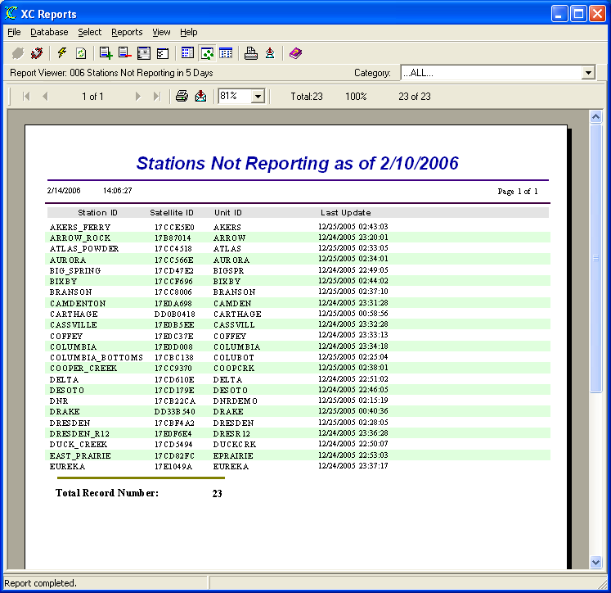
Figure 14. 006 Stations Not Reporting in 5 Days report

007 Stations Last Update
The Stations Last Update Report displays a report showing all the enabled stations and their Last Update time. This reports does not require any user inputs.
The SQL query used by the report is:
SELECT XC_SITES.STATION_ID, XC_SITES.SATELLITE_ID, XC_SITES.UNIT_ID, XC_SITES.ENABLED, XC_SITES.LAST_UPDATE
FROM XC_SITES
WHERE XC_SITES.ENABLED='Y'
ORDER BY XC_SITES.STATION_ID

The example report below was generated on 14 February 2006.

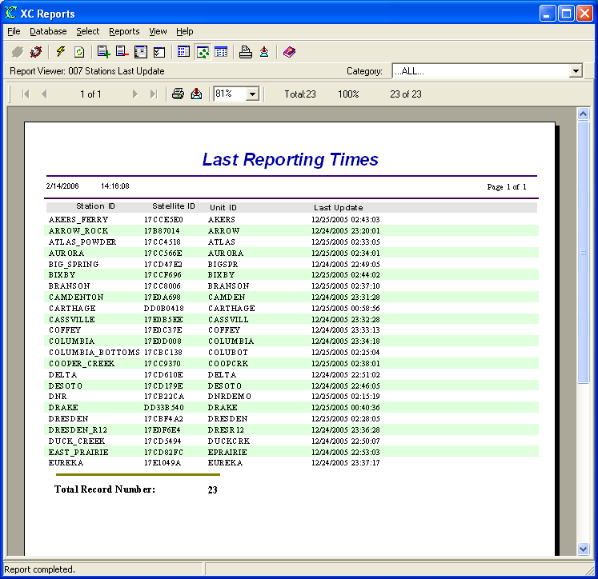
Figure 15. 007 Stations Last Update report

008 Stations Reporting Today
The Stations Reporting Report displays a report showing all the enabled tations that have Last Updates greater than or equal to the current day. This reports does not require any user inputs.
The SQL query used by the report is:
SELECT XC_SITES.STATION_ID, XC_SITES.SATELLITE_ID, XC_SITES.UNIT_ID, XC_SITES.BASIN, XC_SITES.ENABLED, XC_SITES.LAST_UPDATE
FROM XC_SITES
WHERE XC_SITES.ENABLED='Y' AND XC_SITES.LAST_UPDATE>={ts '2006-02-14 00:00:00'}
ORDER BY XC_SITES.STATION_ID

The example report below was generated on 14 February 2006.

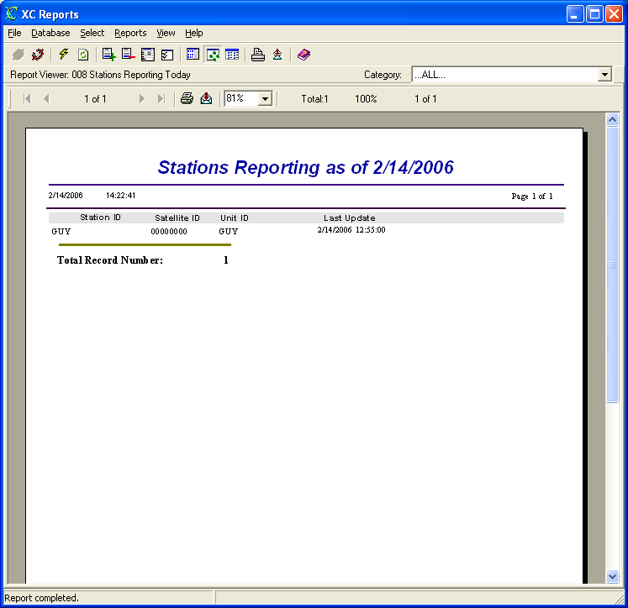
Figure 16. 008 Stations Reporting Today report

009 Stations Not Reporting Since Selected Time
The Stations Not Reporting Since Selected Time Report displays a report showing the enabled stations that do not have data (Last Update) based on a user-selected time. The user will be guided by the Report Wizard to select the desired stations.
The SQL query used by the report is:
SELECT XC_SITES.STATION_ID, XC_SITES.SATELLITE_ID, XC_SITES.UNIT_ID, XC_SITES.BASIN, XC_SITES.ENABLED, XC_SITES.LAST_UPDATE
FROM XC_SITES
WHERE XC_SITES.ENABLED='Y' AND (XC_SITES.LAST_UPDATE IS NULL OR XC_SITES.LAST_UPDATE<{ts '2005-12-25 00:00:00'})
ORDER BY XC_SITES.STATION_ID

The example report below was generated on 14 February 2006.
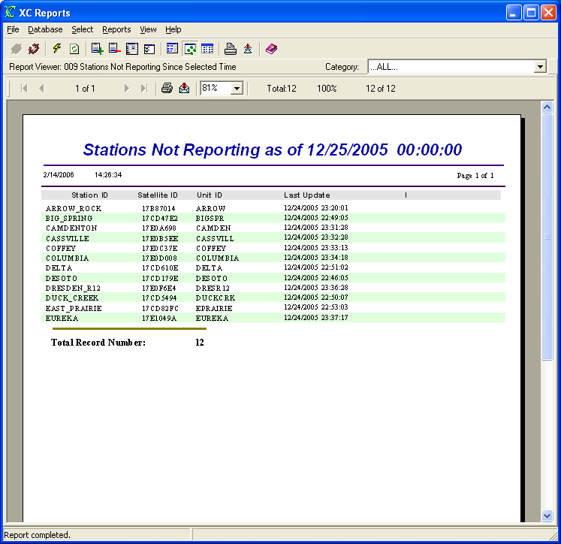
Figure 17. 009 Stations Not Reporting Since Selected Time report

010 System Sensor Details
The System Sensor Details Report displays a report showing the sensor database details for all stations in the system. This reports does not require any user inputs.
The SQL query used by the report is:
SELECT XC_SITESENSORS.STE_STATION_ID, XC_SITESENSORS.SENSORNAME, XC_SITESENSORS.ENABLED, XC_SITESENSORS.DESCRIPTION, XC_SITESENSORS.MANUFACTURER, XC_SITESENSORS.MODEL_NUMBER, XC_SITESENSORS.SHEF_PE_CODE, XC_SITESENSORS.PARAMETER_CODE, XC_SITESENSORS.HIGH_HIGH_LIMIT, XC_SITESENSORS.HIGH_LIMIT, XC_SITESENSORS.LOW_LOW_LIMIT, XC_SITESENSORS.LOW_LIMIT, XC_SITESENSORS.ROC_LIMIT, XC_SITESENSORS.DEADBAND, XC_SITESENSORS.TEXT_LIMIT, XC_SITESENSORS.HIGH_HIGH_ALARM, XC_SITESENSORS.HIGH_ALARM, XC_SITESENSORS.LOW_ALARM, XC_SITESENSORS.LOW_LOW_ALARM, XC_SITESENSORS.ROC_ALARM, XC_SITESENSORS.NO_CHANGE_ALARM, XC_SITESENSORS.TEXT_ALARM, XC_SITESENSORS.ROC_INTERVAL, XC_SITESENSORS.NO_CHANGE_INTERVAL, XC_SITESENSORS.ALT_PARAMETER_CODE_1, XC_SITESENSORS.ALT_PARAMETER_CODE_2, XC_SITESENSORS.GPNUMBER1, XC_SITESENSORS.GPNUMBER2, XC_SITESENSORS.GPSTRING1, XC_SITESENSORS.GPSTRING2, XC_SITESENSORS.COEFFICIENT1, XC_SITESENSORS.COEFFICIENT2, XC_SITESENSORS.COEFFICIENT3, XC_SITESENSORS.COEFFICIENT4, XC_SITESENSORS.COEFFICIENT5
FROM XC_SITESENSORS
ORDER BY XC_SITESENSORS.STE_STATION_ID, XC_SITESENSORS.SENSORNAME

The example report below was generated on 14 February 2006.

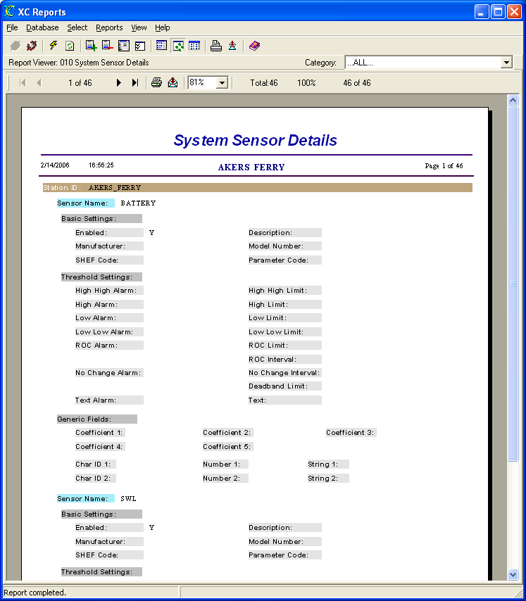
Figure 18. 010 System Sensor Details report

011 Sensor Details for Selected Stations
The Sensor Details for Selected Stations Report displays a report showing the sensor database details for user-selected stations and sensors in the system. The user will be guided by the Report Wizard to select the desired stations and sensors.
The SQL query used by the report is:
SELECT XC_SITESENSORS.STE_STATION_ID, XC_SITESENSORS.SENSORNAME, XC_SITESENSORS.ENABLED, XC_SITESENSORS.DESCRIPTION, XC_SITESENSORS.MANUFACTURER, XC_SITESENSORS.MODEL_NUMBER, XC_SITESENSORS.SHEF_PE_CODE, XC_SITESENSORS.PARAMETER_CODE, XC_SITESENSORS.HIGH_HIGH_LIMIT, XC_SITESENSORS.HIGH_LIMIT, XC_SITESENSORS.LOW_LOW_LIMIT, XC_SITESENSORS.LOW_LIMIT, XC_SITESENSORS.ROC_LIMIT, XC_SITESENSORS.DEADBAND, XC_SITESENSORS.TEXT_LIMIT, XC_SITESENSORS.HIGH_HIGH_ALARM, XC_SITESENSORS.HIGH_ALARM, XC_SITESENSORS.LOW_ALARM, XC_SITESENSORS.LOW_LOW_ALARM, XC_SITESENSORS.ROC_ALARM, XC_SITESENSORS.NO_CHANGE_ALARM, XC_SITESENSORS.TEXT_ALARM, XC_SITESENSORS.ROC_INTERVAL, XC_SITESENSORS.NO_CHANGE_INTERVAL, XC_SITESENSORS.GPSTRING2, XC_SITESENSORS.GPSTRING1, XC_SITESENSORS.ALT_PARAMETER_CODE_1, XC_SITESENSORS.ALT_PARAMETER_CODE_2, XC_SITESENSORS.GPNUMBER1, XC_SITESENSORS.GPNUMBER2, XC_SITESENSORS.COEFFICIENT1, XC_SITESENSORS.COEFFICIENT2, XC_SITESENSORS.COEFFICIENT3, XC_SITESENSORS.COEFFICIENT4, XC_SITESENSORS.COEFFICIENT5
FROM XC_SITESENSORS
WHERE XC_SITESENSORS.STE_STATION_ID='AKERS_FERRY' AND (XC_SITESENSORS.SENSORNAME='BATTERY')
ORDER BY XC_SITESENSORS.STE_STATION_ID, XC_SITESENSORS.SENSORNAME

The example report below was generated on 14 February 2006.

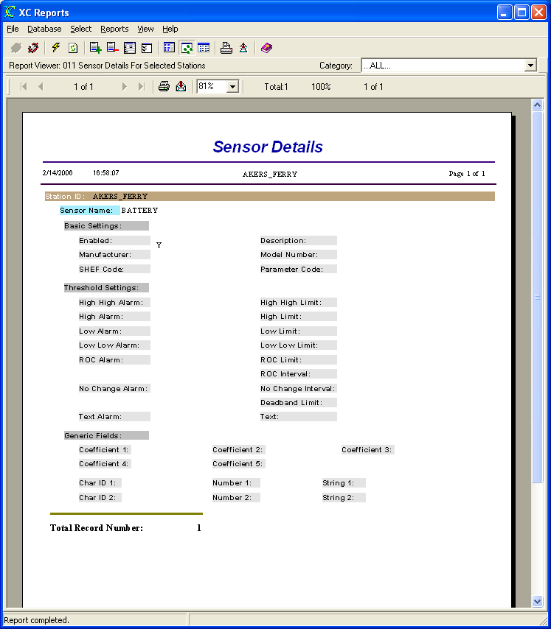
Figure 19. 011 Sensor Details for Selected Stations report

012 Last Reported Battery Value
The Last Reported Battery Value Report displays a report showing the last battery value for all stations. The report looks for sensor names that have BAT or VB as all or part of the name. The report will search up to 30 days past for battery values.
This report uses a sub report to gathers all sensor data with a timestamp greater than 30 days ago. The main report sorts the data looking for sensor names similar to BAT or VB and enabled. Both sql queries are shown below. This reports does not require any user inputs.
The SQL query used by the main report is:
SELECT XC_SITES.STATION_ID, XC_SITES.UNIT_ID, XC_SITES.ENABLED, XC_SITESENSORS.SENSORNAME`
FROM XC_SITES
LEFT OUTER JOIN XC_SITESENSORS ON XC_SITES.STATION_ID=XC_SITESENSORS.STE_STATION_ID
WHERE XC_SITES.ENABLED='Y' AND (XC_SITESENSORS.SENSORNAME LIKE 'BAT%' OR XC_SITESENSORS.SENSORNAME LIKE 'VB%')
ORDER BY XC_SITES.STATION_ID
The SQL query used by the embedded sub report is:
SELECT XC_DATA1.TIME_TAG, XC_DATA1.SENSORNAME, XC_DATA1.STATION_ID, XC_DATA1.ED_VALUE
FROM XC_DATA1
WHERE XC_DATA1.SENSORNAME='BATTERY' AND `XC_DATA1.STATION_ID`='GUY' AND `XC_DATA1.TIME_TAG`>={ts '2006-01-15 00:00:00'}
ORDER BY XC_DATA1.TIME_TAG DESC

The example report below was generated on 14 February 2006.

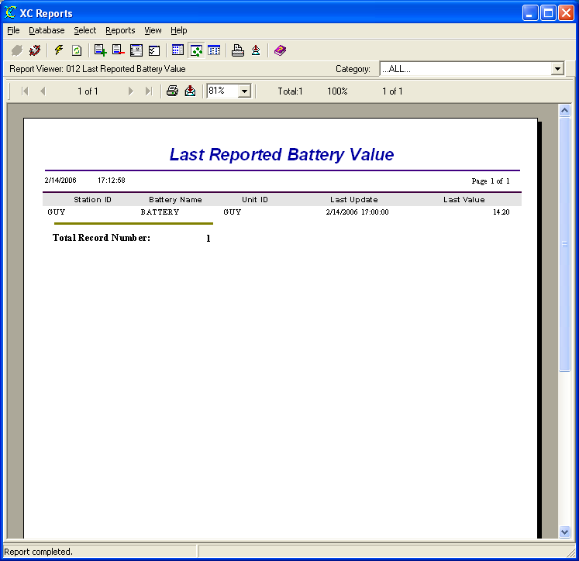
Figure 20. 012 Last Reported Battery Value report

012 Last Reported Sensor Value
The Last Reported Sensor Value Report displays a report showing the last sensor value for each station. The report will search up to 30 days past for battery values.
This report uses a sub report to gathers all sensor data with a timestamp greater than 30 days ago. The main report sorts the data based on sensor names. Both sql queries are shown below. This reports does not require any user inputs.
The SQL query used by the main report is:
SELECT XC_SITES.STATION_ID, XC_SITES.UNIT_ID, XC_SITES.ENABLED, XC_SITESENSORS.SENSORNAME
FROM XC_SITES
LEFT OUTER JOIN XC_SITESENSORS ON XC_SITES.STATION_ID=XC_SITESENSORS.STE_STATION_ID
WHERE XC_SITES.ENABLED`=Y AND XC_SITES.STATION_ID='GUY' AND XC_SITESENSORS.SENSORNAME='BATTERY' AND XC_DATA1.SENSORNAME='TEMP' AND XC_DATA1.SENSORNAME='MAXFLOW'
ORDER BY XC_SITES.STATION_ID
The SQL query used by the embedded sub report is:
SELECT XC_DATA1.TIME_TAG, XC_DATA1.SENSORNAME, XC_DATA1.STATION_ID, XC_DATA1.ED_VALUE
FROM XC_DATA1
WHERE XC_DATA1.SENSORNAME='BATTERY' AND XC_DATA1.SENSORNAME='TEMP' AND XC_DATA1.SENSORNAME='MAXFLOW' AND XC AND XC_DATA1.STATION_ID='GUY' AND XC_DATA1.TIME_TAG>={ts '2006-01-16 00:00:00'}
ORDER BY XC_DATA1.TIME_TAG DESC

The example report below was generated on 15 February 2006.

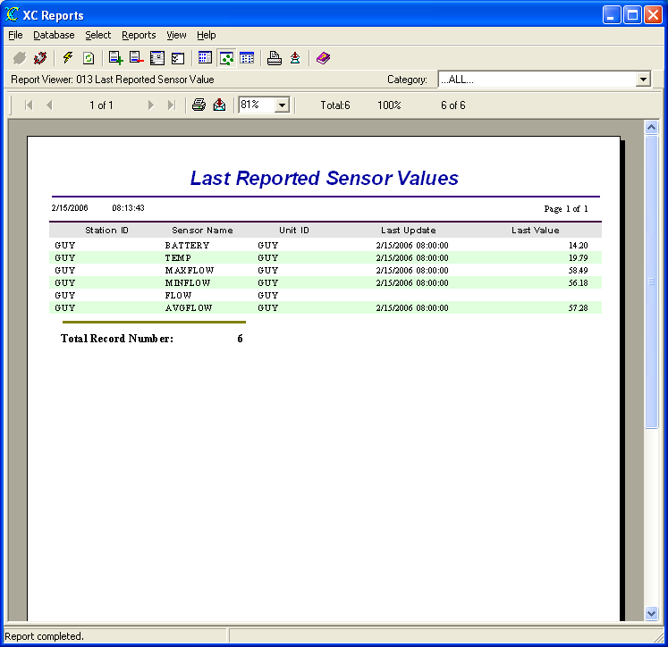
Figure 21. 012 Last Reported Sensor Value report

020 All Data
The All Data Report displays a report showing all the data in the database sorted by station name, sensor name and time. Caution should be used when generating this report. Depending on the amount of data stored in he database, the report may take a considerable amount of time. This reports does not require any user inputs.
The SQL query used by the report is:
SELECT XC_DATA1.STATION_ID, XC_DATA1.SENSORNAME, XC_DATA1.TIME_TAG, XC_DATA1.SOURCE, XC_DATA1.ORIG_VALUE, XC_DATA1.ED_VALUE
FROM XC_DATA1
ORDER BY XC_DATA1.STATION_ID, XC_DATA1.SENSORNAME, XC_DATA1.TIME_TAG

The example report below was generated on 15 February 2006.

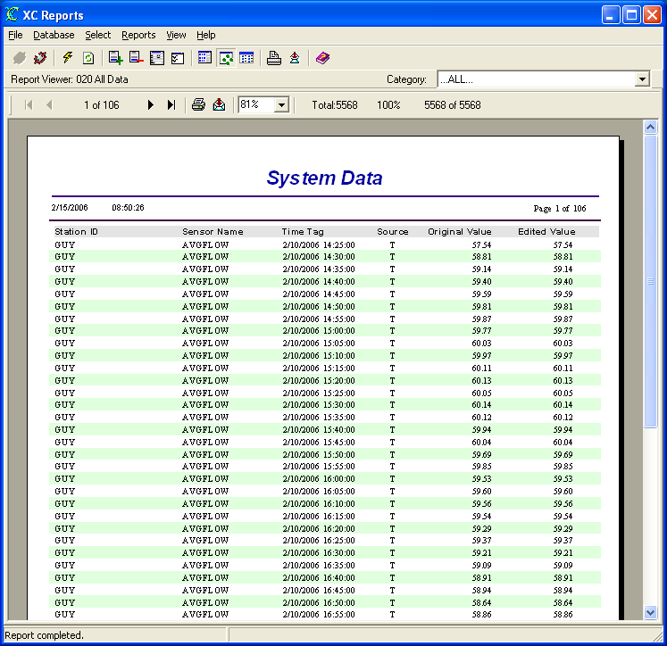
Figure 22. 020 All Data report

021 Data for Selected Stations
The Data for Selected Stations Report displays a report showing all data from all sensors for user-selected stations sorted by station name, sensor name and time. The user will be guided by the Report Wizard to select the desired stations.
The SQL query used by the report is:
SELECT XC_DATA1.STATION_ID, XC_DATA1.SENSORNAME, XC_DATA1.TIME_TAG, XC_DATA1.SOURCE, XC_DATA1.ORIG_VALUE, XC_DATA1.ED_VALUE
FROM XC_DATA1
WHERE XC_DATA1.STATION_ID`='GUY'
ORDER BY XC_DATA1.STATION_ID, XC_DATA1.SENSORNAME, XC_DATA1.TIME_TAG

The example report below was generated on 15 February 2006.

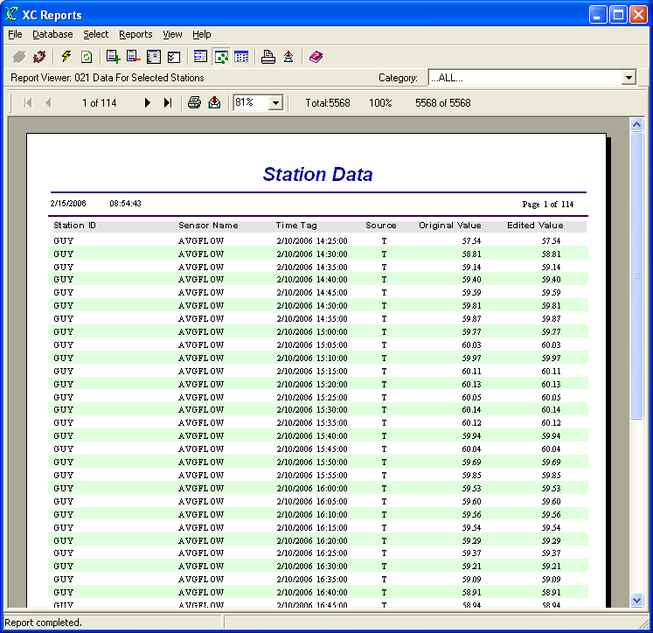
Figure 23. 021 Data for Selected Stations report

022 Data for Selected Stations-Sensors
The Data for Selected Stations-Sensors Report displays a report of all the data from user-selected stations and user-selected sensors sorted by station name, sensor name and time. The user will be guided by the Report Wizard to select the desired stations and sensors.
The SQL query used by the report is:
SELECT XC_DATA1.STATION_ID, XC_DATA1.SENSORNAME, XC_DATA1.TIME_TAG, XC_DATA1.SOURCE, XC_DATA1.ORIG_VALUE, XC_DATA1.ED_VALUE
FROM XC_DATA1
WHERE XC_DATA1.STATION_ID='GUY' AND XC_DATA1.SENSORNAME='AVGFLOW'
ORDER BY XC_DATA1.STATION_ID, XC_DATA1.SENSORNAME, XC_DATA1.TIME_TAG

The example report below was generated on 15 February 2006.

Figure 24. 022 Data for Selected Stations-Sensors report

023 Data for Selected Time Range-Stations-Sensors
The Data for Selected Time Range-Stations-Sensors Report displays a report of sensor data from a user-selected time range, user-selected stations and user-selected sensors sorted by station name, sensor name and time. The user will be guided by the Report Wizard to select the desired time range, stations and sensors.
The SQL query used by the report is:
SELECT XC_DATA1.STATION_ID, XC_DATA1.SENSORNAME, XC_DATA1.TIME_TAG, XC_DATA1.SOURCE, XC_DATA1.ORIG_VALUE, XC_DATA1.ED_VALUE
FROM XC_DATA1
WHERE XC_DATA1.STATION_ID='GUY' AND XC_DATA1.SENSORNAME='MAXFLOW' AND (XC_DATA1.TIME_TAG>={ts '2006-02-15 06:00:00'} AND XC_DATA1.TIME_TAG<{ts '2006-02-15 09:02:56'})
ORDER BY XC_DATA1.STATION_ID, XC_DATA1.SENSORNAME, XC_DATA1.TIME_TAG
The example report below was generated on 15 February 2006.
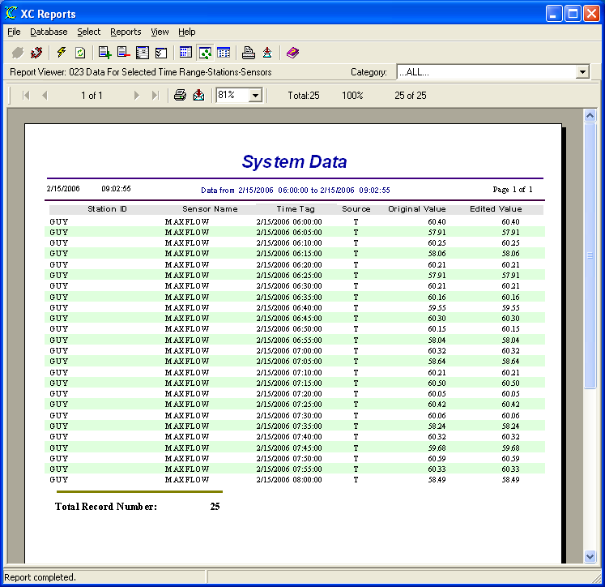
Figure 25. 023 Data for Selected Time Range-Stations-Sensors report

024 Data For Today
The Data For Today Report displays a report showing all the data in the database stored for the current day sorted by station name, sensor name and time. Caution should be used when generating this report. Depending on the amount of data stored in he database, the report may take a considerable amount of time. This reports does not require any user inputs.
The SQL query used by the report is:
SELECT XC_DATA1.STATION_ID, XC_DATA1.SENSORNAME, XC_DATA1.TIME_TAG, XC_DATA1.SOURCE, XC_DATA1.ORIG_VALUE, XC_DATA1.ED_VALUE
FROM XC_DATA1
WHERE XC_DATA1.TIME_TAG>={ts '2006-02-16 00:00:00'}
ORDER BY XC_DATA1.STATION_ID, XC_DATA1.SENSORNAME, XC_DATA1.TIME_TAG

The example report below was generated on 16 February 2006.
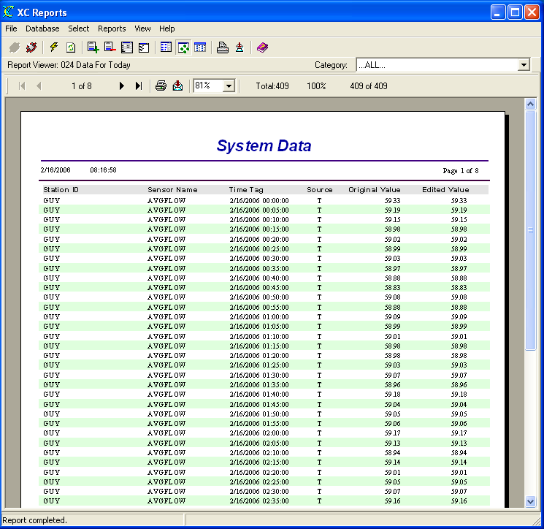
Figure 26. 024 Data For Today report

025 Data For Yesterday
The Data For Today Report displays a report showing all the data in the database stored for the prior day sorted by station name, sensor name and time. Caution should be used when generating this report. Depending on the amount of data stored in he database, the report may take a considerable amount of time. This report does not require any user inputs.
The SQL query used by the report is:
SELECT XC_DATA1.STATION_ID, XC_DATA1.SENSORNAME, XC_DATA1.TIME_TAG, XC_DATA1.SOURCE, XC_DATA1.ORIG_VALUE, XC_DATA1.ED_VALUE
FROM XC_DATA1
WHERE (XC_DATA1.TIME_TAG>={ts '2006-02-15 00:00:00'} AND XC_DATA1.TIME_TAG<{ts '2006-02-16 00:00:00'})
ORDER BY XC_DATA1.STATION_ID, XC_DATA1.SENSORNAME, XC_DATA1.TIME_TAG
The example report below was generated on 16 February 2006.
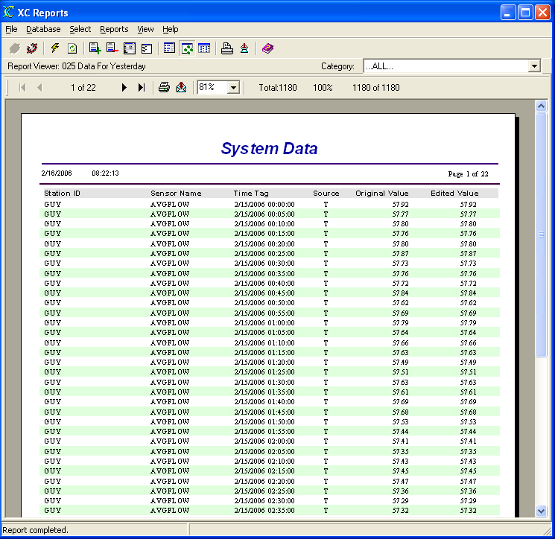
Figure 27. 025 Data For Yesterday report

026 Delta Value for Selected Time Range-Stations-Sensors
The Delta Value for Selected Time Range-Stations-Sensors Report displays a report if sensor data from a user-selected time range, user-selected stations and user-selected sensors sorted by station name, sensor name and time. Additionally, it will calculate the delta between the current value and the prior value. The delta value and the delta time between the two values are displayed beside the data value. The user will be guided by the Report Wizard to select the desired time range, stations and sensors.
The SQL query used by the report is:
SELECT XC_DATA1.STATION_ID, XC_DATA1.SENSORNAME, XC_DATA1.TIME_TAG, XC_DATA1.SOURCE, XC_DATA1.ED_VALUE
FROM XC_DATA1
WHERE XC_DATA1.STATION_ID='GUY' AND XC_DATA1.SENSORNAME='AVGFLOW' AND (XC_DATA1.TIME_TAG>={ts '2006-02-16 00:00:00'} AND XC_DATA1.TIME_TAG<{ts '2006-02-16 08:30:37'})
ORDER BY XC_DATA1.STATION_ID, XC_DATA1.SENSORNAME, XC_DATA1.TIME_TAG

The example report below was generated on 16 February 2006.

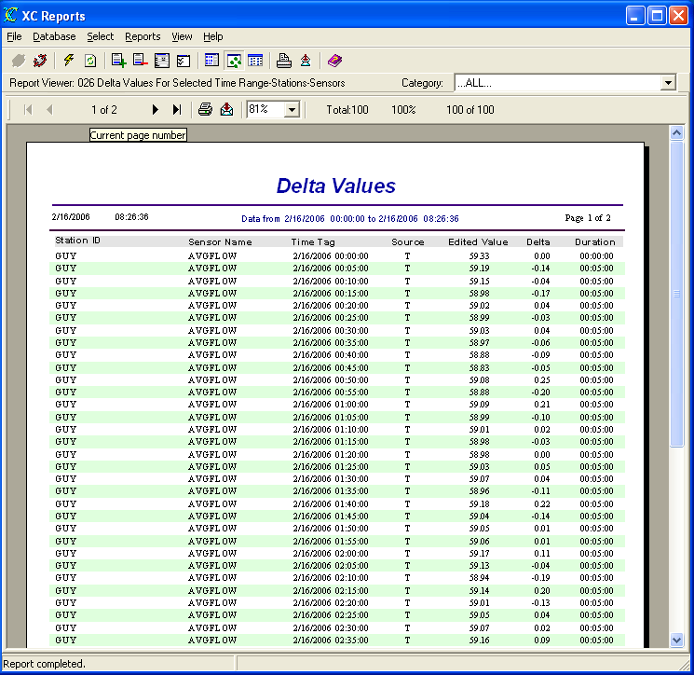
Figure 28. 026 Delta Value for Selected Time Range-Stations-Sensors report

030 Satellite Quality Data
The Satellite Quality Data Report displays a report showing all quality records in the database sorted by NESDIS ID and time. Caution should be used when generating this report. Depending on the amount of data stored in he database, the report may take a considerable amount of time. This reports does not require any user inputs.
Satellite quality records are stored in the XC_GOESQC data table if the users checks the Store Quality parameter on the XC Decode Setup window in XC Desktop. Quality records are used on satellite systems only. This reports display information related to transmission quality.
The SQL query used by the report is:
SELECT XC_GOESQC.NESDIS_ID, XC_GOESQC.TIME_TAG, XC_GOESQC.SOURCE, XC_GOESQC.STATION_ID, XC_GOESQC.FAILURE_CODE, XC_GOESQC.SIG_STRENGTH, XC_GOESQC.MOD_INDEX, XC_GOESQC.MOD_QUAL, XC_GOESQC.CHANNEL, XC_GOESQC.UC_STATUS, XC_GOESQC.FREQ_OFFSET, XC_GOESQC.MESSAGE_LEN, XC_GOESQC.PARITY
FROM XC_GOESQC
ORDER BY XC_GOESQC.NESDIS_ID, XC_GOESQC.TIME_TAG

The example report below was generated on 16 February 2006.

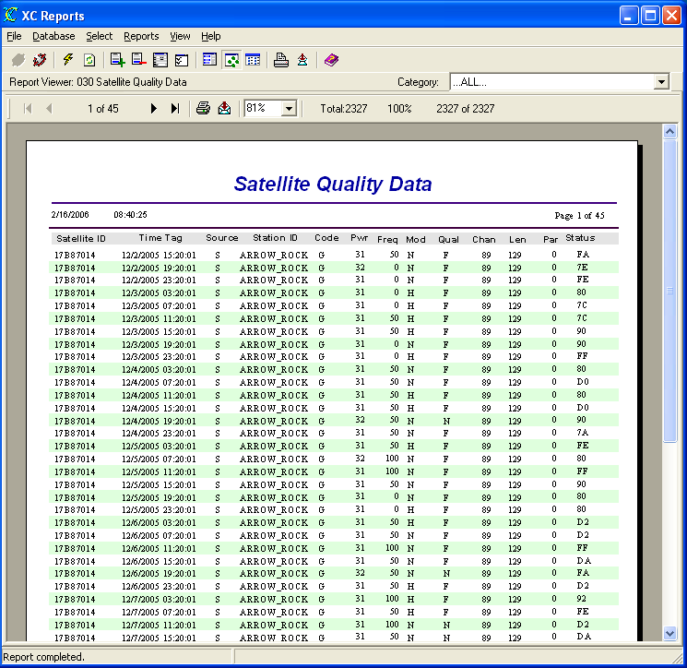
Figure 29. 030 Satellite Quality Data report

031 Satellite Quality Data For Selected Stations
The Satellite Quality Data For Selected Stations Report displays a report showing quality records for user-selected station(s) in the database sorted by NESDIS ID and time. Caution should be used when generating this report. Depending on the amount of data stored in he database, the report may take a considerable amount of time. The user will be guided by the Report Wizard to select the desired stations.
Satellite quality records are stored in the XC_GOESQC data table if the users checks the Store Quality parameter on the XC Decode Setup window in XC Desktop. Quality records are used on satellite systems only.
The SQL query used by the report is:
SELECT XC_GOESQC.NESDIS_ID, XC_GOESQC.TIME_TAG, XC_GOESQC.SOURCE, XC_GOESQC.STATION_ID, XC_GOESQC.FAILURE_CODE, XC_GOESQC.SIG_STRENGTH, XC_GOESQC.FREQ_OFFSET, XC_GOESQC.MOD_INDEX, XC_GOESQC.MOD_QUAL, XC_GOESQC.CHANNEL, XC_GOESQC.UC_STATUS, XC_GOESQC.MESSAGE_LEN, XC_GOESQC.PARITY
FROM XC_GOESQC
WHERE XC_GOESQC.STATION_ID='GUY'
ORDER BY XC_GOESQC.NESDIS_ID, XC_GOESQC.TIME_TAG

The example report below was generated on 16 February 2006.

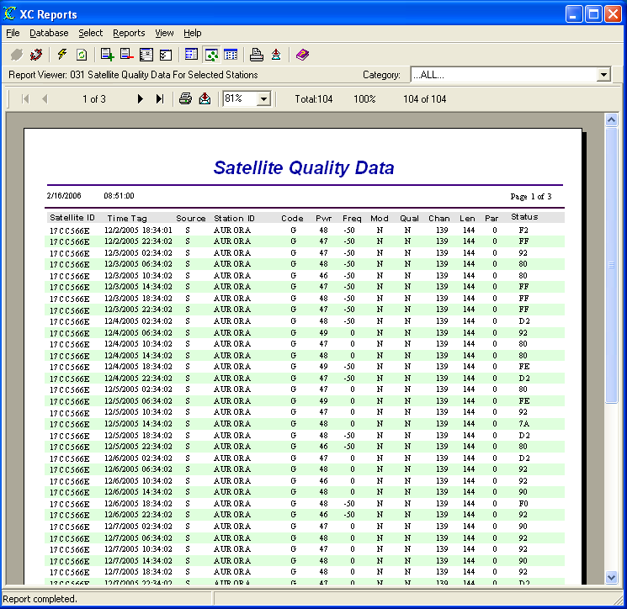
Figure 30. 031 Satellite Quality Data For Selected Stations report

032 Satellite Quality Data For Selected Stations For Today
The Satellite Quality Data For Selected Stations For Today Report displays a report showing quality records for user-selected station(s) in the database for the current day sorted by NESDIS ID and time. Caution should be used when generating this report. The user will be guided by the Report Wizard to select the desired stations.
Satellite quality records are stored in the XC_GOESQC data table if the users checks the Store Quality parameter on the XC Decode Setup window in XC Desktop. Quality records are used on satellite systems only.
The SQL query used by the report is:
SELECT XC_GOESQC.NESDIS_ID, XC_GOESQC.TIME_TAG, XC_GOESQC.SOURCE, XC_GOESQC.STATION_ID, XC_GOESQC.FAILURE_CODE, XC_GOESQC.SIG_STRENGTH, XC_GOESQC.FREQ_OFFSET, XC_GOESQC.MOD_INDEX, XC_GOESQC.MOD_QUAL, XC_GOESQC.CHANNEL, XC_GOESQC.UC_STATUS, XC_GOESQC.MESSAGE_LEN, XC_GOESQC.PARITY
FROM XC_GOESQC
WHERE XC_GOESQC.STATION_ID='AURORA' AND XC_GOESQC.TIME_TAG>={ts '2006-02-16 00:00:00'}
ORDER BY XC_GOESQC.NESDIS_ID, XC_GOESQC.TIME_TAG

The example report below was generated on 16 February 2006.

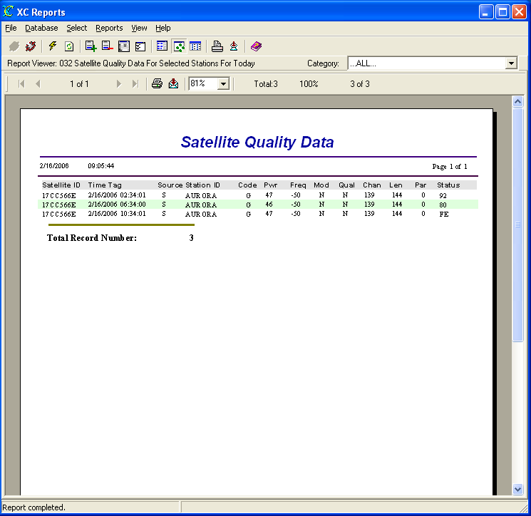
Figure 31. 032 Satellite Quality Data For Selected Stations For Today report

033 Satellite Quality Data For Selected Stations For Yesterday
The Satellite Quality Data For Selected Stations For Yesterday Report displays a report showing quality records for user-selected station(s) in the database for the prior day sorted by NESDIS ID and time. Caution should be used when generating this report. The user will be guided by the Report Wizard to select the desired stations.
Satellite quality records are stored in the XC_GOESQC data table if the users checks the Store Quality parameter on the XC Decode Setup window in XC Desktop. Quality records are used on satellite systems only.
The SQL query used by the report is:
SELECT XC_GOESQC.NESDIS_ID, XC_GOESQC.TIME_TAG, XC_GOESQC.SOURCE, XC_GOESQC.STATION_ID, XC_GOESQC.FAILURE_CODE, XC_GOESQC.SIG_STRENGTH, XC_GOESQC.FREQ_OFFSET, XC_GOESQC.MOD_INDEX, XC_GOESQC.MOD_QUAL, XC_GOESQC.CHANNEL, XC_GOESQC.UC_STATUS, XC_GOESQC.MESSAGE_LEN, XC_GOESQC.PARITY
FROM XC_GOESQC
WHERE XC_GOESQC.STATION_ID='AURORA' AND XC_GOESQC.TIME_TAG>={ts '2006-02-15 00:00:00'}
ORDER BY XC_GOESQC.NESDIS_ID, XC_GOESQC.TIME_TAG

The example report below was generated on 16 February 2006.

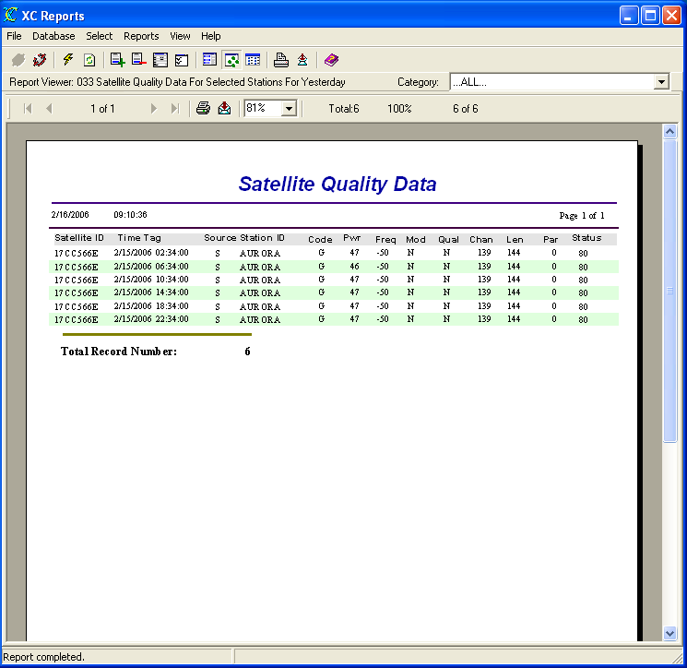
Figure 32. 033 Satellite Quality Data For Selected Stations For Yesterday report

034 All Satellite Quality Data For Today
The Satellite Quality Data For Today Report displays a report showing all quality records in the database for the current day sorted by NESDIS ID and time. Caution should be used when generating this report. This reports does not require any user inputs.
Satellite quality records are stored in the XC_GOESQC data table if the users checks the Store Quality parameter on the XC Decode Setup window in XC Desktop. Quality records are used on satellite systems only.
The SQL query used by the report is:
SELECT XC_GOESQC.NESDIS_ID, XC_GOESQC.TIME_TAG, XC_GOESQC.SOURCE, XC_GOESQC.STATION_ID, XC_GOESQC.FAILURE_CODE, XC_GOESQC.SIG_STRENGTH, XC_GOESQC.MOD_INDEX, XC_GOESQC.MOD_QUAL, XC_GOESQC.CHANNEL, XC_GOESQC.UC_STATUS, XC_GOESQC.FREQ_OFFSET, XC_GOESQC.MESSAGE_LEN, XC_GOESQC.PARITY
FROM XC_GOESQC
WHERE XC_GOESQC.TIME_TAG>={ts '2006-02-16 00:00:00'}
ORDER BY XC_GOESQC.NESDIS_ID, XC_GOESQC.TIME_TAG

The example report below was generated on 16 February 2006.

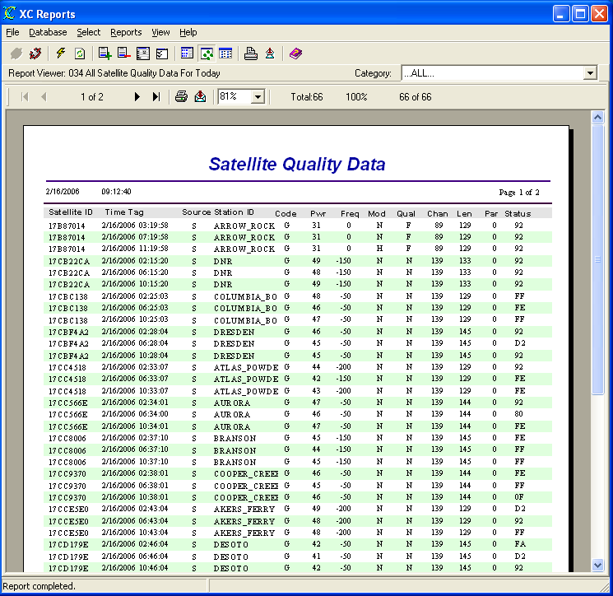
Figure 33. 034 All Satellite Quality Data For Today report

035 All Satellite Quality Data For Yesterday
The Satellite Quality For Yesterday Data Report displays a report showing all quality records in the database for the prior day sorted by NESDIS ID and time. Caution should be used when generating this report. This reports does not require any user inputs.
Satellite quality records are stored in the XC_GOESQC data table if the users checks the Store Quality parameter on the XC Decode Setup window in XC Desktop. Quality records are used on satellite systems only.
The SQL query used by the report is:
SELECT XC_GOESQC.NESDIS_ID, XC_GOESQC.TIME_TAG, XC_GOESQC.SOURCE, XC_GOESQC.STATION_ID, XC_GOESQC.FAILURE_CODE, XC_GOESQC.SIG_STRENGTH, XC_GOESQC.MOD_INDEX, XC_GOESQC.MOD_QUAL, XC_GOESQC.CHANNEL, XC_GOESQC.UC_STATUS, XC_GOESQC.FREQ_OFFSET, XC_GOESQC.MESSAGE_LEN, XC_GOESQC.PARITY
FROM XC_GOESQC
WHERE XC_GOESQC.TIME_TAG>={ts '2006-02-15 00:00:00'}
ORDER BY XC_GOESQC.NESDIS_ID, XC_GOESQC.TIME_TAG

The example report below was generated on 16 February 2006.

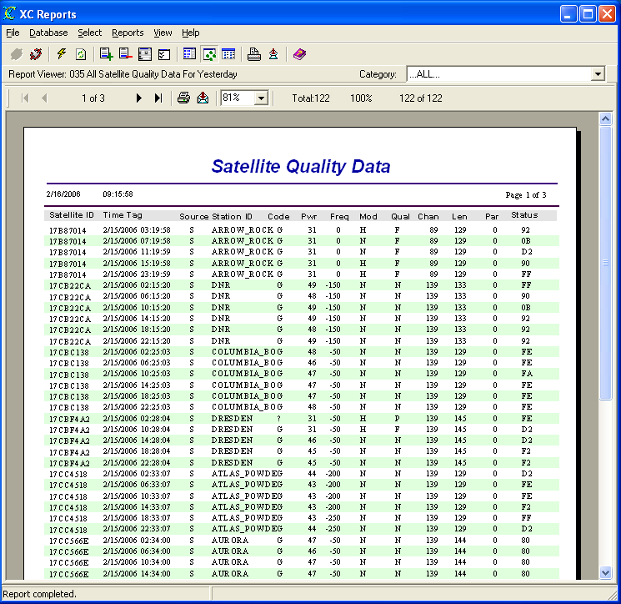
Figure 34. 035 All Satellite Quality Data For Yesterday report

036 Satellite Performance Analysis
The Satellite Performance Analysis Report displays a report showing satellite uplink transmission information stored in the quality records of the database for a user-selected day sorted by Self-Timed Channel, Station Name, NESDIS ID and time.
Satellite quality records are stored in the XC_GOESQC data table if the users checks the Store Quality parameter on the XC Decode Setup window in XC Desktop. Additionally, the Self-Timed Channel must be entered in the Station Database parameter from the Station Setup window in XC Desktop. No data will be generated if the self-timed channel is not entered. Quality records are used on satellite systems only. This reports display information related to uplink transmission parameters.
The SQL query used by the report is:
SELECT XC_GOESQC.NESDIS_ID, XC_GOESQC.TIME_TAG, XC_SITES.STATION_ID, XC_SITES.PRIMARY_CHANNEL, XC_SITES.SATELLITE_ID, XC_SITES.REPORTING_TIME, XC_SITES.REPORTING_INTERVAL, XC_GOESQC.FAILURE_CODE, XC_GOESQC.PARITY, XC_GOESQC.BUFFER_EMPTY, XC_GOESQC.SIG_STRENGTH, XC_GOESQC.FREQ_OFFSET, XC_GOESQC.MOD_INDEX, XC_GOESQC.MOD_QUAL, XC_GOESQC.BATTERY_VOLTAGE, XC_GOESQC.MESSAGE_LEN, XC_SITES.ENABLED
FROM XC_SITES
LEFT OUTER JOIN XC_GOESQC ON XC_SITES.SATELLITE_ID=XC_GOESQC.NESDIS_ID
WHERE XC_SITES.ENABLED='Y' AND (XC_GOESQC.TIME_TAG IS NULL OR (XC_GOESQC.TIME_TAG>={ts '2006-02-14 00:00:00'} AND XC_GOESQC.TIME_TAG<{ts '2006-02-15 00:00:00'})) AND XC_SITES.PRIMARY_CHANNEL IS NOT NULL
ORDER BY XC_SITES.PRIMARY_CHANNEL, XC_SITES.STATION_ID, XC_SITES.SATELLITE_ID, XC_GOESQC.TIME_TAG

The example report below was generated on 16 February 2006.

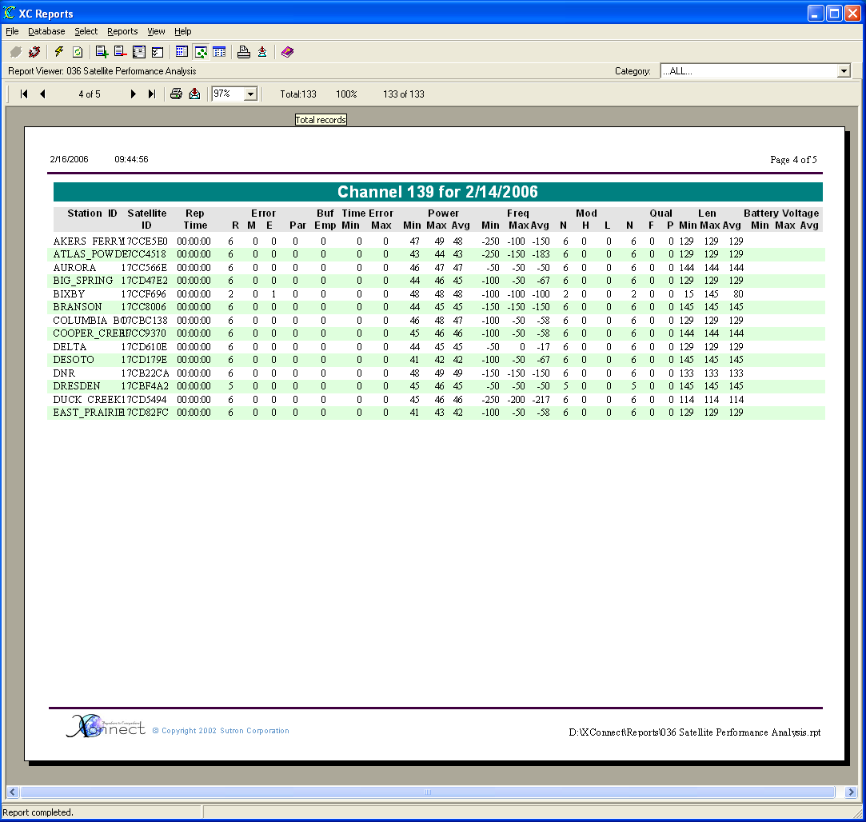
Figure 35. 036 Satellite Performance Analysis report

037 Satellite Performance Analysis For Yesterday
The Satellite Performance Analysis For Yesterday Report displays a report showing satellite uplink transmission information stored in the quality records of the database for the prior day sorted by Self-Timed Channel, Station Name, NESDIS ID and time. This reports does not require any user inputs.
Satellite quality records are stored in the XC_GOESQC data table if the users checks the Store Quality parameter on the XC Decode Setup window in XC Desktop. Additionally, the Self-Timed Channel must be entered in the Station Database parameter from the Station Setup window in XC Desktop. No data will be generated if the self-timed channel is not entered. Quality records are used on satellite systems only. This reports display information related to uplink transmission parameters.
The SQL query used by the report is:
SELECT XC_GOESQC.NESDIS_ID, XC_GOESQC.TIME_TAG, XC_SITES.STATION_ID, XC_SITES.PRIMARY_CHANNEL, XC_SITES.SATELLITE_ID, XC_SITES.REPORTING_TIME, XC_SITES.REPORTING_INTERVAL, XC_GOESQC.FAILURE_CODE, XC_GOESQC.PARITY, XC_GOESQC.BUFFER_EMPTY, XC_GOESQC.SIG_STRENGTH, XC_GOESQC.FREQ_OFFSET, XC_GOESQC.MOD_INDEX, XC_GOESQC.MOD_QUAL, XC_GOESQC.BATTERY_VOLTAGE, XC_GOESQC.MESSAGE_LEN, XC_SITES.ENABLED
FROM XC_SITES
LEFT OUTER JOIN XC_GOESQC ON XC_SITES.SATELLITE_ID=XC_GOESQC.NESDIS_ID
WHERE XC_SITES.ENABLED='Y' AND (XC_GOESQC.TIME_TAG IS NULL OR (XC_GOESQC.TIME_TAG>={ts '2006-02-15 00:00:00'} AND XC_GOESQC.TIME_TAG<{ts '2006-02-16 00:00:00'})) AND XC_SITES.PRIMARY_CHANNEL IS NOT NULL
ORDER BY XC_SITES.PRIMARY_CHANNEL, XC_SITES.STATION_ID, XC_SITES.SATELLITE_ID, XC_GOESQC.TIME_TAG

The example report below was generated on 16 February 2006.

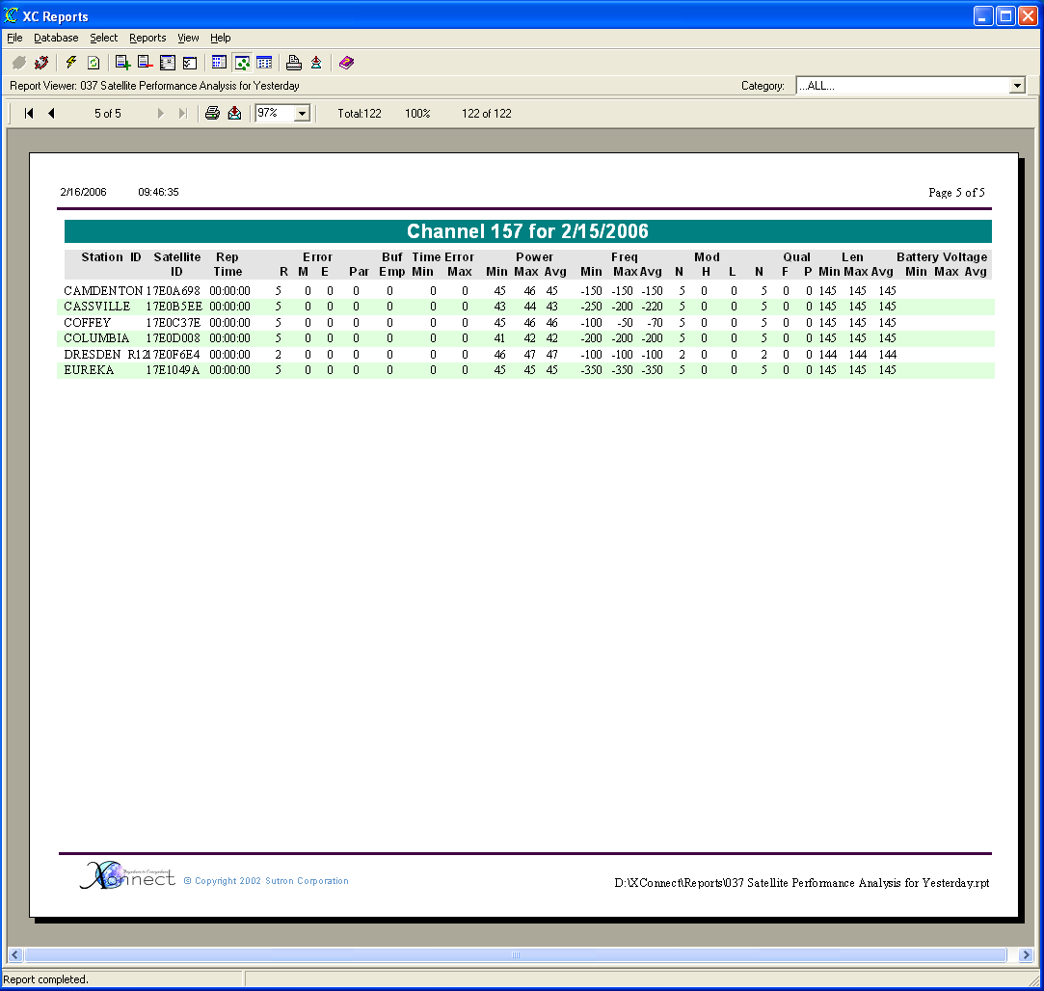
Figure 36. 037 Satellite Performance Analysis For Yesterday report

036 Satellite Performance Analysis For Today
The Satellite Performance Analysis For Today report displays a report showing satellite uplink transmission information stored in the quality records of the database for the current day sorted by Self-Timed Channel, Station Name, NESDIS ID and time. This reports does not require any user inputs.
Satellite quality records are stored in the XC_GOESQC data table if the users checks the Store Quality parameter on the XC Decode Setup window in XC Desktop. Additionally, the Self-Timed Channel must be entered in the Station Database parameter from the Station Setup window in XC Desktop. No data will be generated if the self-timed channel is not entered. Quality records are used on satellite systems only. This reports display information related to uplink transmission parameters.
The SQL query used by the report is:
SELECT XC_GOESQC.NESDIS_ID, XC_GOESQC.TIME_TAG, XC_SITES.STATION_ID, XC_SITES.PRIMARY_CHANNEL, XC_SITES.SATELLITE_ID, XC_SITES.REPORTING_TIME, XC_SITES.REPORTING_INTERVAL, XC_GOESQC.FAILURE_CODE, XC_GOESQC.PARITY, XC_GOESQC.BUFFER_EMPTY, XC_GOESQC.SIG_STRENGTH, XC_GOESQC.FREQ_OFFSET, XC_GOESQC.MOD_INDEX, XC_GOESQC.MOD_QUAL, XC_GOESQC.BATTERY_VOLTAGE, XC_GOESQC.MESSAGE_LEN, XC_SITES.ENABLED
FROM XC_SITES
LEFT OUTER JOIN XC_GOESQC ON XC_SITES.SATELLITE_ID=XC_GOESQC.NESDIS_ID
WHERE XC_SITES.ENABLED='Y' AND (XC_GOESQC.TIME_TAG IS NULL OR (XC_GOESQC.TIME_TAG>={ts '2006-02-16 00:00:00'} AND XC_GOESQC.TIME_TAG<{ts '2006-02-17 00:00:00'})) AND XC_SITES.PRIMARY_CHANNEL IS NOT NULL
ORDER BY XC_SITES.PRIMARY_CHANNEL, XC_SITES.STATION_ID, XC_SITES.SATELLITE_ID, XC_GOESQC.TIME_TAG

The example report below was generated on 16 February 2006.

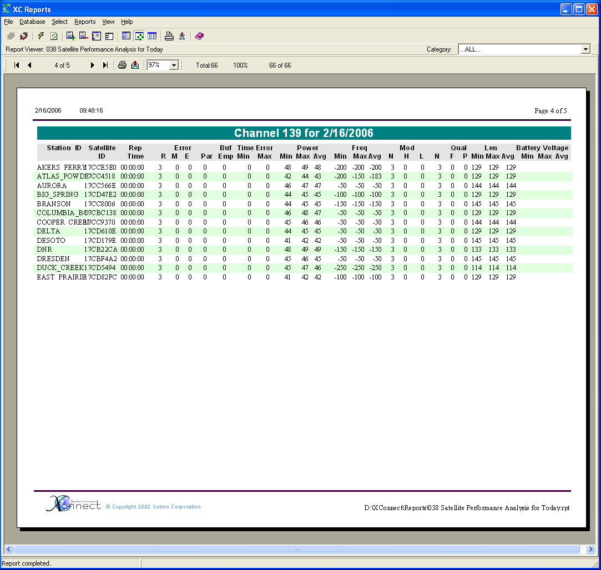
Figure 37. 036 Satellite Performance Analysis For Today report

039 Satellite Performance Analysis For Random Channel
The Satellite Performance Analysis For Random Channel Report displays a report showing satellite uplink transmission information stored in the quality records of the database for a user-selected day sorted by Self-Timed Channel, Station Name, NESDIS ID and time.
Satellite quality records are stored in the XC_GOESQC data table if the users checks the Store Quality parameter on the XC Decode Setup window in XC Desktop. Additionally, the Random Channel must be entered in the Station Database parameter from the Station Setup window in XC Desktop. No data will be generated if the self-timed channel is not entered. Quality records are used on satellite systems only. This reports display information related to uplink transmission parameters.
The SQL query used by the report is:
SELECT XC_GOESQC.NESDIS_ID, XC_GOESQC.TIME_TAG, XC_SITES.STATION_ID, XC_SITES.RANDOM_CHANNEL, XC_SITES.SATELLITE_ID, XC_SITES.REPORTING_TIME, XC_SITES.REPORTING_INTERVAL, XC_GOESQC.FAILURE_CODE, XC_GOESQC.PARITY, XC_GOESQC.BUFFER_EMPTY, XC_GOESQC.SIG_STRENGTH, XC_GOESQC.FREQ_OFFSET, XC_GOESQC.MOD_INDEX, XC_GOESQC.MOD_QUAL, XC_GOESQC.BATTERY_VOLTAGE, XC_GOESQC.MESSAGE_LEN, XC_SITES.ENABLED
FROM XC_SITES
LEFT OUTER JOIN XC_GOESQC ON XC_SITES.SATELLITE_ID=XC_GOESQC.NESDIS_ID
WHERE XC_SITES.ENABLED='Y' AND (XC_GOESQC.TIME_TAG IS NULL OR (XC_GOESQC.TIME_TAG>={ts '2006-02-14 00:00:00'} AND XC_GOESQC.TIME_TAG<{ts '2006-02-15 00:00:00'})) AND XC_SITES.RANDOM_CHANNEL IS NOT NULL
ORDER BY XC_SITES.RANDOM_CHANNEL, XC_SITES.STATION_ID, XC_SITES.SATELLITE_ID, XC_GOESQC.TIME_TAG

The example report below was generated on 16 February 2006.

Figure 38. 039 Satellite Performance Analysis For Random Channel report

040 Satellite Performance Analysis For Random Channel Today
The Satellite Performance Analysis For Random Channel Today Report displaying a report shows satellite uplink transmission information stored in the quality records of the database for the current day sorted by Self-Timed Channel, Station Name, NESDIS ID and time. This reports does not require any user inputs.
Satellite quality records are stored in the XC_GOESQC data table if the users checks the Store Quality parameter on the XC Decode Setup window in XC Desktop. Additionally, the Random Channel must be entered in the Station Database parameter from the Station Setup window in XC Desktop. No data will be generated if the self-timed channel is not entered. Quality records are used on satellite systems only. This reports display information related to uplink transmission parameters.
The SQL query used by the report is:
SELECT XC_GOESQC.NESDIS_ID, XC_GOESQC.TIME_TAG, XC_SITES.STATION_ID, XC_SITES.RANDOM_CHANNEL, XC_SITES.SATELLITE_ID, XC_SITES.REPORTING_TIME, XC_SITES.REPORTING_INTERVAL, XC_GOESQC.FAILURE_CODE, XC_GOESQC.PARITY, XC_GOESQC.BUFFER_EMPTY, XC_GOESQC.SIG_STRENGTH, XC_GOESQC.FREQ_OFFSET, XC_GOESQC.MOD_INDEX, XC_GOESQC.MOD_QUAL, XC_GOESQC.BATTERY_VOLTAGE, XC_GOESQC.MESSAGE_LEN, XC_SITES.ENABLED
FROM XC_SITES
LEFT OUTER JOIN XC_GOESQC ON XC_SITES.SATELLITE_ID=XC_GOESQC.NESDIS_ID
WHERE XC_SITES.ENABLED='Y' AND (XC_GOESQC.TIME_TAG IS NULL OR (XC_GOESQC.TIME_TAG>={ts '2006-02-16 00:00:00'} AND XC_GOESQC.TIME_TAG<{ts '2006-02-17 00:00:00'})) AND XC_SITES.RANDOM_CHANNEL IS NOT NULL
ORDER BY XC_SITES.RANDOM_CHANNEL, XC_SITES.STATION_ID, XC_SITES.SATELLITE_ID, XC_GOESQC.TIME_TAG

The example report below was generated on 16 February 2006.

Figure 39. 040 Satellite Performance Analysis For Random Channel Today report

037 Satellite Performance Analysis For Random Channel Yesterday
The Satellite Performance Analysis For Random Channel Yesterday Report displays a report showing satellite uplink transmission information stored in the quality records of the database for the prior day sorted by Self-Timed Channel, Station Name, NESDIS ID and time. This reports does not require any user inputs.
Satellite quality records are stored in the XC_GOESQC data table if the users checks the Store Quality parameter on the XC Decode Setup window in XC Desktop. Additionally, the Self-Timed Channel must be entered in the Station Database parameter from the Station Setup window in XC Desktop. No data will be generated if the self-timed channel is not entered. Quality records are used on satellite systems only. This reports display information related to uplink transmission parameters.
The SQL query used by the report is:
SELECT XC_GOESQC.NESDIS_ID, XC_GOESQC.TIME_TAG, XC_SITES.STATION_ID, XC_SITES.PRIMARY_CHANNEL, XC_SITES.SATELLITE_ID, XC_SITES.REPORTING_TIME, XC_SITES.REPORTING_INTERVAL, XC_GOESQC.FAILURE_CODE, XC_GOESQC.PARITY, XC_GOESQC.BUFFER_EMPTY, XC_GOESQC.SIG_STRENGTH, XC_GOESQC.FREQ_OFFSET, XC_GOESQC.MOD_INDEX, XC_GOESQC.MOD_QUAL, XC_GOESQC.BATTERY_VOLTAGE, XC_GOESQC.MESSAGE_LEN, XC_SITES.ENABLED
FROM XC_SITES
LEFT OUTER JOIN XC_GOESQC ON XC_SITES.SATELLITE_ID=XC_GOESQC.NESDIS_ID
WHERE XC_SITES.ENABLED='Y' AND (XC_GOESQC.TIME_TAG IS NULL OR (XC_GOESQC.TIME_TAG>={ts '2006-02-15 00:00:00'} AND XC_GOESQC.TIME_TAG<{ts '2006-02-16 00:00:00'})) AND XC_SITES.PRIMARY_CHANNEL IS NOT NULL
ORDER BY XC_SITES.PRIMARY_CHANNEL, XC_SITES.STATION_ID, XC_SITES.SATELLITE_ID, XC_GOESQC.TIME_TAG

The example report below was generated on 16 February 2006.

Figure 40. 037 Satellite Performance Analysis For Random Channel Yesterday report

042 Satellite Performance Analysis (QC Only)
The Satellite Performance Analysis (QC Only) Report displays a report showing satellite uplink transmission information stored in the quality records of the database for a user-selected day sorted by Self-Timed Channel, Station Name, NESDIS ID and time. This reports does not require any user inputs.
Satellite quality records are stored in the XC_GOESQC data table if the users checks the Store Quality parameter on the XC Decode Setup window in XC Desktop. Unlike reports 038 thru 041, the self-timed channel is not required to be entered in the database for each station. Quality records are used on satellite systems only. This reports display information related to uplink transmission parameters.
The SQL query used by the report is:
SELECT XC_GOESQC.NESDIS_ID, XC_GOESQC.TIME_TAG, XC_GOESQC.FAILURE_CODE, XC_GOESQC.PARITY, XC_GOESQC.BUFFER_EMPTY, XC_GOESQC.SIG_STRENGTH, XC_GOESQC.FREQ_OFFSET, XC_GOESQC.MOD_INDEX, XC_GOESQC.MOD_QUAL, XC_GOESQC.BATTERY_VOLTAGE, XC_GOESQC.MESSAGE_LEN, XC_GOESQC.CHANNEL, XC_GOESQC.STATION_ID
FROM XC_GOESQC
WHERE (XC_GOESQC.TIME_TAG IS NULL OR (XC_GOESQC.TIME_TAG>={ts '2006-02-16 00:00:00'} AND XC_GOESQC.TIME_TAG<{ts '2006-02-17 00:00:00'}))
ORDER BY XC_GOESQC.CHANNEL, XC_GOESQC.STATION_ID, XC_GOESQC.NESDIS_ID, XC_GOESQC.TIME_TAG

The example report below was generated on 16 February 2006.

Figure 41. 042 Satellite Performance Analysis (QC Only) report

044 Rtu Performance Analysis For Today
The Rtu Performance Analysis Report displays a report showing polling information stored in the RTU quality records of the database for the current day sorted by Station Name.
Rtu quality records are stored in the XC_RTUQC if the users checks the Store Quality parameter on the XC Rtu Setup window in XC Desktop. Additionally, the Reporting Time and Reporting Interval must be entered in the Station Database parameter from the Station Setup window in XC Desktop. No data will be generated if the Reporting Interval is not entered. Rtu quality records are used on conventional systems only. This reports display information summarizes polling TX/RX statistics.
This report uses a sub report to gathers all RTU quality records with a timestamp for the user-selected day. The main report sorts the data summarizing the OPCode (Current poll, Date Poll, Alarm). Both sql queries are shown below.
The SQL query used by the report is:
SELECT DISTINCT XC_SITES.STATION_ID, XC_SITES.UNIT_ID, XC_SITES.LAST_UPDATE, XC_SITES.REPORTING_TIME, XC_SITES.REPORTING_INTERVAL, XC_SITES.ENABLED
FROM XC_SITES
WHERE XC_SITES.ENABLED='Y'
ORDER BY XC_SITES.STATION_ID

The SQL query used by the embedded sub report is:
SELECT DISTINCT XC_RTUQC.TIME_TAG, XC_RTUQC.STATION_ID, XC_RTUQC.RX_TX, XC_RTUQC.OPCODE
FROM XC_RTUQC
WHERE (XC_RTUQC.TIME_TAG>={ts '2006-02-16 00:00:00'} AND XC_RTUQC.TIME_TAG<{ts '2006-02-17 00:00:00'}) AND XC_RTUQC.STATION_ID`='GUY'
ORDER BY XC_RTUQC.STATION_ID

The example report below was generated on 17 February 2006 at 12:10p. The Reporting/Polling Interval for the station GUY is hourly.

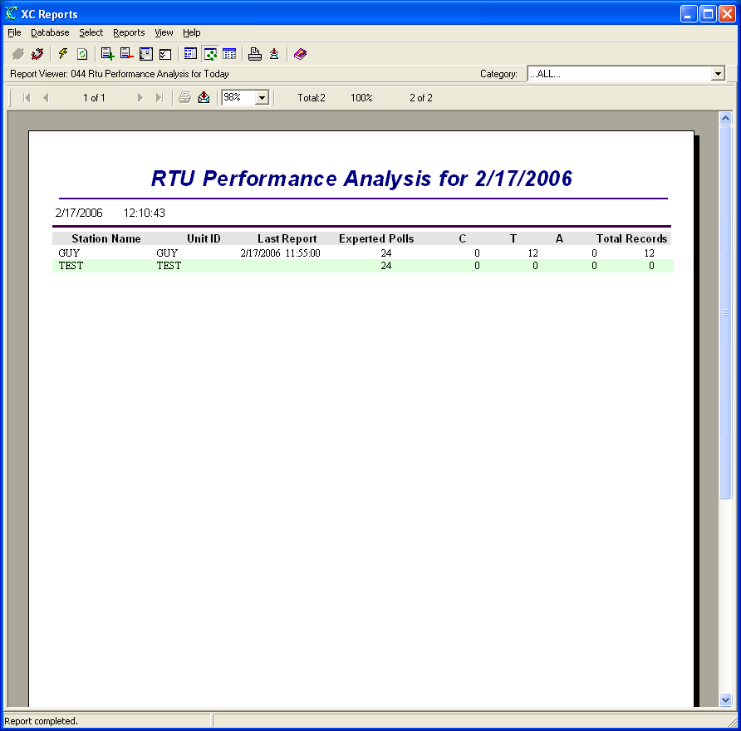
Figure 42. 044 Rtu Performance Analysis For Today report

044 Rtu Performance Analysis For Today
The Rtu Performance Analysis For Today Report displays a report showing polling information stored in the RTU quality records of the database for the current day sorted by Station Name.
Rtu quality records are stored in the XC_RTUQC if the users checks the Store Quality parameter on the XC Rtu Setup window in XC Desktop. Additionally, the Reporting Time and Reporting Interval must be entered in the Station Database parameter from the Station Setup window in XC Desktop. No data will be generated if the Reporting Interval is not entered. Rtu quality records are used on conventional systems only. This reports display information summarizes polling TX/RX statistics.
This report uses a sub report to gathers all RTU quality records with a timestamp for the user-selected day. The main report sorts the data summarizing the OPCode (Current poll, Date Poll, Alarm). Both sql queries are shown below.
The SQL query used by the report is:
SELECT DISTINCT XC_SITES.STATION_ID, XC_SITES.UNIT_ID, XC_SITES.LAST_UPDATE, XC_SITES.REPORTING_TIME, XC_SITES.REPORTING_INTERVAL, XC_SITES.ENABLED
FROM XC_SITES
WHERE XC_SITES.ENABLED='Y'
ORDER BY XC_SITES.STATION_ID

The SQL query used by the embedded sub report is:
SELECT DISTINCT XC_RTUQC.TIME_TAG, XC_RTUQC.STATION_ID, XC_RTUQC.RX_TX, XC_RTUQC.OPCODE
FROM XC_RTUQC
WHERE (XC_RTUQC.TIME_TAG>={ts '2006-02-16 00:00:00'} AND XC_RTUQC.TIME_TAG<{ts '2006-02-17 00:00:00'}) AND XC_RTUQC.STATION_ID`='GUY'
ORDER BY XC_RTUQC.STATION_ID

The example report below was generated on 17 February 2006.

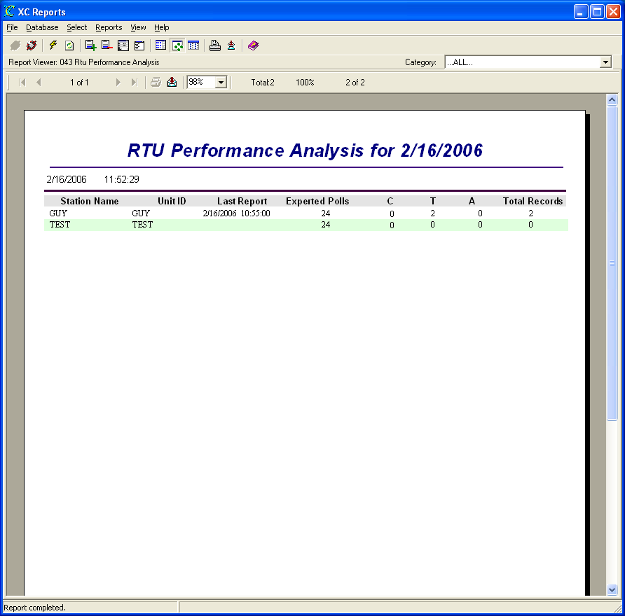
Figure 43. 044 Rtu Performance Analysis For Today report

045 Rtu Performance Analysis For Yesterday
The Rtu Performance Analysis For Yesterday Report displays a report showing polling information stored in the RTU quality records of the database for the prior day sorted by Station Name.
Rtu quality records are stored in the XC_RTUQC if the users checks the Store Quality parameter on the XC Rtu Setup window in XC Desktop. Additionally, the Reporting Time and Reporting Interval must be entered in the Station Database parameter from the Station Setup window in XC Desktop. No data will be generated if the Reporting Interval is not entered. Rtu quality records are used on conventional systems only. This reports display information summarizes polling TX/RX statistics.
This report uses a sub report to gathers all RTU quality records with a timestamp for the user-selected day. The main report sorts the data summarizing the OPCode (Current poll, Date Poll, Alarm). Both sql queries are shown below.
The SQL query used by the report is:
SELECT DISTINCT XC_SITES.STATION_ID, XC_SITES.UNIT_ID, XC_SITES.LAST_UPDATE, XC_SITES.REPORTING_TIME, XC_SITES.REPORTING_INTERVAL, XC_SITES.ENABLED
FROM XC_SITES
WHERE XC_SITES.ENABLED='Y'
ORDER BY XC_SITES.STATION_ID

The SQL query used by the embedded sub report is:
SELECT DISTINCT XC_RTUQC.TIME_TAG, XC_RTUQC.STATION_ID, XC_RTUQC.RX_TX, XC_RTUQC.OPCODE
FROM XC_RTUQC
WHERE (XC_RTUQC.TIME_TAG>={ts '2006-02-16 00:00:00'} AND XC_RTUQC.TIME_TAG<{ts '2006-02-16 00:00:00'}) AND XC_RTUQC.STATION_ID`='GUY'
ORDER BY XC_RTUQC.STATION_ID

The example report below was generated on 17 February 2006.

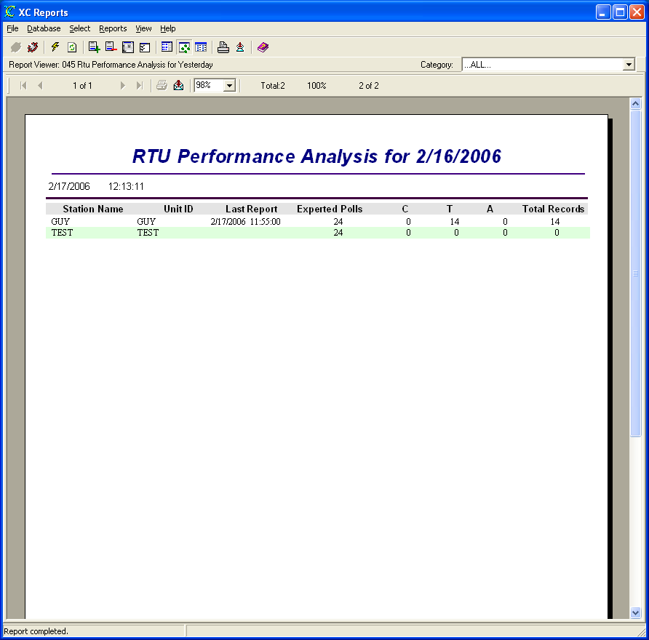
Figure 44. 045 Rtu Performance Analysis For Yesterday report

046 Rtu Poll Summary
The Rtu Poll Summary Report displays a report summarizing polling information and poll responses stored in the RTU quality records of the database for a user-selected day sorted by Station Name and date/time.
Rtu quality records are stored in the XC_RTUQC if the users checks the Store Quality parameter on the XC Rtu Setup window in XC Desktop. Additionally, the Reporting Time and Reporting Interval must be entered in the Station Database parameter from the Station Setup window in XC Desktop. No data will be generated if the Reporting Interval is not entered. Rtu quality records are used on conventional systems only. This reports display information summarizes polling TX/RX statistics.
The SQL query used by the report is:
SELECT DISTINCT XC_SITES.STATION_ID, XC_SITES.UNIT_ID, XC_SITES.LAST_UPDATE, XC_SITES.REPORTING_TIME, XC_SITES.REPORTING_INTERVAL, XC_SITES.ENABLED, XC_RTUQC.TIME_TAG, XC_RTUQC.STATUS, XC_RTUQC.GOOD, XC_RTUQC.BAD, XC_RTUQC.CRC, XC_RTUQC.RX_TX, XC_RTUQC.RETRIES
FROM XC_SITES XC_SITES INNER JOIN XC_RTUQC XC_RTUQC ON XC_SITES.STATION_ID=XC_RTUQC.STATION_ID
WHERE XC_SITES.ENABLED='Y' AND (XC_RTUQC.TIME_TAG IS NULL OR (XC_RTUQC.TIME_TAG>={ts '2006-02-23 00:00:00'} AND XC_RTUQC.TIME_TAG<{ts '2006-02-24 00:00:00'}))
ORDER BY XC_SITES.STATION_ID, XC_RTUQC.TIME_TAG

The example report below was generated on 24 February 2006. The Reporting/Polling Interval for the station GUY is hourly.

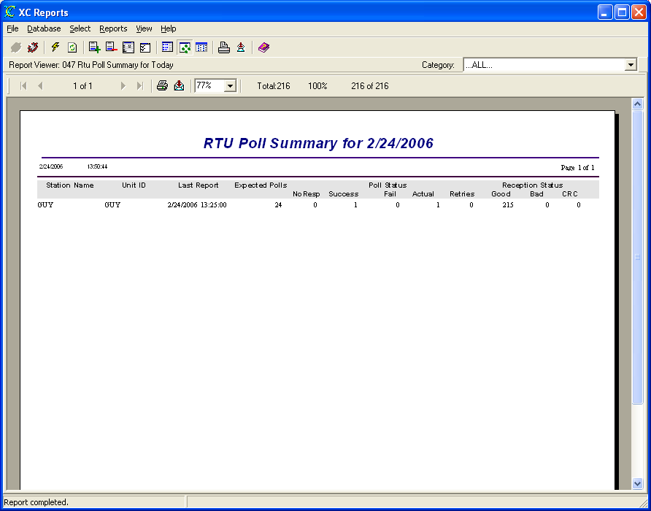
Figure 45. 046 Rtu Poll Summary report

047 Rtu Poll Summary For Today
The Rtu Poll Summary For Today Report displays a report summarizing polling information and poll responses stored in the RTU quality records of the database for the current day sorted by Station Name and date/time.
Rtu quality records are stored in the XC_RTUQC if the users checks the Store Quality parameter on the XC Rtu Setup window in XC Desktop. Additionally, the Reporting Time and Reporting Interval must be entered in the Station Database parameter from the Station Setup window in XC Desktop. No data will be generated if the Reporting Interval is not entered. Rtu quality records are used on conventional systems only. This reports display information summarizes polling TX/RX statistics.
The SQL query used by the report is:
SELECT DISTINCT XC_SITES.STATION_ID, XC_SITES.UNIT_ID, XC_SITES.LAST_UPDATE, XC_SITES.REPORTING_TIME, XC_SITES.REPORTING_INTERVAL, XC_SITES.ENABLED, XC_RTUQC.TIME_TAG, XC_RTUQC.STATUS, XC_RTUQC.GOOD, XC_RTUQC.BAD, XC_RTUQC.CRC, XC_RTUQC.RX_TX, XC_RTUQC.RETRIES
FROM XC_SITES XC_SITES INNER JOIN XC_RTUQC XC_RTUQC ON XC_SITES.STATION_ID=XC_RTUQC.STATION_ID
WHERE XC_SITES.ENABLED='Y' AND (XC_RTUQC.TIME_TAG IS NULL OR (XC_RTUQC.TIME_TAG>={ts '2006-02-24 00:00:00'} AND XC_RTUQC.TIME_TAG<{ts '2006-02-25 00:00:00'}))
ORDER BY XC_SITES.STATION_ID, XC_RTUQC.TIME_TAG

The example report below was generated on 24 February 2006. The Reporting/Polling Interval for the station GUY is hourly.

Figure 46. 047 Rtu Poll Summary For Today report

047 Rtu Poll Summary For Yesterday
The Rtu Poll Summary For Yesterday Report displays a report summarizing polling information and poll responses stored in the RTU quality records of the database for the prior day sorted by Station Name and date/time.
Rtu quality records are stored in the XC_RTUQC if the users checks the Store Quality parameter on the XC Rtu Setup window in XC Desktop. Additionally, the Reporting Time and Reporting Interval must be entered in the Station Database parameter from the Station Setup window in XC Desktop. No data will be generated if the Reporting Interval is not entered. Rtu quality records are used on conventional systems only. This reports display information summarizes polling TX/RX statistics.
The SQL query used by the report is:
SELECT DISTINCT XC_SITES.STATION_ID, XC_SITES.UNIT_ID, XC_SITES.LAST_UPDATE, XC_SITES.REPORTING_TIME, XC_SITES.REPORTING_INTERVAL, XC_SITES.ENABLED, XC_RTUQC.TIME_TAG, XC_RTUQC.STATUS, XC_RTUQC.GOOD, XC_RTUQC.BAD, XC_RTUQC.CRC, XC_RTUQC.RX_TX, XC_RTUQC.RETRIES
FROM XC_SITES XC_SITES INNER JOIN XC_RTUQC XC_RTUQC ON XC_SITES.STATION_ID=XC_RTUQC.STATION_ID
WHERE XC_SITES.ENABLED='Y' AND (XC_RTUQC.TIME_TAG IS NULL OR (XC_RTUQC.TIME_TAG>={ts '2006-02-24 00:00:00'} AND XC_RTUQC.TIME_TAG<{ts '2006-02-25 00:00:00'}))
ORDER BY XC_SITES.STATION_ID, XC_RTUQC.TIME_TAG

The example report below was generated on 25 February 2006. The Reporting/Polling Interval for the station GUY is hourly.

Figure 47. 047 Rtu Poll Summary For Yesterday report

037 Satellite Performance Analysis Time Range
The Satellite Performance Analysis Time Range Report displays a report showing satellite uplink transmission information stored in the quality records of the database for a user-select time range sorted by Self-Timed Channel, Station Name, NESDIS ID and time. The user will be guided by the Report Wizard to select the desired time range.
Satellite quality records are stored in the XC_GOESQC data table if the users checks the Store Quality parameter on the XC Decode Setup window in XC Desktop. Additionally, the Self-Timed Channel must be entered in the Station Database parameter from the Station Setup window in XC Desktop. No data will be generated if the self-timed channel is not entered. Quality records are used on satellite systems only. This reports display information related to uplink transmission parameters.
The SQL query used by the report is:
SELECT XC_GOESQC.NESDIS_ID, XC_GOESQC.TIME_TAG, XC_SITES.STATION_ID, XC_SITES.PRIMARY_CHANNEL, XC_SITES.SATELLITE_ID, XC_SITES.REPORTING_TIME, XC_SITES.REPORTING_INTERVAL, XC_GOESQC.FAILURE_CODE, XC_GOESQC.PARITY, XC_GOESQC.BUFFER_EMPTY, XC_GOESQC.SIG_STRENGTH, XC_GOESQC.FREQ_OFFSET, XC_GOESQC.MOD_INDEX, XC_GOESQC.MOD_QUAL, XC_GOESQC.BATTERY_VOLTAGE, XC_GOESQC.MESSAGE_LEN, XC_SITES.ENABLED
FROM XC_SITES
LEFT OUTER JOIN XC_GOESQC ON XC_SITES.SATELLITE_ID=XC_GOESQC.NESDIS_ID
WHERE XC_SITES.ENABLED='Y' AND (XC_GOESQC.TIME_TAG IS NULL OR (XC_GOESQC.TIME_TAG>={ts '2006-02-12 00:00:00'} AND XC_GOESQC.TIME_TAG<{ts '2006-02-24 14:13:42'})) AND XC_SITES.PRIMARY_CHANNEL IS NOT NULL
ORDER BY XC_SITES.PRIMARY_CHANNEL, XC_SITES.STATION_ID, XC_SITES.SATELLITE_ID, XC_GOESQC.TIME_TAG

The example report below was generated on 24 February 2006.

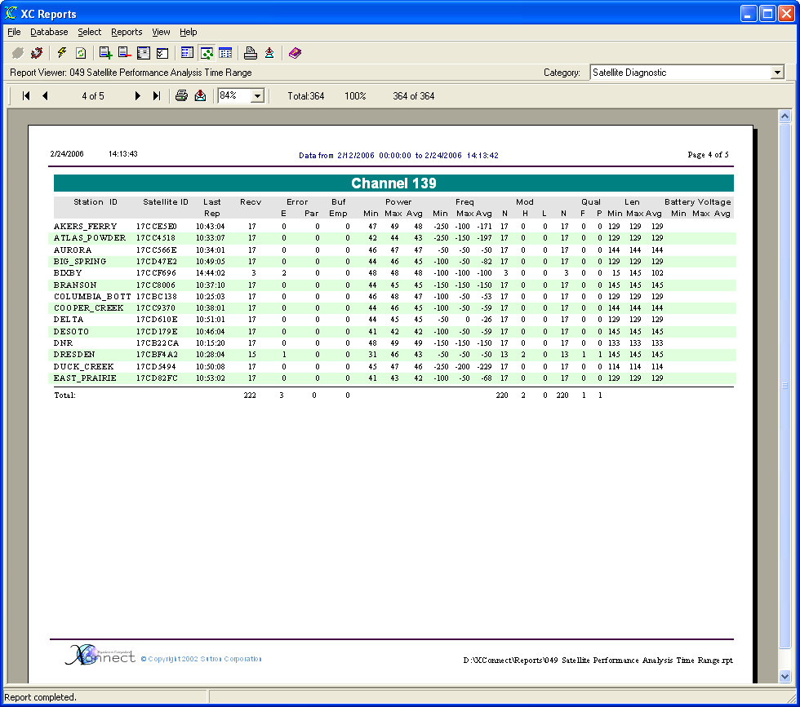
Figure 48. 037 Satellite Performance Analysis Time Range report

050 Data Analysis 1
The Data Analysis 1 Report displays a report summarizing all sensor data stored in XC_DATA1 by total values received, total error values evaluated with flags set (i.e., high high, high, low low, low, rate-of-change..., etc), minimum, maximum and average of all values for a user-selected day sorted by station name, sensor name and date/time.
The SQL query used by the report is:
SELECT DISTINCT XC_DATA1.SENSORNAME, XC_DATA1.TIME_TAG, XC_DATA1.FLAG1, XC_DATA1.ED_VALUE, XC_SITES.STATION_ID, XC_DATA1.STATION_ID, XC_SITES.REPORTING_TIME, XC_SITES.REPORTING_INTERVAL
FROM XC_SITES XC_SITES LEFT OUTER JOIN XC_DATA1 XC_DATA1 ON XC_SITES.STATION_ID=XC_DATA1.STATION_ID
WHERE (XC_DATA1.STATION_ID IS NULL OR (XC_DATA1.TIME_TAG>={ts '2006-02-22 00:00:00'} AND XC_DATA1.TIME_TAG<{ts '2006-02-23 00:00:00'}))
ORDER BY XC_SITES.STATION_ID, XC_DATA1.SENSORNAME, XC_DATA1.TIME_TAG

The example report below was generated on 24 February 2006.

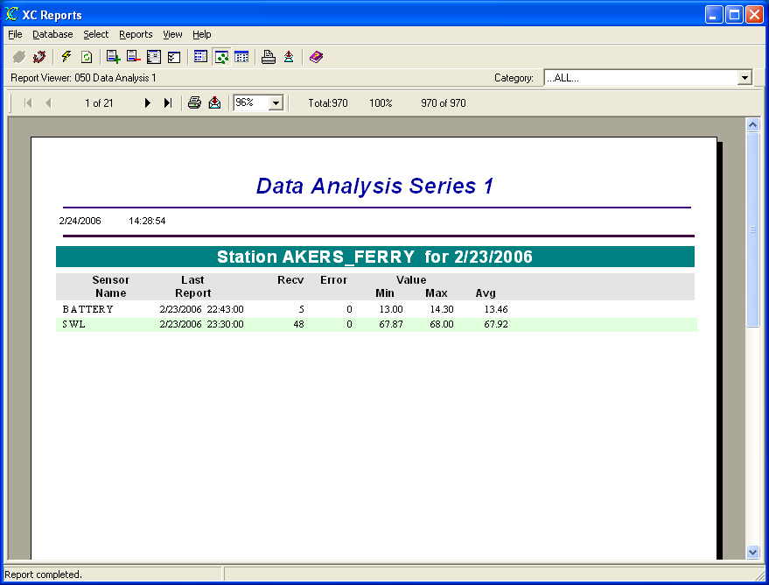
Figure 49. 050 Data Analysis 1 report

051 Data Analysis 2
The Data Analysis 2 Report displays a report summarizing all sensor data stored in XC_DATA1 by total values received, total error values evaluated with flags set (i.e., high high, high, low low, low, rate-of-change..., etc), minimum, maximum and average of all values for a user-selected day sorted by station name, sensor name and date/time.
The SQL query used by the report is:
SELECT DISTINCT XC_DATA1.SENSORNAME, XC_DATA1.TIME_TAG, XC_DATA1.FLAG1, XC_DATA1.ED_VALUE, XC_SITES.STATION_ID, XC_DATA1.STATION_ID, XC_SITES.REPORTING_TIME, XC_SITES.REPORTING_INTERVAL
FROM XC_SITES XC_SITES LEFT OUTER JOIN XC_DATA1 XC_DATA1 ON XC_SITES.STATION_ID=XC_DATA1.STATION_ID
WHERE (XC_DATA1.STATION_ID IS NULL OR (XC_DATA1.TIME_TAG>={ts '2006-02-21 00:00:00'} AND XC_DATA1.TIME_TAG<{ts '2006-02-22 00:00:00'}))
ORDER BY XC_SITES.STATION_ID, XC_DATA1.SENSORNAME, XC_DATA1.TIME_TAG

The example report below was generated on 27 February 2006.

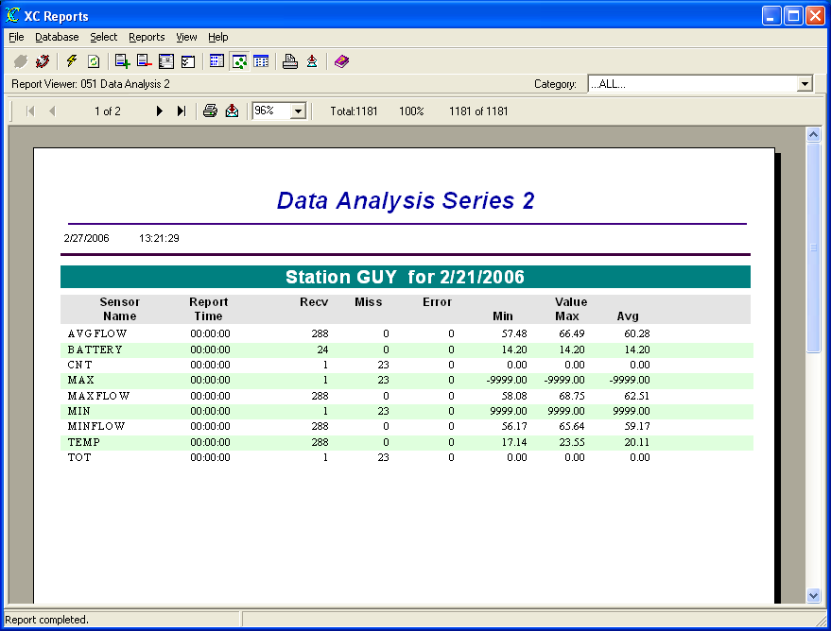
Figure 50. 051 Data Analysis 2 report

052 Data Analysis 1 For Selected Time Range
The Data Analysis 1 For Selected Time Range Report displays a report summarizing all sensor data stored in XC_DATA1 by total error values received, total values evaluated with flags set (i.e., high high, high, low low, low, rate-of-change..., etc), minimum, maximum and average of all values for a user-selected time range sorted by station name, sensor name and date/time. The user will be guided by the Report Wizard to select the desired time range.
The SQL query used by the report is:
SELECT DISTINCT XC_DATA1.SENSORNAME, XC_DATA1.TIME_TAG, XC_DATA1.FLAG1, XC_DATA1.ED_VALUE, XC_SITES.STATION_ID, XC_DATA1.STATION_ID, XC_SITES.REPORTING_TIME, XC_SITES.REPORTING_INTERVAL
FROM XC_SITES XC_SITES LEFT OUTER JOIN XC_DATA1 XC_DATA1 ON XC_SITES.STATION_ID=XC_DATA1.STATION_ID
WHERE (XC_DATA1.STATION_ID IS NULL OR (XC_DATA1.TIME_TAG>={ts '2006-02-19 00:00:00'} AND XC_DATA1.TIME_TAG<{ts '2006-02-24 14:54:51'}))
ORDER BY XC_SITES.STATION_ID, XC_DATA1.SENSORNAME, XC_DATA1.TIME_TAG

The example report below was generated on 24 February 2006 for the data ranging from 19 February to 24 February.

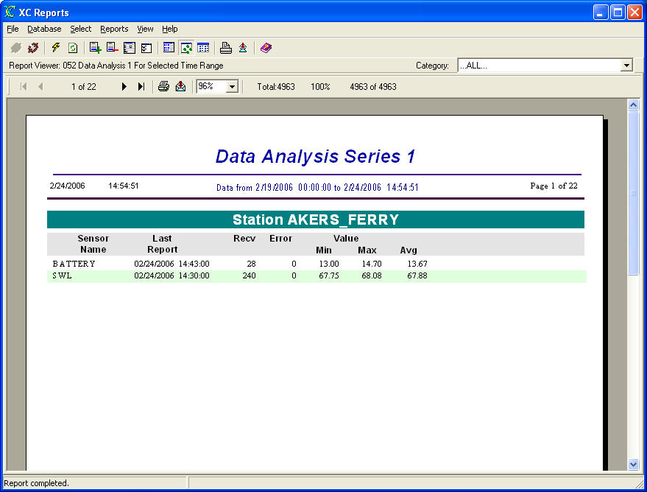
Figure 51. 052 Data Analysis 1 For Selected Time Range report

053 Rtu Channel Summary
The Rtu Channel Summary Report displays a report summarizing polling information and poll responses stored in the RTU quality records of the database for a user-selected day sorted by Com port number and Station Name.
Rtu quality records are stored in the XC_RTUQC if the users checks the Store Quality parameter on the XC Rtu Setup window in XC Desktop. Additionally, the Reporting Time and Reporting Interval must be entered in the Station Database parameter from the Station Setup window in XC Desktop. The Expected Polls column will not be displayed/calculated correctly if the Reporting Interval is not entered. Rtu quality records are used on conventional systems only. This reports display information summarizes polling TX/RX statistics.
The SQL query used by the report is:
SELECT DISTINCT XC_SITES.STATION_ID, XC_SITES.UNIT_ID, XC_SITES.LAST_UPDATE, XC_SITES.REPORTING_TIME, XC_SITES.REPORTING_INTERVAL, XC_SITES.ENABLED, XC_RTUQC.TIME_TAG, XC_RTUQC.STATUS, XC_RTUQC.GOOD, XC_RTUQC.BAD, XC_RTUQC.CRC, XC_RTUQC.PORT, XC_RTUQC.RX_TX, XC_RTUQC.RETRIES
FROM XC_SITES XC_SITES INNER JOIN XC_RTUQC XC_RTUQC ON XC_SITES.STATION_ID=XC_RTUQC.STATION_ID
WHERE XC_SITES.ENABLED='Y' AND (XC_RTUQC.TIME_TAG IS NULL OR (XC_RTUQC.TIME_TAG>={ts '2006-02-25 00:00:00'} AND XC_RTUQC.TIME_TAG<{ts '2006-02-26 00:00:00'}))
ORDER BY XC_RTUQC.PORT, XC_SITES.STATION_ID

The example report below was generated on 27 February 2006.

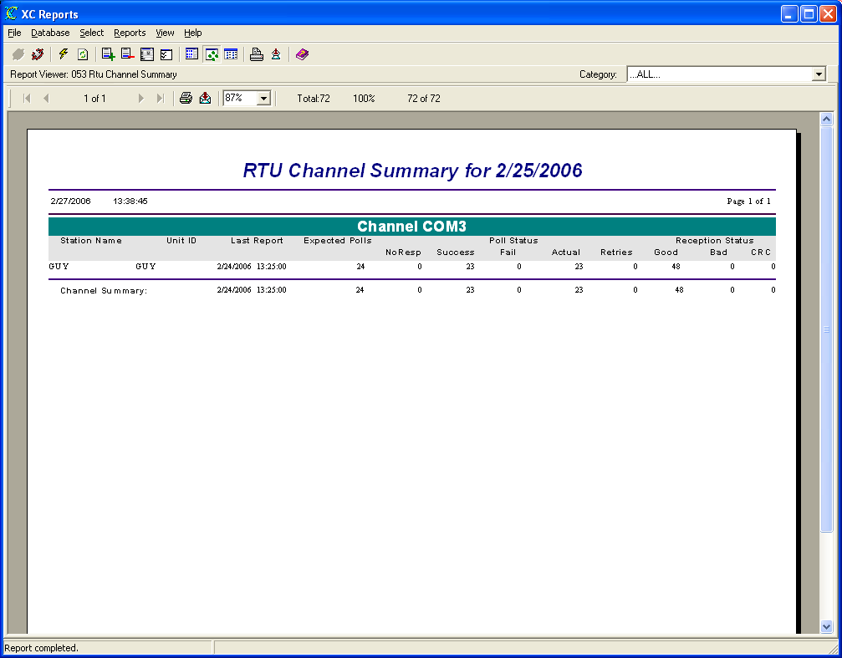
Figure 52. 053 Rtu Channel Summary report

054 Rtu Channel Summary for Today
The Rtu Channel Summary For Today Report displays a report summarizing polling information and poll responses stored in the RTU quality records of the database for the current day sorted by Com port number and Station Name.
Rtu quality records are stored in the XC_RTUQC if the users checks the Store Quality parameter on the XC Rtu Setup window in XC Desktop. Additionally, the Reporting Time and Reporting Interval must be entered in the Station Database parameter from the Station Setup window in XC Desktop. The Expected Polls column will not be displayed/calculated correctly if the Reporting Interval is not entered. Rtu quality records are used on conventional systems only. This reports display information summarizes polling TX/RX statistics.
The SQL query used by the report is:
SELECT DISTINCT XC_SITES.STATION_ID, XC_SITES.UNIT_ID, XC_SITES.LAST_UPDATE, XC_SITES.REPORTING_TIME, XC_SITES.REPORTING_INTERVAL, XC_SITES.ENABLED, XC_RTUQC.TIME_TAG, XC_RTUQC.STATUS, XC_RTUQC.GOOD, XC_RTUQC.BAD, XC_RTUQC.CRC, XC_RTUQC.PORT, XC_RTUQC.RX_TX, XC_RTUQC.RETRIES
FROM XC_SITES XC_SITES INNER JOIN XC_RTUQC XC_RTUQC ON XC_SITES.STATION_ID=XC_RTUQC.STATION_ID
WHERE XC_SITES.ENABLED='Y' AND (XC_RTUQC.TIME_TAG IS NULL OR (XC_RTUQC.TIME_TAG>={ts '2006-02-27 00:00:00'} AND XC_RTUQC.TIME_TAG<{ts '2006-02-28 00:00:00'}))
ORDER BY XC_RTUQC.PORT, XC_SITES.STATION_ID

The example report below was generated on 28 February 2006.

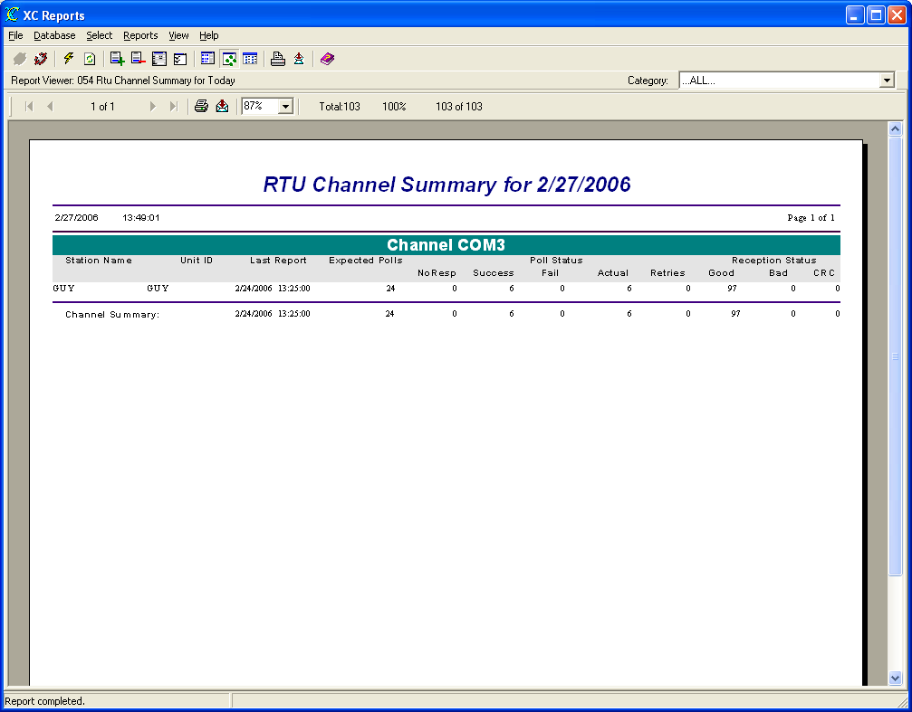
Figure 53. 054 Rtu Channel Summary for Today report

054 Rtu Channel Summary for Today
The Rtu Channel Summary For Yesterday Report displays a report summarizing polling information and poll responses stored in the RTU quality records of the database for the current day sorted by Com port number and Station Name.
Rtu quality records are stored in the XC_RTUQC if the users checks the Store Quality parameter on the XC Rtu Setup window in XC Desktop. Additionally, the Reporting Time and Reporting Interval must be entered in the Station Database parameter from the Station Setup window in XC Desktop. The Expected Polls column will not be displayed/calculated correctly if the Reporting Interval is not entered. Rtu quality records are used on conventional systems only. This reports display information summarizes polling TX/RX statistics.
The SQL query used by the report is:
SELECT DISTINCT XC_SITES.STATION_ID, XC_SITES.UNIT_ID, XC_SITES.LAST_UPDATE, XC_SITES.REPORTING_TIME, XC_SITES.REPORTING_INTERVAL, XC_SITES.ENABLED, XC_RTUQC.TIME_TAG, XC_RTUQC.STATUS, XC_RTUQC.GOOD, XC_RTUQC.BAD, XC_RTUQC.CRC, XC_RTUQC.PORT, XC_RTUQC.RX_TX, XC_RTUQC.RETRIES
FROM XC_SITES XC_SITES INNER JOIN XC_RTUQC XC_RTUQC ON XC_SITES.STATION_ID=XC_RTUQC.STATION_ID
WHERE XC_SITES.ENABLED='Y' AND (XC_RTUQC.TIME_TAG IS NULL OR (XC_RTUQC.TIME_TAG>={ts '2006-02-27 00:00:00'} AND XC_RTUQC.TIME_TAG<{ts '2006-02-28 00:00:00'}))
ORDER BY XC_RTUQC.PORT, XC_SITES.STATION_ID

The example report below was generated on 27 February 2006.

Figure 54. 054 Rtu Channel Summary for Today report

057 Rtu Quality Data For Selected Time Range-Stations
The Rtu Quality Data For Time Range Selected Stations Report displays a report showing quality records for user-selected station(s) in the database sorted by NESDIS ID and time. Caution should be used when generating this report. Depending on the amount of data stored in he database, the report may take a considerable amount of time. The user will be guided by the Report Wizard to select the desired stations.
Satellite quality records are stored in the XC_GOESQC data table if the users checks the Store Quality parameter on the XC Decode Setup window in XC Desktop. Quality records are used on satellite systems only.
The SQL query used by the report is:
SELECT XC_RTUQC.STATION_ID, XC_RTUQC.TIME_TAG, XC_RTUQC.RX_TX, XC_RTUQC.PORT, XC_RTUQC.SEQUENCENUM, XC_RTUQC.OPCODE, XC_RTUQC.STATUS, XC_RTUQC.RETRIES, XC_RTUQC.GOOD, XC_RTUQC.BAD, XC_RTUQC.CRC
FROM XC_RTUQC
WHERE XC_RTUQC.STATION_ID='GUY' AND (XC_RTUQC.TIME_TAG>={ts '2006-02-27 12:10:10'} AND XC_RTUQC.TIME_TAG<{ts '2006-02-27 15:10:10'})
ORDER BY XC_RTUQC.STATION_ID

The example report below was generated on 27 February 2006 at 15:08 requesting RTU quality data for the last 3 hours.

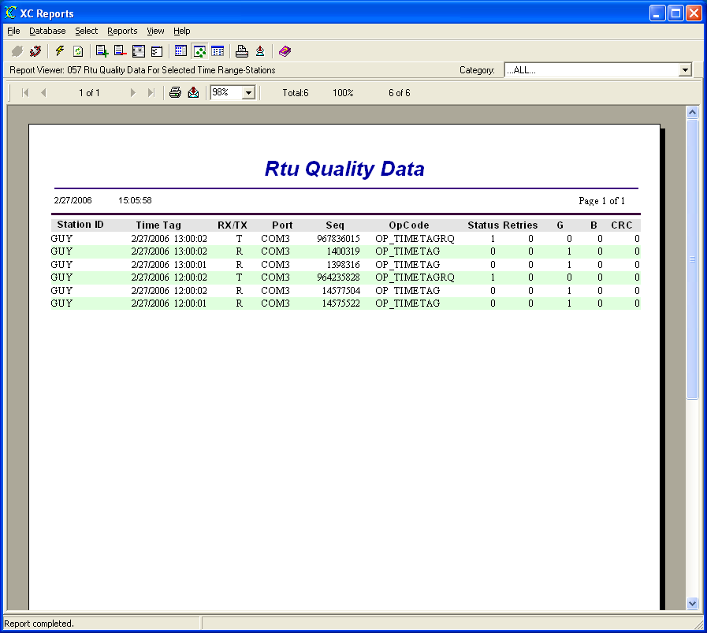
Figure 55. 057 Rtu Quality Data For Selected Time Range-Stations report

056 Rtu Quality Data For Selected Stations
The Rtu Quality Data For Selected Stations Report displays a report showing quality records for user-selected station(s) in the database sorted by NESDIS ID and time. Caution should be used when generating this report. Depending on the amount of data stored in he database, the report may take a considerable amount of time. The user will be guided by the Report Wizard to select the desired time range and stations.
Satellite quality records are stored in the XC_GOESQC data table if the users checks the Store Quality parameter on the XC Decode Setup window in XC Desktop. Quality records are used on satellite systems only.
The SQL query used by the report is:
SELECT XC_RTUQC.STATION_ID, XC_RTUQC.TIME_TAG, XC_RTUQC.RX_TX, XC_RTUQC.PORT, XC_RTUQC.SEQUENCENUM, XC_RTUQC.OPCODE, XC_RTUQC.STATUS, XC_RTUQC.RETRIES, XC_RTUQC.GOOD, XC_RTUQC.BAD, XC_RTUQC.CRC
FROM XC_RTUQC
WHERE XC_RTUQC.STATION_ID='GUY'
ORDER BY XC_RTUQC.STATION_ID

The example report below was generated on 27 February 2006.

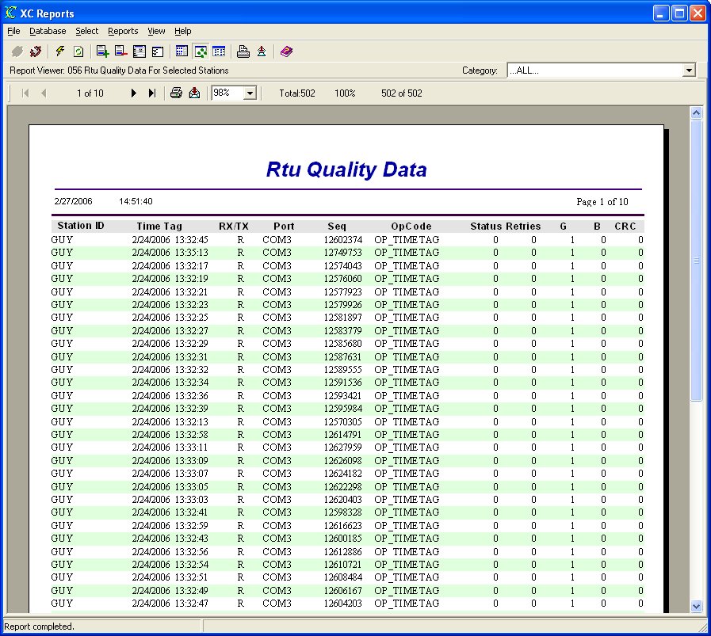
Figure 56. 056 Rtu Quality Data For Selected Stations report

060 Bad Data For Today
The Bad Data For Today Report displays a report showing all the data in the database stored for the current day sorted by station name, sensor name and time that has a non-zero or non blank threshold flag value. These data have exceeded a user-defined threshold evaluate either by the field station (RTU) or XC Alarm. Caution should be used when generating this report. Depending on the amount of data stored in he database, the report may take a considerable amount of time. This reports does not require any user inputs.
XC Alarm can evaluate sensor thresholds. Sensor threshold values are entered in XC Desktop on the Sensor Setup window - Database Fields. XC Alarm will enter a "+1" or "-1" in the appropriate flag fields (high high, high, lowlow, low, rate-of-change, no-change...,etc) if the sensor value has exceeded the threshold(s).
The SQL query used by the report is:
SELECT XC_DATA1.STATION_ID, XC_DATA1.SENSORNAME, XC_DATA1.TIME_TAG, XC_DATA1.SOURCE, XC_DATA1.ORIG_VALUE, XC_DATA1.ED_VALUE, XC_DATA1.FLAG1, XC_DATA1.FLAG2, XC_DATA1.FLAG3, XC_DATA1.FLAG4, XC_DATA1.HIGH_HIGH_FLAG, XC_DATA1.HIGH_FLAG, XC_DATA1.LOW_FLAG, XC_DATA1.LOW_LOW_FLAG, XC_DATA1.ROC_FLAG, XC_DATA1.NO_CHG_FLAG
FROM XC_DATA1
WHERE XC_DATA1.TIME_TAG>={ts '2006-02-27 00:00:00'} AND (XC_DATA1.FLAG1 IS NOT NULL AND XC_DATA1.FLAG1<>' ' OR XC_DATA1.FLAG2 IS NOT NULL AND XC_DATA1.FLAG2<>' ' OR XC_DATA1.FLAG3` IS NOT NULL AND XC_DATA1.FLAG3<>' ' OR XC_DATA1.FLAG4 IS NOT NULL AND XC_DATA1.FLAG4<>' ' OR XC_DATA1.HIGH_HIGH_FLAG IS NOT NULL AND XC_DATA1.HIGH_HIGH_FLAG`<>0 OR XC_DATA1.HIGH_FLAG IS NOT NULL AND XC_DATA1.HIGH_FLAG<>0 OR XC_DATA1.LOW_FLAG IS NOT NULL AND XC_DATA1.LOW_FLAG`<>0 OR XC_DATA1.LOW_LOW_FLAG IS NOT NULL AND XC_DATA1.LOW_LOW_FLAG<>0 OR XC_DATA1.ROC_FLAG IS NOT NULL AND XC_DATA1.ROC_FLAG<>0 OR XC_DATA1.NO_CHG_FLAG IS NOT NULL AND XC_DATA1.NO_CHG_FLAG<>0)
ORDER BY XC_DATA1.STATION_ID, XC_DATA1.SENSORNAME, XC_DATA1.TIME_TAG

The example report below was generated on 27 February 2006.

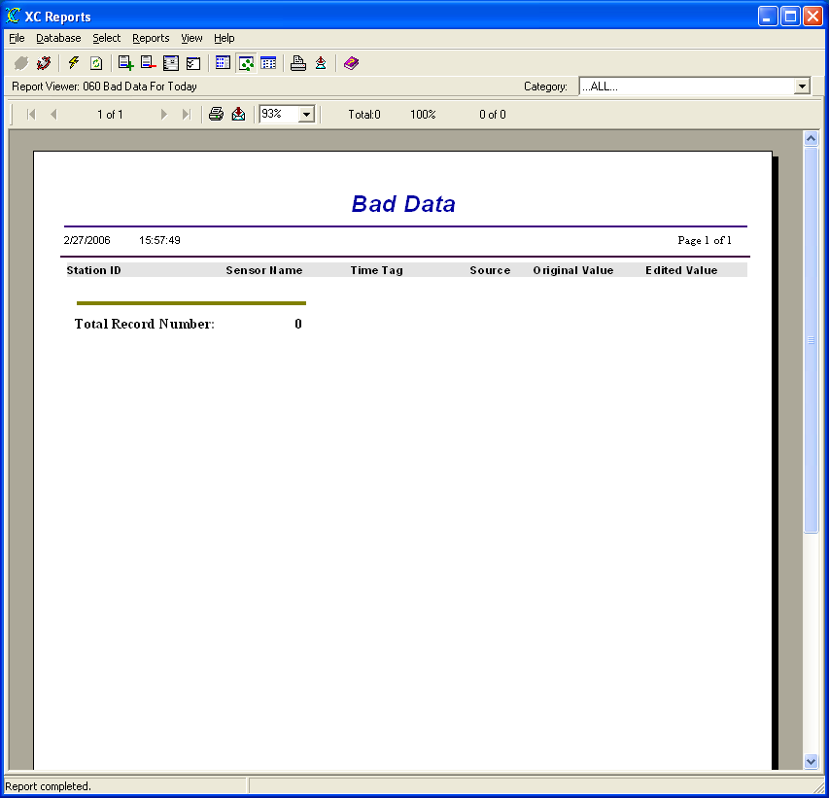
Figure 57. 060 Bad Data For Today report

061 Bad Data For Yesterday
The Bad Data For Yesterday Report displays a report showing all the data in the database stored for the prior day sorted by station name, sensor name and time that has a non-zero or non blank threshold flag value. These data have exceeded a user-defined threshold evaluate either by the field station (RTU) or XC Alarm. Caution should be used when generating this report. Depending on the amount of data stored in he database, the report may take a considerable amount of time. This reports does not require any user inputs.
XC Alarm can evaluate sensor thresholds. Sensor threshold values are entered in XC Desktop on the Sensor Setup window - Database Fields. XC Alarm will enter a "+1" or "-1" in the appropriate flag fields (high high, high, lowlow, low, rate-of-change, no-change...,etc) if the sensor value has exceeded the threshold(s).
The SQL query used by the report is:
SELECT XC_DATA1.STATION_ID, XC_DATA1.SENSORNAME, XC_DATA1.TIME_TAG, XC_DATA1.SOURCE, XC_DATA1.ORIG_VALUE, XC_DATA1.ED_VALUE, XC_DATA1.FLAG1, XC_DATA1.FLAG2, XC_DATA1.FLAG3, XC_DATA1.FLAG4, XC_DATA1.HIGH_HIGH_FLAG, XC_DATA1.HIGH_FLAG, XC_DATA1.LOW_FLAG, XC_DATA1.LOW_LOW_FLAG, XC_DATA1.ROC_FLAG, XC_DATA1.NO_CHG_FLAG
FROM XC_DATA1
WHERE (XC_DATA1.FLAG1 IS NOT NULL AND XC_DATA1.FLAG1<>' ' OR XC_DATA1.FLAG2 IS NOT NULL AND XC_DATA1.FLAG2<>' ' OR XC_DATA1.FLAG3 IS NOT NULL AND XC_DATA1.FLAG3<>' ' OR XC_DATA1.FLAG4 IS NOT NULL AND XC_DATA1.FLAG4<>' ' OR XC_DATA1.HIGH_HIGH_FLAG IS NOT NULL AND XC_DATA1.HIGH_HIGH_FLAG<>0 OR XC_DATA1.HIGH_FLAG IS NOT NULL AND XC_DATA1.HIGH_FLAG<>0 OR XC_DATA1.LOW_FLAG IS NOT NULL AND XC_DATA1.LOW_FLAG<>0 OR XC_DATA1.LOW_LOW_FLAG IS NOT NULL AND XC_DATA1.LOW_LOW_FLAG<>0 OR XC_DATA1.ROC_FLAG IS NOT NULL AND XC_DATA1.ROC_FLAG<>0 OR XC_DATA1.NO_CHG_FLAG` IS NOT NULL AND XC_DATA1.NO_CHG_FLAG<>0) AND (XC_DATA1.TIME_TAG>={ts '2006-02-26 00:00:00'} AND XC_DATA1.TIME_TAG<{ts '2006-02-27 00:00:00'})
ORDER BY `XC_DATA1.STATION_ID, XC_DATA1.SENSORNAME, XC_DATA1.TIME_TAG`

The example report below was generated on 27 February 2006.

Figure 58. 061 Bad Data For Yesterday report

062 Bad Data For Selected Time Range
The Bad Data For Yesterday Report displays a report showing all the data in the database stored for a user-selected time range sorted by station name, sensor name and time that has a non-zero or non blank threshold flag value. These data have exceeded a user-defined threshold evaluate either by the field station (RTU) or XC Alarm. Caution should be used when generating this report. Depending on the amount of data stored in he database, the report may take a considerable amount of time. The user will be guided by the Report Wizard to select the desired time range.
XC Alarm can evaluate sensor thresholds. Sensor threshold values are entered in XC Desktop on the Sensor Setup window - Database Fields. XC Alarm will enter a "+1" or "-1" in the appropriate flag fields (high high, high, lowlow, low, rate-of-change, no-change...,etc) if the sensor value has exceeded the threshold(s).
The SQL query used by the report is:
SELECT XC_DATA1.STATION_ID, XC_DATA1.SENSORNAME, XC_DATA1.TIME_TAG, XC_DATA1.SOURCE, XC_DATA1.ORIG_VALUE, XC_DATA1.ED_VALUE, XC_DATA1.FLAG1, XC_DATA1.FLAG2, XC_DATA1.FLAG3, XC_DATA1.FLAG4, XC_DATA1.HIGH_HIGH_FLAG, XC_DATA1.HIGH_FLAG, XC_DATA1.LOW_FLAG, XC_DATA1.LOW_LOW_FLAG, XC_DATA1.ROC_FLAG, XC_DATA1.NO_CHG_FLAG
FROM XC_DATA1
WHERE (XC_DATA1.FLAG1 IS NOT NULL AND XC_DATA1.FLAG1<>' ' OR XC_DATA1.FLAG2 IS NOT NULL AND XC_DATA1.FLAG2<>' ' OR XC_DATA1.FLAG3 IS NOT NULL AND XC_DATA1.FLAG3<>' ' OR XC_DATA1.FLAG4 IS NOT NULL AND XC_DATA1.FLAG4<>' ' OR XC_DATA1.HIGH_HIGH_FLAG IS NOT NULL AND XC_DATA1.HIGH_HIGH_FLAG<>0 OR XC_DATA1.HIGH_FLAG IS NOT NULL AND XC_DATA1.HIGH_FLAG<>0 OR XC_DATA1.LOW_FLAG IS NOT NULL AND XC_DATA1.LOW_FLAG<>0 OR XC_DATA1.LOW_LOW_FLAG IS NOT NULL AND XC_DATA1.LOW_LOW_FLAG<>0 OR XC_DATA1.ROC_FLAG IS NOT NULL AND XC_DATA1.ROC_FLAG<>0 OR XC_DATA1.NO_CHG_FLAG` IS NOT NULL AND XC_DATA1.NO_CHG_FLAG<>0) AND (XC_DATA1.TIME_TAG>={ts '2006-02-26 00:00:00'} AND XC_DATA1.TIME_TAG<{ts '2006-02-27 00:00:00'})
ORDER BY `XC_DATA1.STATION_ID, XC_DATA1.SENSORNAME, XC_DATA1.TIME_TAG`

The example report below was generated on 27 February 2006.

Figure 59. 062 Bad Data For Selected Time Range report

063 Bad Data For Selected Time Range-Stations-Sensors
The Bad Data For Selected Time Range-Stations-Sensors Report displays a report showing all the data in the database stored for a user-selected time range sorted by station name, sensor name and time that has a non-zero or non blank threshold flag value. These data have exceeded a user-defined threshold evaluate either by the field station (RTU) or XC Alarm. Caution should be used when generating this report. Depending on the amount of data stored in he database, the report may take a considerable amount of time. The user will be guided by the Report Wizard to select the desired time range and stations.
XC Alarm can evaluate sensor thresholds. Sensor threshold values are entered in XC Desktop on the Sensor Setup window - Database Fields. XC Alarm will enter a "+1" or "-1" in the appropriate flag fields (high high, high, lowlow, low, rate-of-change, no-change...,etc) if the sensor value has exceeded the threshold(s).
The SQL query used by the report is:
SELECT XC_DATA1.STATION_ID, XC_DATA1.SENSORNAME, XC_DATA1.TIME_TAG, XC_DATA1.SOURCE, XC_DATA1.ORIG_VALUE, XC_DATA1.ED_VALUE, XC_DATA1.FLAG1, XC_DATA1.FLAG2, XC_DATA1.FLAG3, XC_DATA1.FLAG4, XC_DATA1.HIGH_HIGH_FLAG, XC_DATA1.HIGH_FLAG, XC_DATA1.LOW_FLAG, XC_DATA1.LOW_LOW_FLAG, XC_DATA1.ROC_FLAG, XC_DATA1.NO_CHG_FLAG
FROM XC_DATA1
WHERE XC_DATA1.STATION_ID='GUY' AND XC_DATA1.SENSORNAME='FLOW' AND (XC_DATA1.TIME_TAG>={ts '2006-02-27 00:00:00'} AND XC_DATA1.TIME_TAG<{ts '2006-02-27 16:16:05'}) AND (XC_DATA1.FLAG1 IS NOT NULL AND XC_DATA1.FLAG1<>' ' OR XC_DATA1.FLAG2 IS NOT NULL AND XC_DATA1.FLAG2<>' ' OR XC_DATA1.FLAG3 IS NOT NULL AND XC_DATA1.FLAG3<>' ' OR XC_DATA1.FLAG4 IS NOT NULL AND XC_DATA1.FLAG4<>' ' OR XC_DATA1.HIGH_HIGH_FLAG IS NOT NULL AND XC_DATA1.HIGH_HIGH_FLAG`<>0 OR XC_DATA1.HIGH_FLAG IS NOT NULL AND XC_DATA1.HIGH_FLAG<>0 OR XC_DATA1.LOW_FLAG IS NOT NULL AND XC_DATA1.LOW_FLAG<>0 OR XC_DATA1.LOW_LOW_FLAG IS NOT NULL AND XC_DATA1.LOW_LOW_FLAG<>0 OR XC_DATA1.ROC_FLAG IS NOT NULL AND XC_DATA1.ROC_FLAG<>0 OR XC_DATA1.NO_CHG_FLAG IS NOT NULL AND XC_DATA1.NO_CHG_FLAG<>0)
ORDER BY XC_DATA1.STATION_ID, XC_DATA1.SENSORNAME, XC_DATA1.TIME_TAG

The example report below was generated on 27 February 2006.

Figure 60. 063 Bad Data For Selected Time Range-Stations-Sensors report

Troubleshooting

Troubleshooting tips
Network errors can potentially be the source of most errors in XC Reports. In most cases, databases are stored on separate network servers. If a sudden loss of network connectivity should occur, reports will fail to generate. Ensure network access is available to the network database server as well as the correct login privileges. Again, in a large network where the database is on a separate server, verify your database login name and password with you network administrator.
On small systems using Access as you database, the Access database (.MDB) may or may not be stored in the same PC. Make sure, for all Data Sources configurations, the data source is configured as a system resource (System DSN) and not as a user resource. Access, based on the data source configuration, may or may not require a password. Verify any login parameters.
There is a chance that the Crystal Report file (.RPT) may become corrupt. If so, the user can copy or re-install the file from the XConnect installation CD.

Error Messages
Potential error messages generated by XC Reports are:

Error 8: Invalid License Key. Please verify XConnect is properly installed.

Troubleshooting steps:
Ensure that:
- Current XConnect application is part of the purchased XConnect license.
Refer to the original purchase order.

Error 9: Invalid License Key. Exiting now...

Troubleshooting steps:
Potential reasons for error:
- Current XConnect application is not valid for use with existing XConnect license.
Call Sutron Sales to upgrade XConnect license.

Error 1200: Unable to connect to database.

Troubleshooting steps:
Potential reasons for error:
- The database configuration has changed on the current machine/network PC or has XConnect been installed on a new PC where the Data Source is not configured.
Verify the Data Source (ODBC) settings for XConnect database.
Check settings in Data Sources control applet either in the Control Panel or in Administrative Tools.
Verify user name and password are correct for database login.

Error 1201: Crystal Reports file does not exist.

Troubleshooting steps:
Potential reasons for error:
- Selected report has been moved from original locations.
In the Report Manager, select the View|Report List|Details. The third column in the Details view displays the expected file location. Using Windows Explorer, verify the file is present on the hard disk.

Error 1202: Report file xxx is not enabled.

Troubleshooting steps:
Potential reasons for error:
- The report, when added to XC Reports, was not enabled.
Highlight the report in the Report Manager. From the main menu, select Reports|Report Setup or click from the toolbar. Check the Enabled box to enable the report.

Error 1203: Unable to set Crystal Reports run parameters.

Troubleshooting steps:
Potential reasons for error:
- Report is not properly configured. For, example, input selections were check in the Report setup when the report was added to XC Reports, but input is not required.
Highlight the report in the Report Manager. From the main menu, select Reports|Report Setup or click from the toolbar. Correct errors in the report setup.

Error 1204: Unable to save new report information.

Troubleshooting steps:
Potential reasons for error:
- While trying to add a new report to the report manager, XC Reports was unable to save user settings in the XCReports.XFG file.
In Windows Explorer, ensure the file is in the XConnect installation directory and it is not marked as READ-ONLY.

Error 1205: Report Title can not be empty. Please try again.

Troubleshooting steps:
Potential reasons for error:
- While adding a new report to the Report Manager, the Report Title was left blank. This is the title or text that XC Report will display in the Report Manager.
Enter report title name for new Crystal Report.

Error 1206: Crystal Reports file not selected.

Troubleshooting steps:
Potential reasons for error:
- While adding a new report to the Report Manager, the file name of the new report was left blank.
Enter/select Crystal Report (.RPT) file on PC.

Error 1207: xxx.rpt does not exist.

Troubleshooting steps:
Potential reasons for error:
- While adding a new report to the Report Manager, the Report Title was entered does not exist.
Enter report title name for new Crystal Report or use the Browse button to browse files on PC.

Error 1208: Invalid report category selected.

Troubleshooting steps:
Potential reasons for error:
- An invalid category was selected from the category list while adding a report to XC Reports
Select a valid category from the Category list.

Error 1209: Data operation error. Unable to read from database.

Troubleshooting steps:
Potential reasons for error:
- Database is down due to a network error.
Verify the network or database PC is functioning properly. Check with your network administrator.
- Database drivers are incorrect or corrupt.
Check and verify the settings the Data Sources (ODBC) configuration.
Access the database using another application on the PC that also uses ODBC.
Access the database from another computer that also has the database source configured.
Download ODBC drivers from Windows' or the database vendors' web site.

Error 1210: Filter file not selected.

Troubleshooting steps:
Potential reasons for error:
- The user selected the Apply Filter button in the Report Wizard, however a filter file was not specified.
Enter filter file name and then select Apply Filter.

Error 1211: Unable to load filter file.

Troubleshooting steps:
Potential reasons for error:
- Filter file may be corrupt or incorrect.
Using Notepad, open the filter file. Filter files are ASCII files and are readable in Notepad.
Re-create the filter file in XC DataView.

Error 1212: Unable to update report information.

Troubleshooting steps:
Potential reasons for error:
- Once a report has been added, the user can modify the report settings by highlight the report and selecting Report|Report Setup. After changes, XC Report was unable to update the user changes to the XCReports.XFG
In Windows Explorer, ensure the file is in the XConnect installation directory and it is not marked as READ-ONLY.
Ensure another application does not have this file open.

Error 1213: Unable to add category - category file.

Troubleshooting steps:
Potential reasons for error:
- , XC Report was unable to update category change to the XCReports.XFG
In Windows Explorer, ensure the file is in the XConnect installation directory and it is not marked as READ-ONLY.
Ensure another application does not have this file open.

Error 1214: Unable to add Crystal Reports file xxx into list view.

Troubleshooting steps:
Potential reasons for error:
- XC Report was unable to add the new file to the XCReports.XFG and thus the list view.
In Windows Explorer, ensure the file is in the XConnect installation directory and it is not marked as READ-ONLY.
Ensure another application does not have this file open.

Error 1215: Unable to remove the xxx from XC Reports.

Troubleshooting steps:
Potential reasons for error:
- XC Report was unable to erase the report entry in the XCReports.XFG
In Windows Explorer, ensure the file is in the XConnect installation directory and it is not marked as READ-ONLY.
Ensure another application does not have this file open.

Error 1216: Unable to load/refresh report properties.

Troubleshooting steps:
Potential reasons for error:
- Crystal report file may be corrupt.
Copy report (RPT) file from XConnect installation CD.
- Abrupt loss of network.
Check network connection (Network neighborhood) or contact your network administrator.

Error 1217: Unable to run/generate report.

Troubleshooting steps:
Potential reasons for error:
- Crystal report file may be corrupt.
Copy report (RPT) file from XConnect installation CD.
- Abrupt loss of network.
Check network connection (Network neighborhood) or contact your network administrator.

Error 1218: Failed to get SQL string from Crystal Reports.

Troubleshooting steps:
Potential reasons for error:
- This error may be generated during the debug mode of XC Reports. In the debug mode, the actual SQL string will be returned.

Error 1219: The starting time must be earlier than the ending time.

Troubleshooting steps:
Potential reasons for error:
- An invalid start time was entered. Start time must be earlier than the end time.

Index

A
Adding
new Report 10
Adding 10
Apply button
clicking 14
Apply button 14
Apply Filter 105
Apply Filter button
selected 105
Apply Filter button 105
ASCII 105
Available Categories 10
C
Category list 10, 105
changes
database source 7
XCReports.XFG 105
changes 7
changes 105
Check
Enabled 105
Check 10
Check 105
Connect 7
Contents 4
Control Panel 105
Crystal Report 1, 5, 10, 105
Crystal Report Viewer 4
Crystal Reports file 10, 105
D
Data Sources 4, 5, 7, 105
Database Alias list 7
Database menu 7
database source
Changing 7
database source 7
Details 5, 105
Disconnect 7
display
Report Properties 4, 5
display 4
display 5
document/report
Author - Author 6
Category - Category 6
regarding 6
Subject - Subject 6
Title - Title 6
document/report 6
E
Enabled - Check 10
Enabled - This 6
Error Messages 105
existing
XConnect 105
existing 105
Exporting
reports 10
Exporting 10
F
Filter File Required 6, 10
M
machine/network PC 105
Menu Bar 3, 4
Moving
around 3
Moving 3
N
Name 6, 10
new Report
Adding 10
new Report 10
O
ODBC 4, 5, 7, 14, 105
P
Password 7
PC 105
Post-Processed data 15
Print Setup 4
R
Register Report 4, 10
Reload Last Report 4
Remove Report 4, 13
report
Exporting 10
Removing 13
Report Manager 4, 5, 105
Running 9
report 4
report 5
report 6
report 9
report 10
report 13
report 105
Report Library 9
Report Manager 3, 4, 5, 8, 10, 105
Report Manager list 13, 14
Report Manager/Report Viewer 3
Report Properties
display 4, 5
Report Properties 3
Report Properties 4
Report Properties 5
Report Properties 6
Report Settings 6
Report Setup 4
Report Setup Parameters 10
Report Setup window 10
Report Statistics 6
Report Summary 6
Report Title 14, 105
Report Viewer 3, 4, 5, 8, 10
Report Wizard 14, 105
Reports menu 10, 13
RPT 10, 13, 105
Run Report
select 9
Run Report 4
Run Report 9
Run Report 10
run/generate 105
Running
Report 9
Running 9
S
Select menu 15
Sensor Selection Required 6, 10
Settings 6
Setup Requirements 10
Show Report Manager 5
Show Report Viewer 5
Start Menu 7, 10, 13
Station Selection Required 6, 10
Status Bar 6
Summary, Statistics 6
System DSN 105
T
Time Range Required 6, 10
tips
Troubleshooting 105
tips 105
Title - Title
document/report 6
Title - Title 6
Title - Title 10
Toggling 8
Troubleshooting
steps 105
tips 105
Troubleshooting 105
Troubleshooting 105
V
Viewing
Sensor Data 15
Viewing 15
X
XC PostProc 15
XC Reports
Welcome 1
XC Reports 1
XC Reports 3
XC Reports 5
XC Reports 5
XC Reports 5
XC Reports 7
XC Reports 8
XC Reports 9
XC Reports 10
XC Reports 10
XC Reports 14
XC Reports 105
XC Reports 105
XC_DATA1 15
XC_PPDATA1 15
XConnect 1, 105
XCReports.XFG
changes 105
XCReports.XFG 105
XCReports.XFG file 105

