
XC DataView


Sutron Corporation
21300 Ridgetop Circle
Sterling, Virginia 20166
TEL: (703) 406-2800
FAX: (703) 406-2801
WEB: http://www.sutron.com/
Table Of Contents
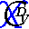 Welcome to XC DataView 1
Using XC DataView 3
Moving around in XC DataView 3
The Menu Bar 4
The XC DataView Toolbar 5
The following tools are provided: 5
Sensor Tree View 5
Data Retrieval 6
Display Area 6
The Status Bar 6
Configuring a data source 7
To configure a data source: 7
To change the data source: 8
Displaying data 10
To display data in a graph: 10
To display data in a list: 11
Displaying sensor database parameters 12
Displaying station database parameters 12
Graph Options 13
Printing Graphs 13
Exporting Graphs 14
Copying Graphs 14
Single/Multi-Axis 14
Data Pointer 16
Data Markers 18
Graph Display Options Parameters 20
Extended Graph Display Options 24
Zooming and Panning 25
Select Data Points 28
Modify Selected Data Points 29
Data Increment 30
List display options 31
Using an Interval 31
Using Approximate Times 33
Editing data values 35
Sensor Statistics 38
Sorting the Sensor Tree view 41
Filter Files 44
Creating a simple filter file 44
Applying Filter files 50
Selecting sensors 53
Sensor settings file 53
To create a sensor settings file: 53
To recall a sensor settings file: 53
Using sensor settings files on startup: 54
Viewing Sensor Data or Post-Processed data 56
Importing data 57
Import parameters 57
Exporting data 58
Troubleshooting 59
Troubleshooting tips 59
Database configuration 59
PcBase2 binary files 59
No data displayed in graph or list view 59
Wrong data displayed 59
No stations/sensors displayed in Sensor Tree view 60
Error messages 61
Error 606: Unable to read data from file filename. 61
Error 1200: Unable to connect to database. 61
Error 1401: Error loading station sensors. 61
Error 1402: Invalid sensor settings file. 61
Error 1403: Crystal Reports file filename does not exist. 61
Error 1404: Too many columns. Columns must be less than 13. 61
Error 1405: Database not selected. 62
Error 1406: XC DataView can only display a maximum number of 86400 records. 62
Error 1407: Unable to delete filename. Check file attributes. 62
Error 1408: Unable to export graph data to XML file. 62
Error 1409: Unable to export graph data to CSV file. 62
Error 1410: The starting time must be earlier than the ending time. 62
Error 1411: Database error - %p. 63
Error 1412: The min must be less than the max. 63
Index 65

Table of Figures
Figure 1. XC DataView main window 3
Figure 2. Data Source Explorer window 7
Figure 3. Select directory for PcBase2 binary files 8
Figure 4. Select database Data Source window 8
Figure 5. Data Source Explorer window 9
Figure 6. Data displayed in a graph view 11
Figure 7. Data displayed in a list view 12
Figure 8. Graph toolbar 13
Figure 9. Print Preview window 14
Figure 10. Export format selection window 14
Figure 11. Multi axis graph display 15
Figure 12. Single axis graph display 16
Figure 13. Select Chart Series window 17
Figure 14. Using data pointer with graph 18
Figure 15. Graph without data markers 19
Figure 16. Graph with data markers 20
Figure 17. Graph display options window 20
Figure 18. Multi-axis graph display 21
Figure 19. Individual Y-axis min settings 22
Figure 20. Individual Y-axis max settings 22
Figure 21. Graph without data markers 23
Figure 22. Graph with data markers 24
Figure 23. Extended graph options window 25
Figure 24. Dragging a box on the graph 26
Figure 25. Zoomed area of graph 27
Figure 26. Graph panned to left 28
Figure 27. Graph edit mode 29
Figure 28. Modify data in graph view 29
Figure 29. List view of sensor data 31
Figure 30. Only display data every 6 hours 32
Figure 31. All Data displayed 34
Figure 32. Aligned using Approx Times parameter 35
Figure 33. Editing individual data values in list view 36
Figure 34. Editing multiple (batch) data values in list view 37
Figure 35. Modify data in list view 37
Figure 36. Sensor statistics list view 38
Figure 37. Avg, Min and Max statistics selected 39
Figure 38. Printing sensor statistics 40
Figure 39. Export format selection window 40
Figure 40. Sensor Tree view sorted by stations 42
Figure 41. Sensor Tree view sorted by sensor 43
Figure 42. Filters window 44
Figure 43. Filter field parameter selection 45
Figure 44. Filter value parameter selection 46
Figure 45. Filter selections 47
Figure 46. Adding filter condition 48
Figure 47. Executing filter conditions 49
Figure 48. Saving filter conditions to file 49
Figure 49. Filters window 50
Figure 50. Select filter file window 51
Figure 51. Sensor tree view with filter applied 52
Figure 52. XC DataView shortcut properties 54
Figure 53. XC DataView shortcut with Sensor Settings file 55
Figure 54. Import window 57
Figure 55. Import progress 57

Welcome to XC DataView
XConnect is Sutron Corporation's latest data collection, data processing and data storage software. Built on the strong principles of PcBase2, XConnect is compliant with today's 32-bit Windows operating systems and provides new tools and options for the user.
XConnect is a collection of executables designed to provide a complete solution for data collection, data handling, data viewing and data storage
The role of XC DataView within an XConnect data collection system is to display in a tabular or graphical form data processed and stored by XC Rtu or XC Decode. XC DataView can display data from the PcBase2 binary data files as well as the XConnect database. Many data sources can be defined in XC DataView, so the user can connect/disconnect to different data sources.

Using XC DataView

Moving around in XC DataView
The XC DataView application consists of these main areas:
- The Menu Bar provides access to all user-controllable functions within the application.
- The Toolbar provides one-click access to important functions.
- The System View provides the user with a flexible tree view representation of the XConnect stations. Expanding the tree displays stations and sensors.
- The Data Retrieval box displays the user sensor selections and time range of the desired data.
- The Data Display window

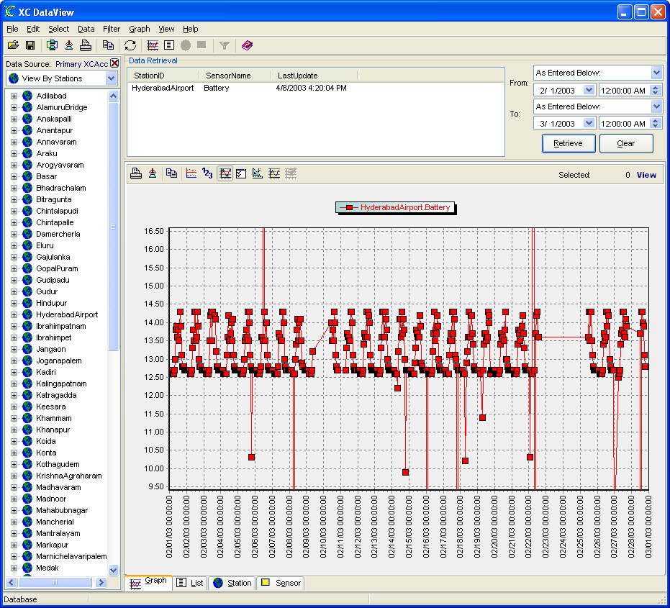
Figure 1. XC DataView main window

The Menu Bar
The Menu Bar provides access to the following menus:
File | - Open Sensor Settings -- opens a sensor settings file (.SFG) to recall saved sensor selections.  - Save Sensor Settings -- save current sensor selections, from and to dates for later recall.  - Change Data Source -- opens connect window to select or add new data sources.  - Import -- imports data from a file (.CSV, .TXT) into data source.  - Export -- exports selected sensors to disk file (.CSV, .TXT, .XLS) for select time range.  - Print Setup -- send shutdowns command to XConnect applications.  - Print -- connects XC Desktop to remote XC Setup.  - Exit -- terminates the application.
Edit | - Copy -- copies highlighted text to Windows clipboard.  - Paste -- pastes contents of Windows clipboard.
Select | - Add To Retrieval List -- adds selected sensor(s) to Data Retrieval list.  - Add All to Retrieval List -- adds all sensors to Data Retrieval list.  - Delete From Retrieval List -- deletes sensor(s) from Data Retrieval list.  - Delete All From Retrieval List -- deletes all sensors from Data Retrieval list.  - Sensor Data (XC_DATA1) -- retrieves data from sensor data table.  - Post Processed Data (XC_PPDATA1) -- retrieves data from post processing data table.
Data | - List -- retrieves data and displays in list tab.  - Graph -- retrieves data and displays in graph tab.  - Station Properties -- displays station database information for selected station.  - Sensor Properties -- displays sensor database information for selected sensor.  - Clear -- clears the data displayed in the graph and the list.
Filter | - Select Filter -- selects a filter file.  - Apply Filter -- applies/removes filter conditions.
Graph | - Multi-Axis -- toggles between using a single axis for all sensor data or individual axes for each sensor.  - Data Under Cursor -- snaps cursor to data points and displays data values on status bar.  - Graph Options -- opens window to edit basic graph display options.  - Graph Styles -- opens window to edit extended graph styles.
View | - Refresh -- refreshes sensor tree view from data source.  - Expand Tree -- expands to all sub-nodes of sensor tree.  - Collapse Tree -- displays only major modes of sensor tree.  - Options -- display date/times as local from GMT (data stored as GMT).
Help | - XC DataView Help -- accesses this help system and defaults to Index tab.  - XC DataView Contents -- accesses this help system and defaults to Contents tab.  - About -- gets version information for this application.

The XC DataView Toolbar
The toolbar area allows you to quickly access various XC Desktop functions.

The following tools are provided:
Select a sensor settings file (.SFG) to recall sensor selections.
Save current sensor selections, from and to date fields to disk.
Open connect window to select or add new data sources.
Export current graph data or list data.
Print current graph or list data.
Copy current graph data as a bitmap or list data.
Refresh sensor tree view from data source.
Graph selected sensor data listed in Data Retrieval list box.
View tabular list of selected sensor data in Data Retrieval list box.
Display station database parameters on Station tab for selected station.
Display sensor database parameters on Sensor tab for selected sensor.
Apply selected filter file to station-sensor list.

Sensor Tree View
The Sensor tree view displays all available stations and sensors stored in the data source as well as displaying the selected data source name. If a filter is applied, the filter is displayed at the bottom of the sensor tree panel and the sensor list will display stations and sensors compliant with the filter.
The sensor tree can be sorted by stations, sensor or other attributes. Click on the pull-down list box at the tree view. The sort options will differ based on the data source selected (i.e., database, PcBase2, ...).

Data Retrieval
The Data Retrieval section of XC DataView displays the sensor(s) selected to display in graph and list tabs. Sensors can be easily added and removed from the list by double-clicking on the sensor or selecting the appropriate menu options from the main or pop-up menu (accessed by using the right-click mouse button). Selecting the display start date and end date is as easy as choosing a convenient time-date qualifier such as Last Month, Last Week or Yesterday, or entering a specific date and time.
The Data Retrieval list box can also be easily sorted, like in Windows Explorer, by clicking on the column header. For example, by click on the SensorName column will sort all the sensor names alphabetically, in ascending order (A-Z). Clicking on it a second time will sort the sensor names in descending order (A-Z).

Display Area
The Display Area of XC DataView is a 4-tabbed control allowing the user to see the data in graph or a list. The user can also display database parameters for a selected station or sensor. Additional display and list options are also provided on each tab.

The Status Bar
The Status Bar is divided in three sections. The left-hand panel displays the type of data storage used: PCBase2, ASCII Log, Excel, or Database The middle panel displays parameter hints. The right-hand panel displays any other messages including the sensor data value when using the data pointer function on a graph.

Configuring a data source
XC DataView can connect to different data sources, if necessary. Usually in a system, there is one data source (data storage choice). However, if a system has changed sensors or station names, it may be useful to backup/rename the current data source and create a new one. Or, in a redundant system, there could be two separate data sources, one for each system.

To configure a data source:
- From the File menu, select Change Data Source or from the toolbar click . The Data Source Explorer window will appear.
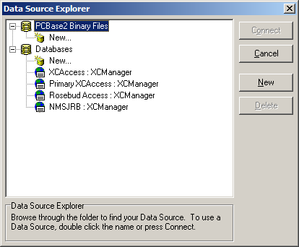
Figure 2. Data Source Explorer window
- Expand data sources tree and click on the data source node (PcBase2 Binary files or Databases) where the new node will be added. Click the New button or double-click on the node.
- For Pcbase2 Binary Files, a window will open to allow the user to choose a data file directory.
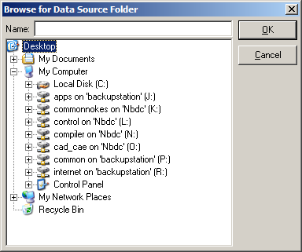
Figure 3. Select directory for PcBase2 binary files
For Databases, a window will open to allow the user to choose a data source name.
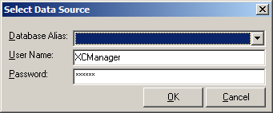
Figure 4. Select database Data Source window
Note, for databases, the Data Source must be configured prior to adding the data source in XC DataView. Go to the Administrative Tools|Data Sources (ODBC) control panel applet to configure the database source or consult your Network Administrator.
- Click OK when finished. The new data source will appear under the data source node.
- Click on the newly added data source and click the Connect button.
- XC DataView will now refresh the sensor tree view with the stations and sensors in the new data source.

To change the data source:
- From the File menu, select Change Data Source or from the toolbar click . The Data Source Explorer window will appear.
Figure 5. Data Source Explorer window
- Expand data sources tree and click on another data source in the list. Then click the Connect button.
- XC DataView will now refresh the sensor tree view with the stations and sensors in the new data source.

Displaying data
XC DataView can display data on a graph or in a tabular list. Either viewing method is very simple. All the user needs to do is to select the sensors from the sensor tree, enter the desired start and stop dates and then click Retrieve button. Clicking the Retrieve button will display data in the current selected tab (Graph or List). To clear the data on the graph or list, click the Clear button.

To display data in a graph:
- Highlight a sensor in the sensor tree and then from the Select menu, select Add to Retrieval List menu option. Double-clicking on the sensor also adds the Data Retrieval list.
Double-clicking or selecting the tree node will add all sensors in the subnodes to the Data Retrieval list.
- Select the desired start date and stop date. The user can select As Entered Below: and enter a specific date and time or select a date-time qualifier like Yesterday, Last Week, Last Month. The date-time qualifiers will be used to calculate the start and stop time based on the current date and time.
Time-date qualifiers allow the user to always see the same range of data each time without manually entering in the date and time. In many cases, using the viewing dates of Yesterday to Now allow the user to easily pull up the most recent data each day without additional keystrokes to modify the exact date and time each day. The exact start date of Yesterday will be automatically calculated based on the current date and time. The same applies for the end date of Now.
- From the Data menu, select Graph or from the toolbar, click the icon.
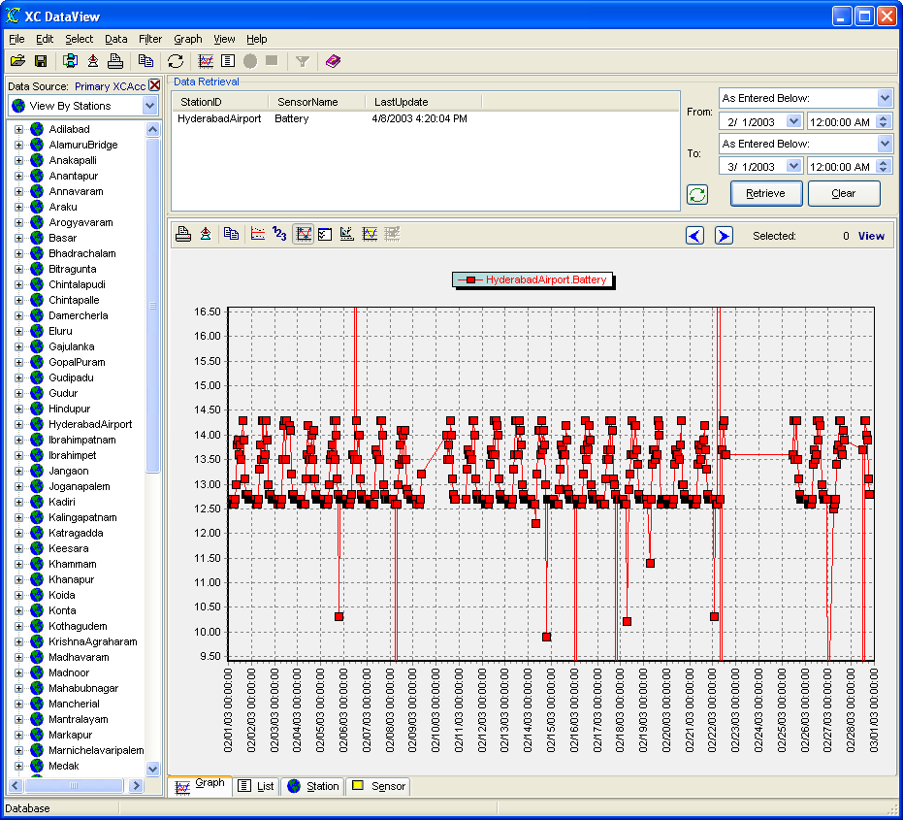
Figure 6. Data displayed in a graph view

To display data in a list:
- Highlight a sensor in the sensor tree and then from the Select menu, select Add to Retrieval List menu option. Double-clicking on the sensor also adds the Data Retrieval list.
Double-clicking or selecting the tree node will add all sensors in the subnodes to the Data Retrieval list.
- Select the desired start date and stop date. The user can select As Entered Below: and enter a specific date and time or select a date-time qualifier like Yesterday, Last Week, Last Month. The date-time qualifiers will be used to calculate the start and stop time based on the current date and time.
Time-date qualifiers allow the user to always see the same range of data each time without manually entering in the date and time. In many cases, using the viewing dates of Yesterday to Now allow the user to easily pull up the most recent data each day without additional keystrokes to modify the exact date and time each day. The exact start date of Yesterday will be automatically calculated based on the current date and time. The same applies for the end date of Now.
- From the Data menu, select List or from the toolbar, click the icon.
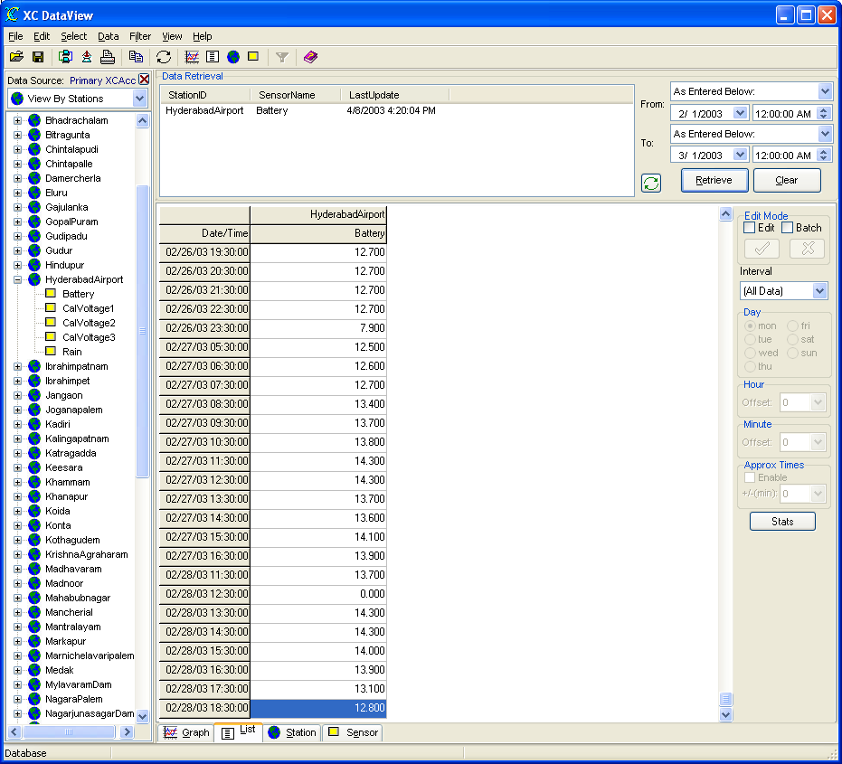
Figure 7. Data displayed in a list view

Displaying sensor database parameters
For convenience, XC DataView can display the sensor database parameters. To display parameters for a selected sensor:
- Highlight a sensor in the sensor tree view and then from the Select menu, select Sensor Properties or, from the toolbar click the icon.
- The sensor parameters stored in the database will be retrieved and displayed on the Sensor tab of the display area. Changes to the database parameters can be done using XC Desktop.

Displaying station database parameters
For convenience, XC DataView can display the station database parameters. To display parameters for a selected station:
- Highlight a station in the sensor tree and then from the Select menu, select Station Properties or, from the toolbar click the icon.
- The station parameters stored in the database will be retrieved and displayed on the Station tab of the display area. Changes to the database parameters can be done using XC Desktop.

Graph Options
Once the data is graphed, several options are available, including editing data values. The options are represented by the graph options toolbar located above the graph.

Figure 8. Graph toolbar
These options include:
- Printing Graphs ()
- Exporting Graphs ()
- Copying Graphs ()
- Single/Multi-Axis ()
- Data Pointer ()
- Data Markers ()
- Graph Display Options ()
- Extended Graph Display Options ()
- Zooming and Panning
- Select Data Points ()
- Modify Selected Data Points ()
- Data Increment ()

Printing Graphs
The Print button opens the Print Preview window that allows the user to make an additional margin and sizing adjustments before printing.
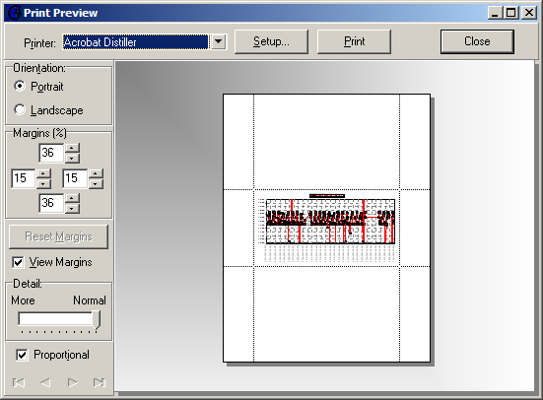
Figure 9. Print Preview window

Exporting Graphs
The Export button allows the user to export the data values and their corresponding time stamps and labels to disk. The user has export format options of: XML, comma-separated (CSV) or Excel (XLS) files.
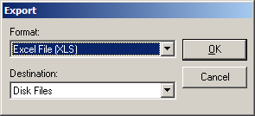
Figure 10. Export format selection window

Copying Graphs
The Copy button will copy to graph to the Windows clipboard so that it can be pasted, as a bitmap, in other Windows applications for reports and presentations.

Single/Multi-Axis
The Single/Multi-Axis button is used when more than one sensor is plotted on the graph. By default, the all the sensors are plotted using one Y-axis. By toggling the button, the sensors can be individually graph against their own Y-axis. The multiple graphs will appear stacked. This option is also available on the Graph Display Options dialog box.
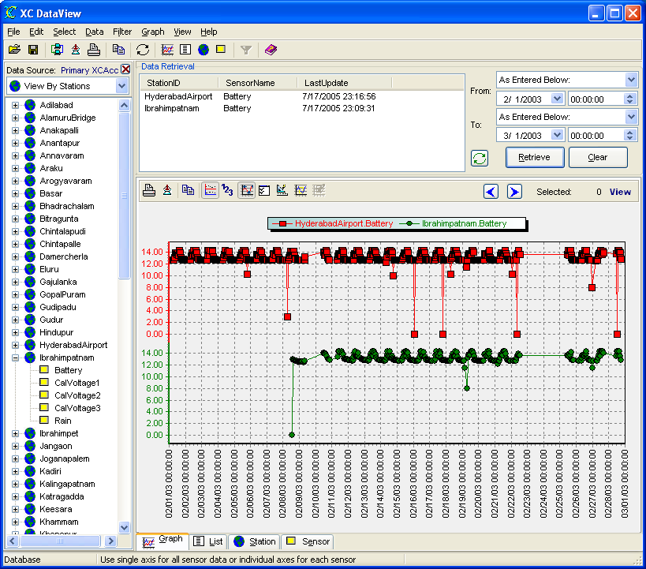
Figure 11. Multi axis graph display
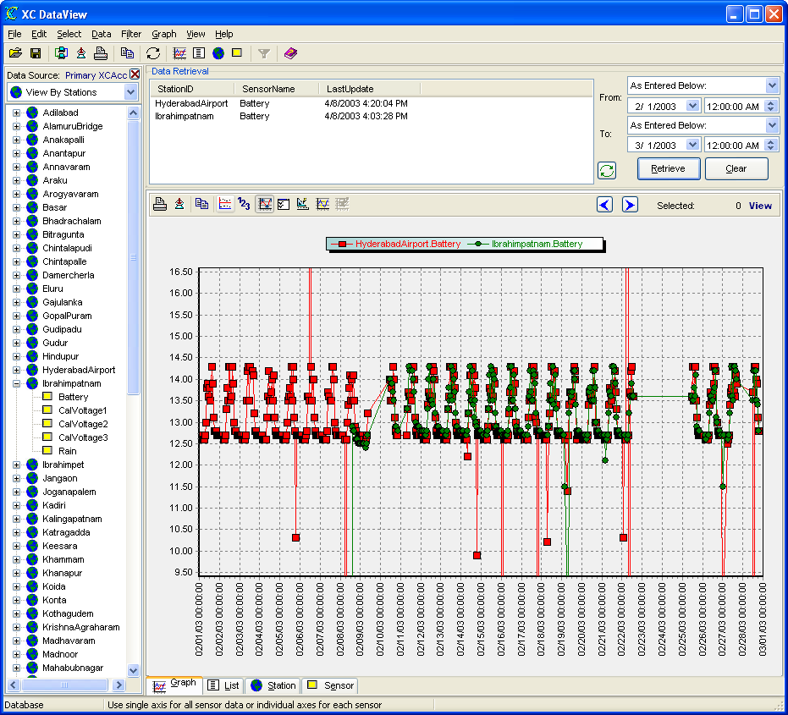
Figure 12. Single axis graph display

Data Pointer
The Data Pointer option allows the user to display the actual value and its corresponding date and time on the right most section of the status bar. A line will appear and snap to the actual data points. The user will be asked to select the sensor data series to investigate.
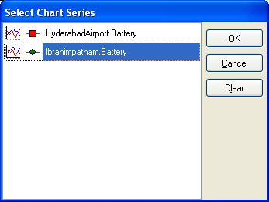
Figure 13. Select Chart Series window
Once the data series is selected a vertical bar will snap to the data points. The data value and time stamp will be displayed on the status bar.
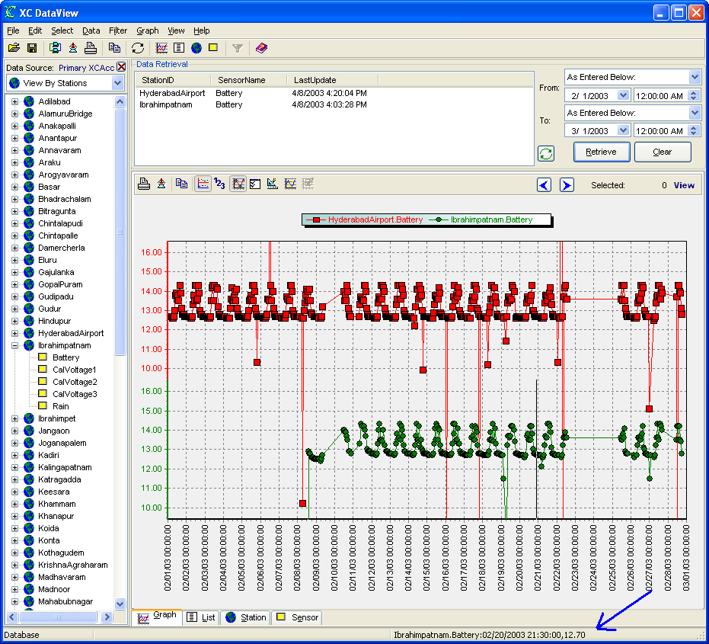
Figure 14. Using data pointer with graph

Data Markers
By default, the graph is a line graph that connects one point to the next. If data points were expected to be evenly spaced, and some data points were missing, this would be detected if the data markers marking each data point were not displayed on the screen. This option is also available on the Graph Display Options dialog box.
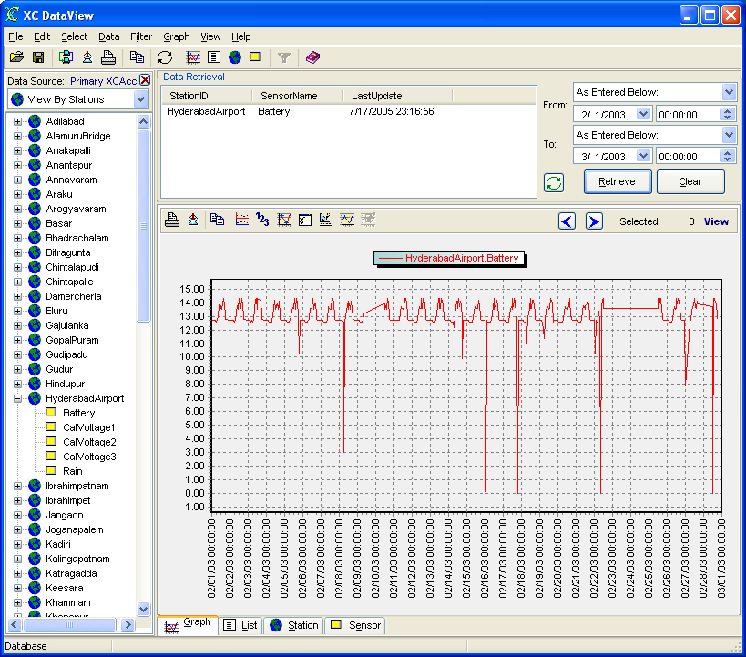
Figure 15. Graph without data markers

Figure 16. Graph with data markers

Graph Display Options Parameters
The most common graph display options are conveniently grouped together on a window accessed on the graph window.
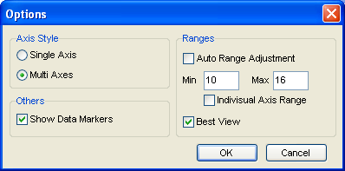
Figure 17. Graph display options window
- Axis Style - The Single Axis and Multi-Axis radio button is used when more than one sensor is plotted on the graph. By default, the all the sensors are plotted using one Y-axis. By toggling the button, the sensors can be individually graph against their own Y-axis. The multiple graphs will appear stacked.
Figure 18. Multi-axis graph display
- Ranges
  - Auto Range Adjustment - The program will automatically adjust the Y-axis min and max to the minimum and maximum values of the retrieved data. By not selecting this option, the Min and Max fields become enabled.
  - Min - This represents the Y-axis minimum if the Auto Range Adjustment parameter is NOT checked.
  - Max - This represents the Y-axis maximum if the Auto Range Adjustment parameter is NOT checked.
  - Individual Axis Range - The program will use the individual minimum and maximum axes values entered in the Extended Graph Options window.
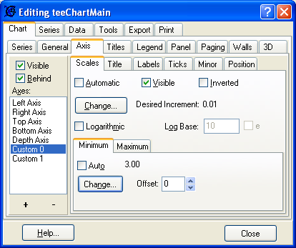
Figure 19. Individual Y-axis min settings
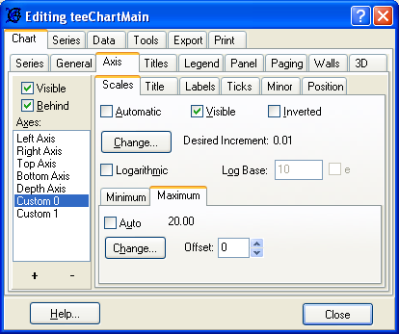
Figure 20. Individual Y-axis max settings
  - Best View - The program will automatically add 10 percent of the Y-range to the Y-axis min and max. If Auto Range Adjustment is also checked, this will add 10 percent to the minimum and maximum range value of the retrieved data to the Y-axis min and max. If Auto Range Adjustment is not checked, this will add 10 percent of the user-entered Min and Max range to the Y-axis min and max. Best View will not affect the graph if Auto Range Adjustment is not checked and Individual Axis Range is checked.
- Show Data Markers - By default, the graph is a line graph that connects one point to the next.
Figure 21. Graph without data markers
With Show Data Markers checked, each data point will be designated by a marker.
Figure 22. Graph with data markers

Extended Graph Display Options
The Extended Graph Display options window is a multi-tabbed window that allows the user to changes almost every aspect of the graph to his/her preference.
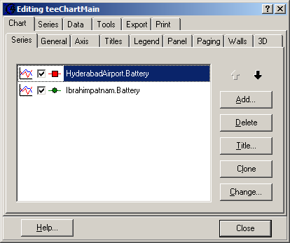
Figure 23. Extended graph options window
Among the tabbed windows, the user can change the order of the data series, the color of the data series, the line pointer shape, the graph style (line style to bar to 3D), the labels on the graph and much more. Rather than describing ALL the parameter options, our best advice is to take a bit of time and just play with each of the parameters to understand which options are the most useful.

Zooming and Panning
The user can easily zoom in on a section of the graph or pan to another section of the graph. Zooming and panning are accomplished using the right and left mouse buttons

To zoom:
- Place the cursor in the upper left-hand corner of where you would like to zoom.
- While holding the left mouse button down, drag the cursor to the right toward the lower right-hand corner of the desired zoom area.
- Notice a black rectangle being drawn as you are dragging.
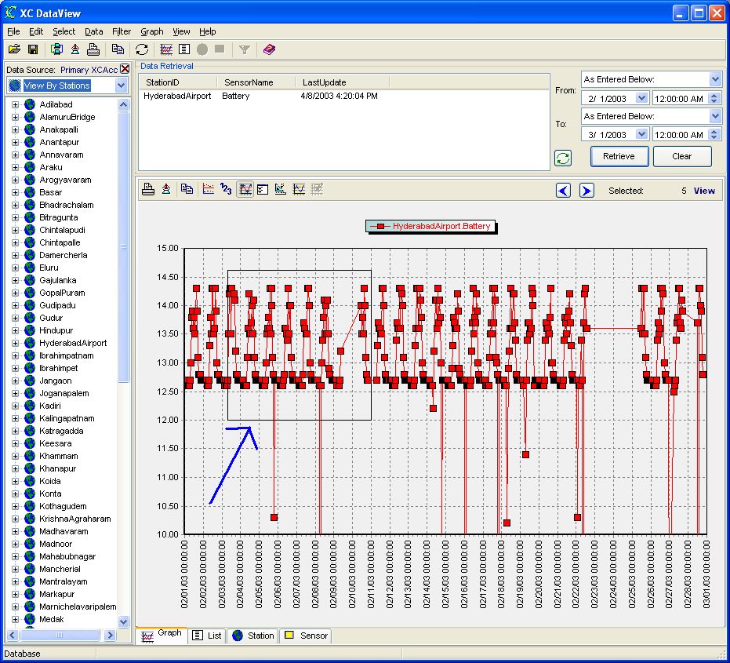
Figure 24. Dragging a box on the graph
- Release the mouse when you select the area of the graph to zoom in on.
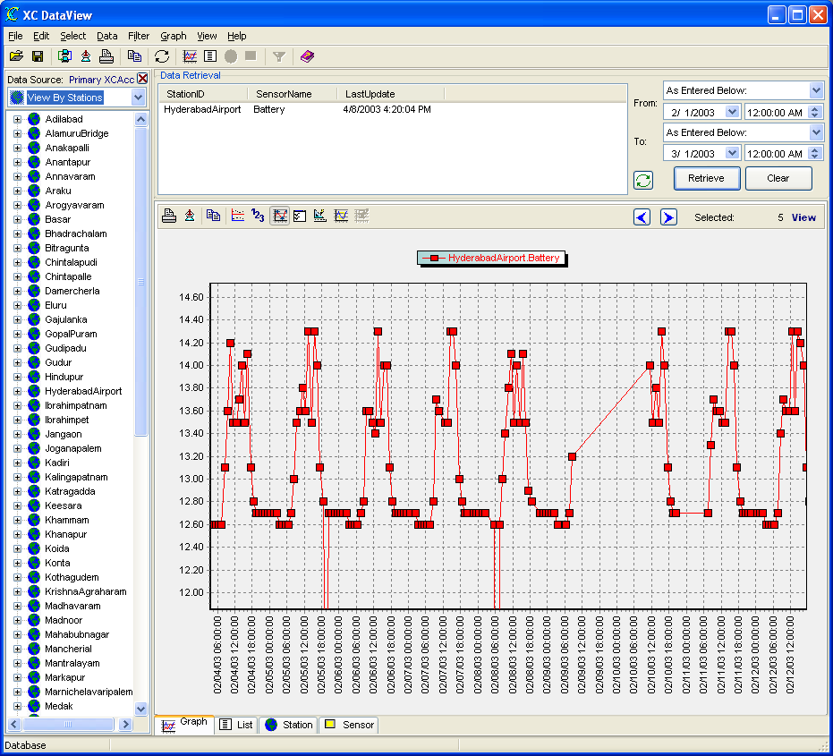
Figure 25. Zoomed area of graph

To un-zoom:
- Place the cursor anywhere on the graph.
- While holding the left mouse button down, drag the cursor, briefly, to the left toward the upper left-hand corner of the graph.
- Release the mouse and the graph will zoom out to the original state.

To pan:
- Place the cursor anywhere on the graph.
- While holding the right mouse button down, move the cursor in the direction where you would like to pan the graph.
- Release the mouse and the graph will pan to that area.
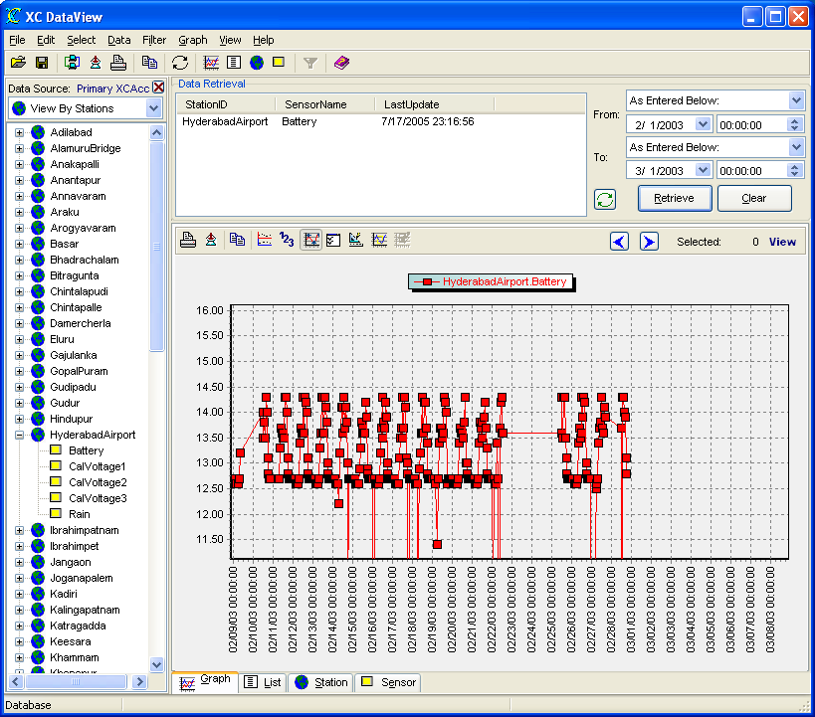
Figure 26. Graph panned to left

To un-pan:
- Place the cursor anywhere on the graph.
- While holding the left mouse button down, drag the cursor, briefly, to the left toward the upper left-hand corner of the graph.
- Release the mouse and the graph will zoom out to the original state.

Select Data Points
The user can select and edit data from the graph. Once data is graph, the user can switch from "view" mode to "edit" mode by clicking the Select Data Points toolbar button () on the graph toolbar button.
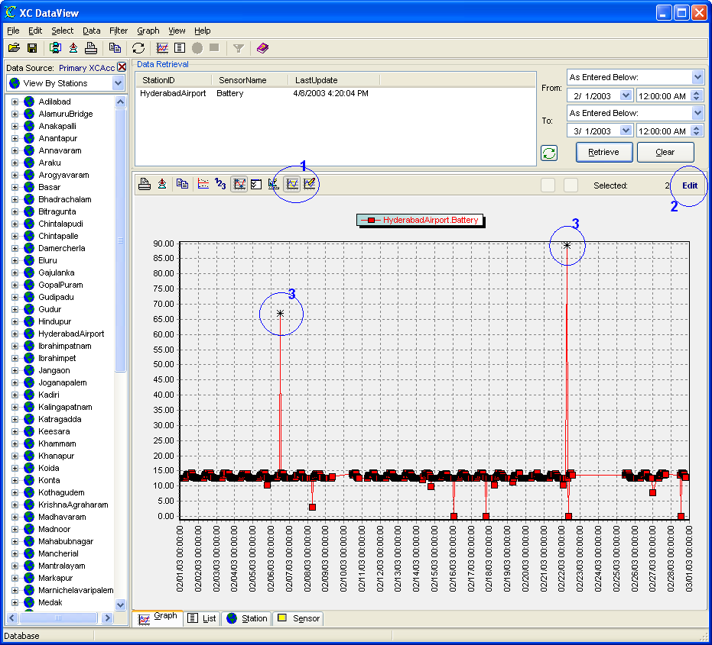
Figure 27. Graph edit mode
Note the highlighted/circled areas.
- Shows clicking toolbar button to begin edit mode.
- Noted Edit text above graph.
- Drag a region from upper left to lower right to highlight data point(s).

Modify Selected Data Points
After data points have been selected as described in the previous section, click the Modify Data Points toolbar button () on the graph toolbar button. The user will be prompted to enter the new value.
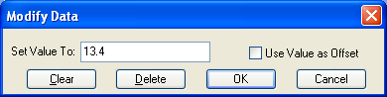
Figure 28. Modify data in graph view
The modify/edit options are:
- Use Value as Offset - When this option is checked the value will be added to all selected data points. Value can be positive or negative.
- Clear - This option clears the previously selected data for edit and re-paints the graph.
- Delete - This option deletes the selected data points from the database. In the case of the database, privileges granted to the user login account will affect whether the use can actually delete data from the database.
- Ok - Select OK will modify the existing data values to the value.

Data Increment
The Data Increment arrows allows the user increment/decrement to the next section to data without editing the from/To dates and click Retrieve. The Start and Stop time is incremented/decremented by an additional 25 percent of the original range. As an example:
- Let's say the user originally selected to view 24 hours worth of data and the start time was 2/1/2006 00:00:00 and the end time 2/2/2006 00:00:00.
- After clicking the right increment button, the start time would be 2/1/2006 06:00:00 and the end time would be 2/2/2006 06:00:00.
- The original total range of 24 hours is divided by 4 (25%) and then added/subtracted to the original start and stop time.

List display options
Once the data is displayed in the tabular list, several options are available. The options are available to the right of the data grid.
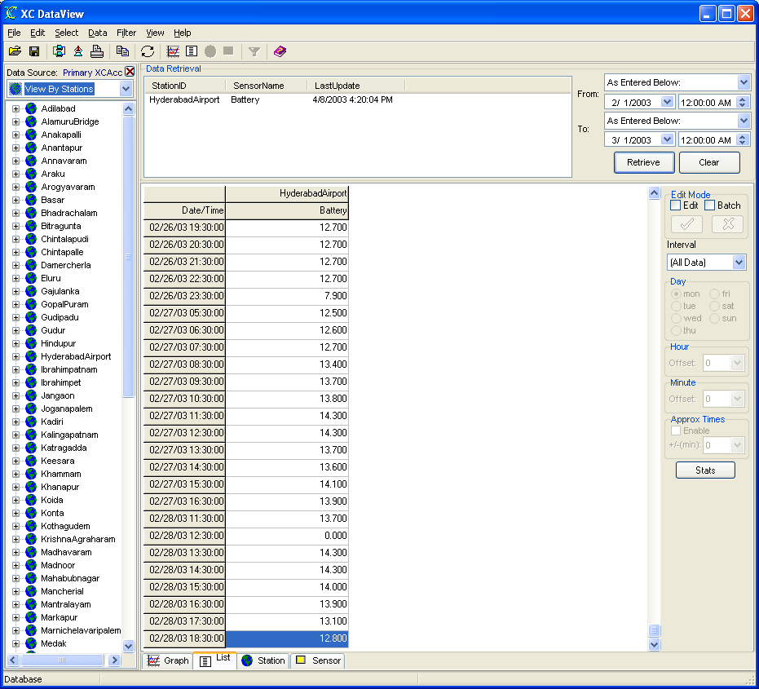
Figure 29. List view of sensor data
The list display options include:
- controlling the interval of the data to display (i.e. only data at top of hour, or data at beginning of each day)
- using approximate times with real-time data (XC Rtu) and a database.
- editing data values.
- on-the-fly sensor statistics.

Using an Interval
By default, when data is displayed, all the data is shown. However, the user may be interested only in the data at the beginning of each day. In this case, the use can select a Interval of 6 hours and Offset of 30 . Automatically, the data will be refreshed to only show data for 00:30:00. 06:30:00. 12:30: 00, 18:30:00, etc.
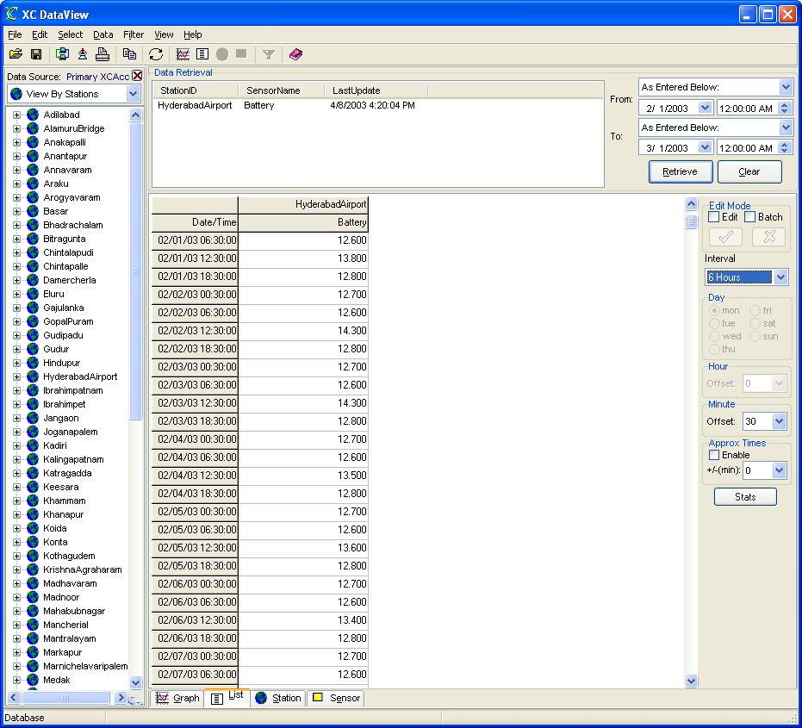
Figure 30. Only display data every 6 hours
Additionally, using the Day, Hour or Minute, selections allows the user to specifically view a time offset into the select interval.
Example 1
Interval - 1 Day
Hour - 0
Minute - 0
Using these parameters, the data for the beginning of each day at 00:00:00 will be displayed.

Example 2
Interval - 1 Day
Hour - 6
Minute - 0
Using these parameters, the data for the each day at 06:00:00 will be displayed.

Example 3
Interval - 1 Day
Hour - 0
Minute - 15
Using these parameters, the data for the each day at 00:05:00 will be displayed.

Example 4
Interval - 1 Month
Day - Mon
Hour - 0
Minute - 0
Using these parameters, the data for every Monday at 00:00:00 of the month will be displayed.

Using Approximate Times
The Approx Times parameter on the list view applies only to the database data storage option. In PcBase2 and the PcBase2 binary files, data was always forced in the evenly-spaced time slots. The user was required to specify the interval of the data (i.e., 00:15:00 or 01:00:00) when the data file was created. Thus, all data was easily stored and displayed on even time increments.
However, in a database, there is no such "even time slot" concept. Databases only store data that has come in and not data the is "expected" to come in. More importantly, the exact time and date the data was received is what is stored in the database. This creates problems for displaying data in a list with columns. Because the date and times will never be exactly the same from station to station, displaying data in columns will created a staggered appearance.
The Approx Times parameter acts as a round-off in the time when displaying the data so the can be displayed in even increments. This parameter applies to conventional systems where data is collected in real-time via radio, phone, direct... using XC Rtu. When viewing data in a system like this, the list view of data may appear as seen below.
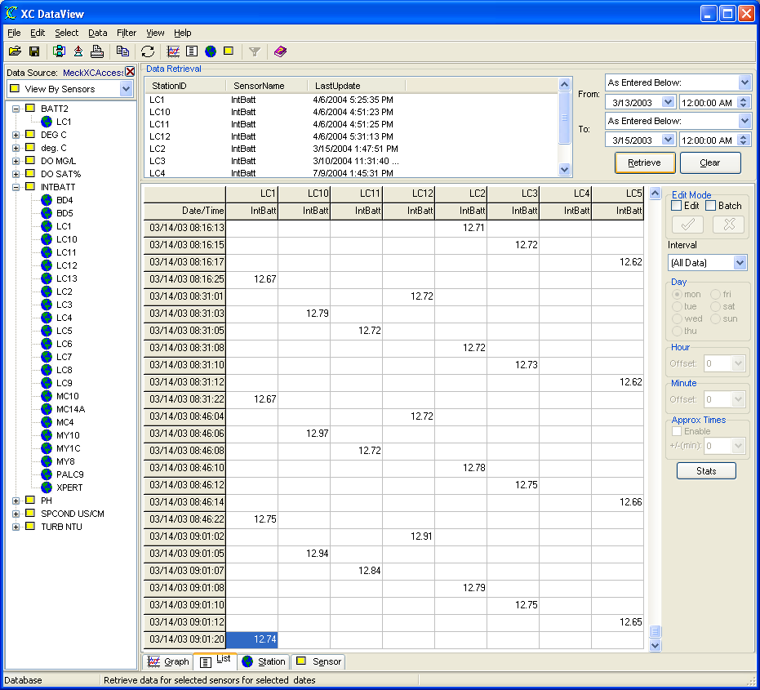
Figure 31. All Data displayed
In this example, the times of the batteries across all the stations differ by seconds, the actual time when each station was polled. In order to align the data and columns, the user can enable the Approx Times parameter and specify a "buffer" range along with an Interval (as described in the above section).
As seen from the data displayed above, the stations were polled every 15 minutes. The screen below shows the result of using the Approx Times parameters.
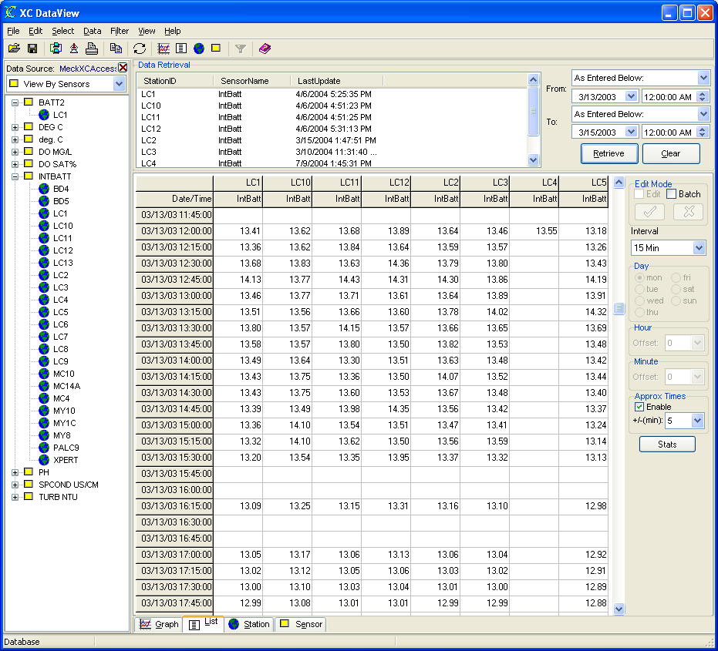
Figure 32. Aligned using Approx Times parameter
The data interval of 15 minutes was selected. The Approx Times parameter was enabled. The +/- (min) parameter indicated that if a time fell +/- 5 minutes around a 15 minute interval, it would be considered a 15 minute value. In this particular system, it took about 5 minutes to poll/query all the stations for data, so the +/- was adjusted to 5 minutes to accommodate for time range. As a result, the data can now be viewed in consistent columns for easier comparison and analysis.

Editing data values
XC DataView allows the user to edit individual sensor values or multiple values. When using the database data storage option, the edits will only affects the ED_VALUE column in the XC_DATA1 data table. The ORIG_VALUE column will always have the original received or decoded value.

Individual sensor edits
Click on the Edit check box in located in the Edit Mode group box on the right hand side of the list view. After checking the Edit box, enter/modify the sensor value. Click on the Save button () in the Edit Mode group box to save changes or the Cancel button () to cancel changes. When edits are finished, make sure to un-check the Edit check box.
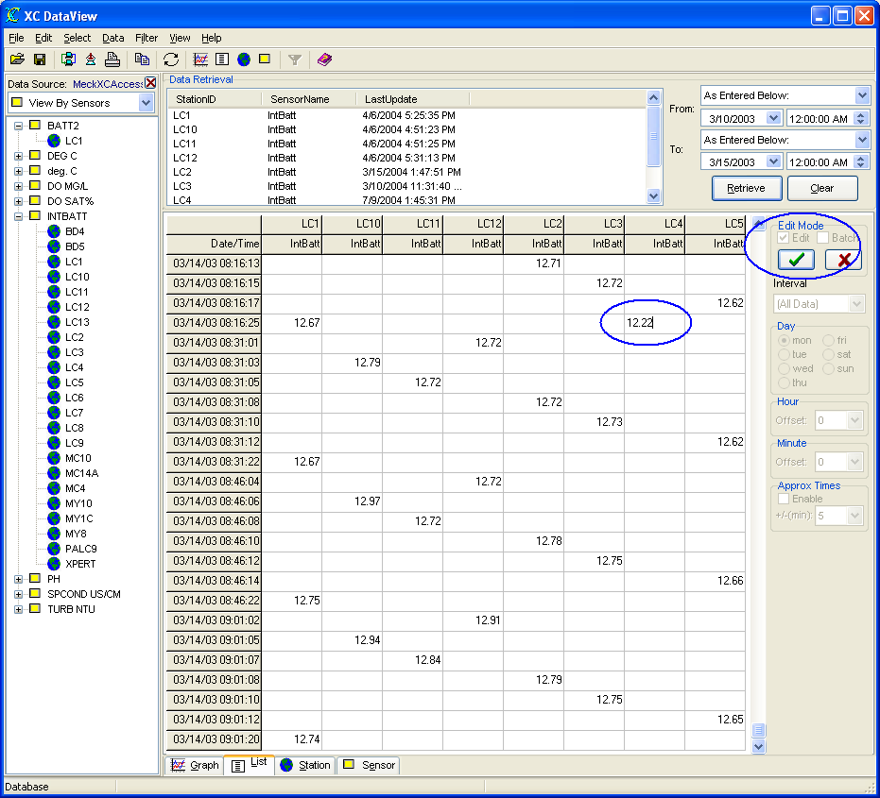
Figure 33. Editing individual data values in list view

Batch sensor edits
Click on the Batch check box in located in the Edit Mode group box on the right hand side of the list view. After checking the Batch box, drag an box on the area of the cells you wish to edit. The cells wil become highlighted.
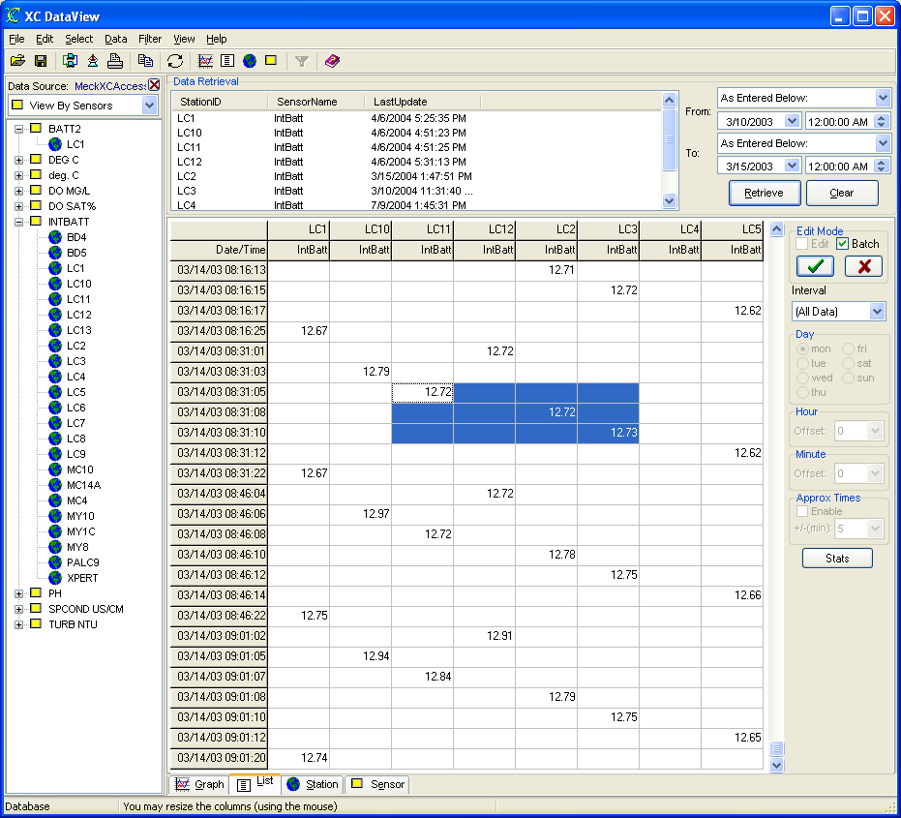
Figure 34. Editing multiple (batch) data values in list view
Click on the Save button () in the Edit Mode group box. The Modify dialog will appear. The user will be prompted to enter the new value.
Figure 35. Modify data in list view
The modify/edit options are:
- Clear - This option clears the previously selected data for edit and re-paints the graph.
- Delete - This option deletes the selected data points from the database. In the case of the database, privileges granted to the user login account will affect whether the use can actually delete data from the database.
- Ok - Select OK will modify the existing data values to the value.
When edits are finished, make sure to un-check the Batch check box.

Sensor Statistics
The statistics mode of XC DataView provides the user with convenient on-fly statistics of the displayed sensor data. Click the Stats button to switch to statistics mode.
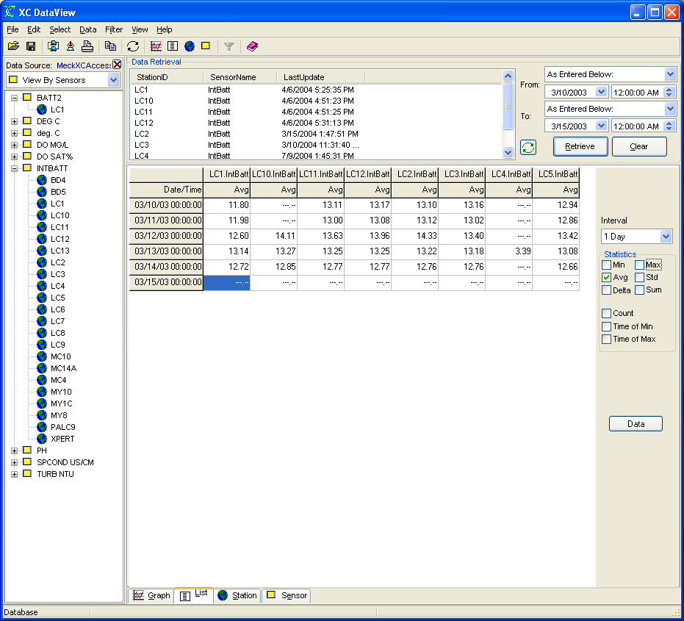
Figure 36. Sensor statistics list view
The Statistics box provides several statistics that can be calculated on the sensors displayed in the list. The user just needs to check the box corresponding to the desired statistic and automatically the sensor data list will update with the newly calculated values.
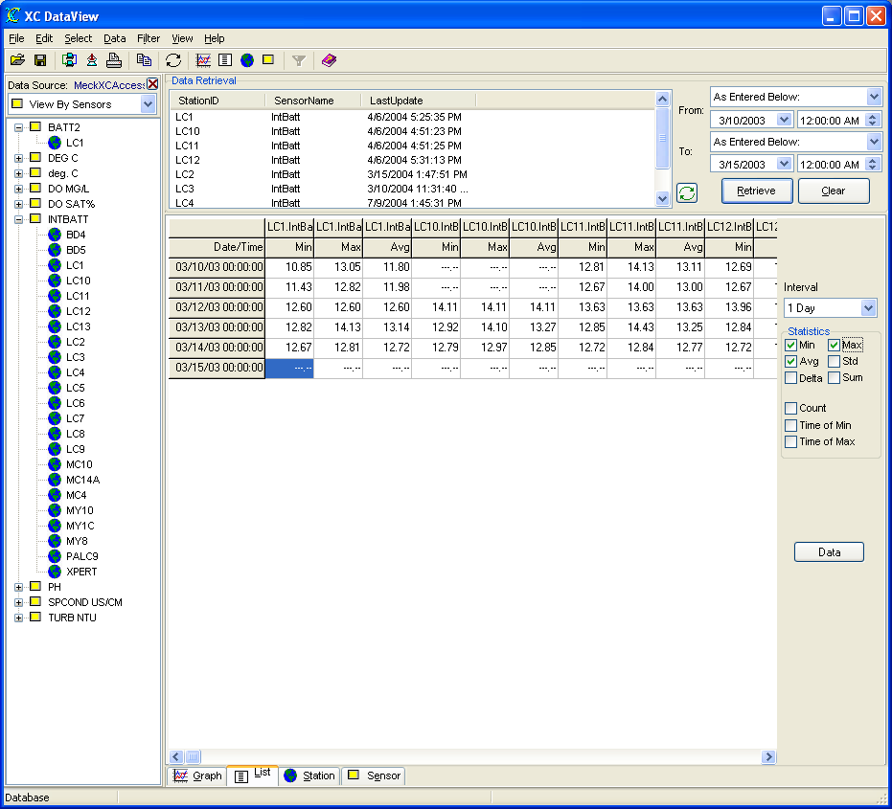
Figure 37. Avg, Min and Max statistics selected

Sensor Statistics functions
- Min - Computes the minimum sensor value in the selected Interval.
- Max - Computes the maximum sensor value in the selected Interval.
- Std - Computes the standard deviation of the sensor values in the selected Interval.
- Delta - Computes the delta (difference) between the max and min sensor values in the selected Interval.
- Sum - Computes the sum of all sensor values in the selected Interval.
- Count - Computes the total number of sensor values record in the sensor Interval.
- Time of Min - Computes the time of the minimum sensor value was recorded in the sensor Interval.
- Time of Max - Computes the time of the maximum sensor value was recorded in the sensor Interval.

Printing Sensor Statistics
Sensor statistics are computed in memory and not stored in data storage. However, XC DataView can print the data in a convenient Crystal Report. From the File menu, select Print option. XC DataView will display the report in print preview mode first before printing.
`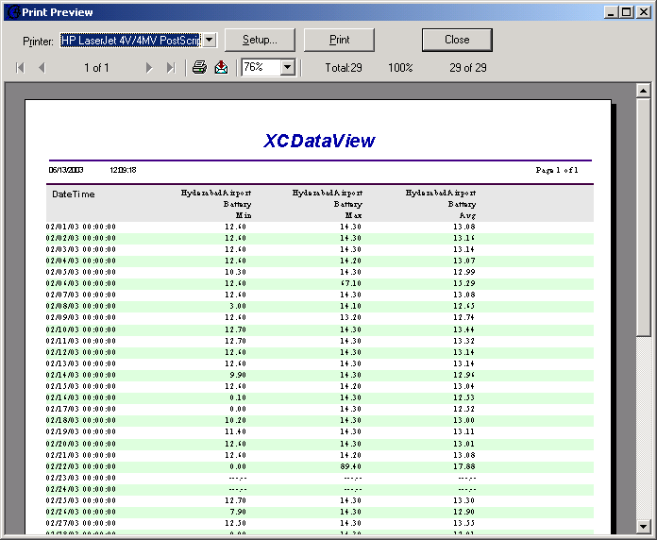
Figure 38. Printing sensor statistics

Exporting Sensor Statistics
The Export button allows the user to export the data values and their corresponding time stamps to disk. The user has export format options of: XML, comma-separated (CSV) or Excel (XLS) files.
Figure 39. Export format selection window

Sorting the Sensor Tree view
XC DataView allows the user to sort the Sensor Tree view in many ways to conveniently allow the user to view the sensor list in the most beneficial manner. Above the Sensor Tree view is pull-down list box that lists the options by which the sensor tree can be sorted.
For the Database storage option, the sort selections are:
- View By Stations
- View By Sensors
- View By Basin
- View By District
- View By City
- View By County
- View By State
- View By Country
- View By Primary Channel
- View By Random Channel

For the PcBase2 binary file storage option, the sort selections are:
- View By Data Files
- View By Stations
- View By Sensors

An example of the Sensor tree view with View by Station selection:
Figure 40. Sensor Tree view sorted by stations

An example of the Sensor tree view with View by Sensor selection:
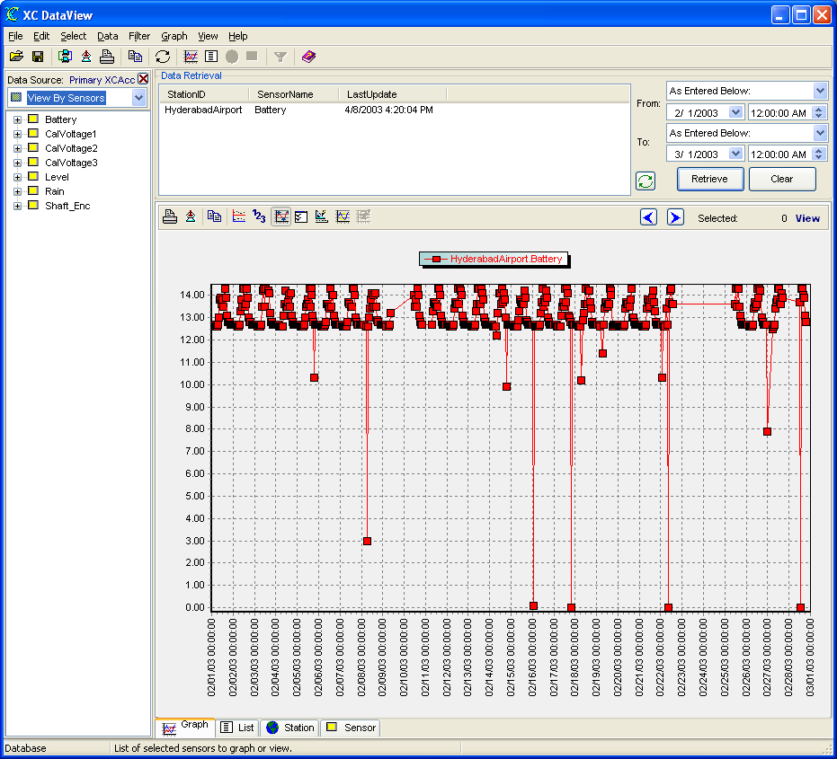
Figure 41. Sensor Tree view sorted by sensor

Filter Files
Filter files are very convenient in large system and used only with the database data storage option. Filter files affect the list of sites/sensors displayed in the sensor tree view. In large system, browsing through such a long list of sites/senors is tedious. Select a Filter File to reduce the list of sites/sensors displayed to a specific list targeting the viewing purpose. Filter files are ASCII files with a .FLT extension containing statements used to filter/reduce the site/sensor list. These statements are used directly in the SQL statement when the data is retrieved.
Filter files are created in XC DataView and can be used in XC DataView, XC Reports and XC Export. After selecting a filter file, the user can choose to apply the filter conditions to the sensor tree view or now.

Creating a simple filter file
Let's create a filter file to only show the stations that have level as a sensor.
- From the Filter menu, select Select Filter. The Filters window will open.
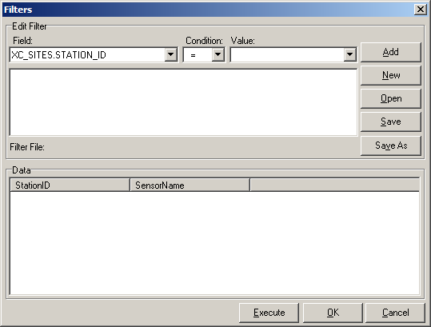
Figure 42. Filters window
- Click on the Field parameter and select from the list of possible database fields.
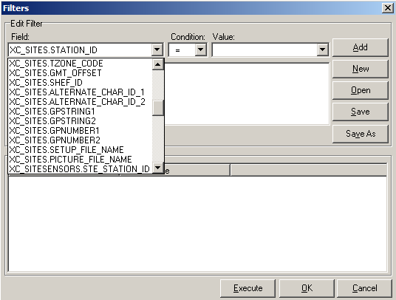
Figure 43. Filter field parameter selection
- Select the XCSITESENSORS.SENSORNAME for the Field parameter and Level for the Value parameter.
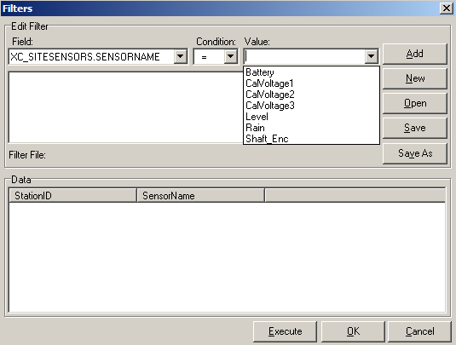
Figure 44. Filter value parameter selection
- The selections should look as shown below.
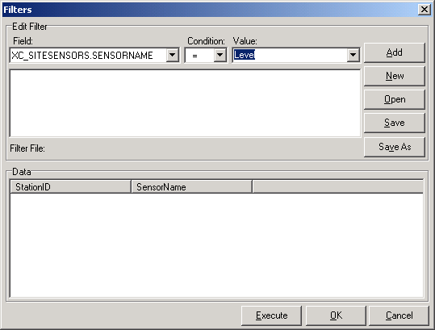
Figure 45. Filter selections
- Click the Add button to remember the condition and add it to the memo list below.
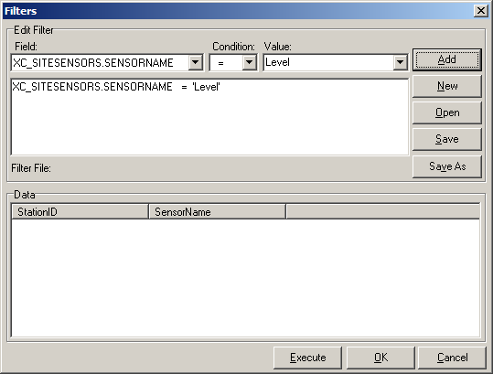
Figure 46. Adding filter condition
- Click the Execute button to run the query and see the results in the Data box.
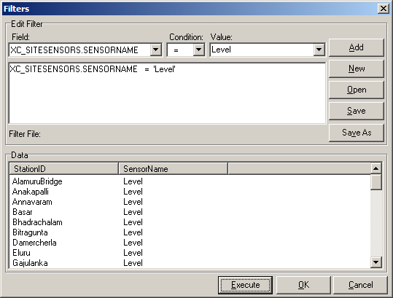
Figure 47. Executing filter conditions
- Once satisfied with the results, click the Save button to save the filter conditions to disk.
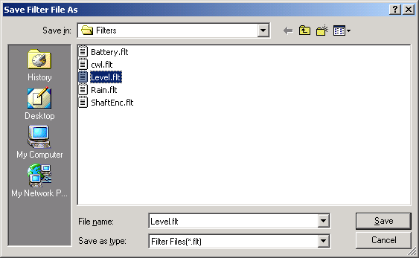
Figure 48. Saving filter conditions to file
Steps 2-5 can be repeated for as many filter conditions as desired.

Applying Filter files
In order to apply conditions from a filter file, first the user must create or select a filter file, then it can be applied.
- From the Filter menu, select Select Filter. The Filters window will open.
Figure 49. Filters window
- The user can create a filter file here or click the Open button to select a filter file (.FLT) located on the hard disk.
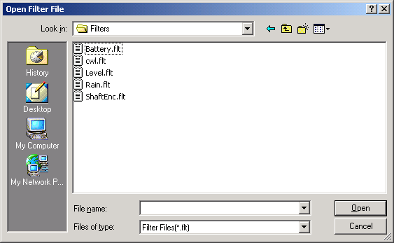
Figure 50. Select filter file window
- Optionally, the user can click the Execute button to test the filter conditions and see the reduced station/sensor list.
- After a filter file has been selected, click OK to exit the window.
- To apply the filter, from the Filter menu, select Apply Filter or from the toolbar click the icon.
- The sensor tree view will be refreshed with the filter conditions applied. Additionally, the filter conditions will be displayed below the sensor tree view.
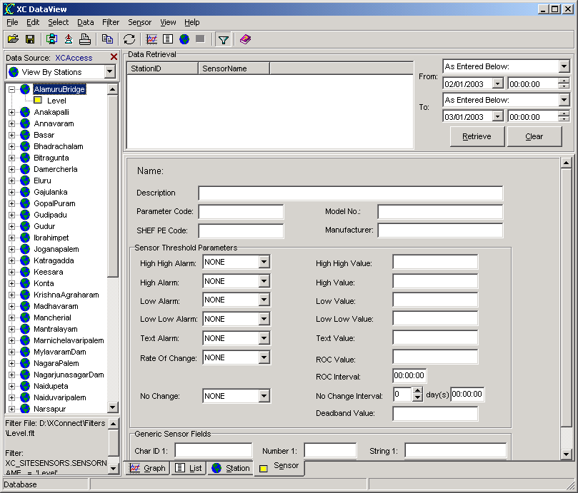
Figure 51. Sensor tree view with filter applied

Selecting sensors
XC DataView provides many ways to select sensors to graph or display.
- Selecting sensors using the menus
Highlight the tree node or sensor. From the Select menu, click Add to Retrieval List or Add All to Retrieval List options.
- Right-click on Sensor Tree view
Right click to highlight the tree node or sensor. From the pop-menu, click Add to Retrieval List or Add All to Retrieval List options.
- Double-click on tree node or sensor
Double-click on the tree node or sensor. The sensor(s) will automatically be added to the Data Retrieval list box.
- Drag and drop tree node or sensor
Left click on a tree node or sensor. While holding the left-click button, drag the tree node or sensor to the Data Retrieval List box. The sensor(s) will automatically be added to the Data Retrieval list box.
All methods are familiar to operators using today's Windows applications.

Sensor settings file
Sensor settings files (.SFG) allow the user to save away frequently view sensor lists and the corresponding From and To dates. This is extremely useful if you always view the same sensors over the same time period, such as all the stage data for yesterday. So, instead of re-selecting sensors each time, just save the settings to a sensor settings file (.SFG) and then recall it at any future time.

To create a sensor settings file:
- Select the desired sensors to the Data Retrieval list.
- Select the desired From and To dates.
The use of time-date qualifiers is especially useful here. For example, to always view todays data, select Today as the From date and Now as the To date. Or, to always view yesterday's data, select Yesterday to Today as the From and To dates, respectively. The exact dates are calculated by XC DataView.
- From the File menu, select Save Sensor settings. The user will be prompted to enter a filename and directory location. Sensor settings files have a .SFG file extension.

To recall a sensor settings file:
- From the File menu, select Open Sensor settings file. The user will be prompted to select a sensor settings (.SFG) file. Once opened, the sensors will first be validated and then displayed on the Data Retrieval list.
The sensor will not appear in the Data Retrieval list unless it has been validated. If a sensor settings file contains sensors not in the current selected data source, it is considered invalid.
- The use simply clicks the Retrieve button to display the data.

Using sensor settings files on startup:
A user can automatically load a sensor settings file (.SFG) on startup of XC DataView. Use the file name as a command-line parameter when in the XC DataView shortcut.
- Create a shortcut to XCDataView on our desktop.
- Right click on the shortcut icon and select Properties. The properties dialog box will open.
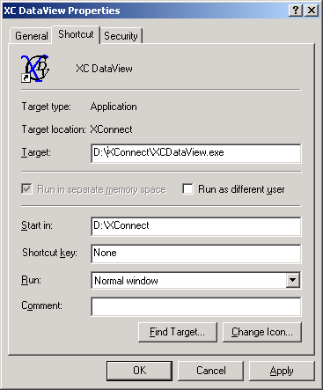
Figure 52. XC DataView shortcut properties
- On the Target parameter add the name of the sensor settings file (.SFG) you would like to load on startup.
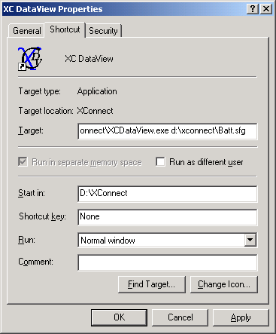
Figure 53. XC DataView shortcut with Sensor Settings file
- Click OK button when finished.

Viewing Sensor Data or Post-Processed data
XC DataView, by default, will retrieve data from the sensor data table (XC_DATA1). However, as part of the XConnect database schema, data is also stored in the post processing data table (XC_PPDATA1). XC_PPDATA1 will have data only if you are using XC PostProc. XC PostProc is used to perform some post-processing calculations on the sensor data. Typically, daily or monthly averages, minimums or maximums are examples of post processed data. To graph or list this data, XC DataView needs to switch focus from the sensor data table, XC_DATA1, to the post-processed data table, XC_PPDATA1.
To retrieve data from XC_PPDATA1,
- From the Select menu, select Post Processed Data (XC_PPDATA1) option. XC DataView will refresh the Sensor tree view with the available processed sensors.
- Continue with normal sensor selection and viewing.

To return to view sensor data from XC_DATA1,
- From the Select menu, select Sensor Data (XC_DATA1) option. XC DataView will refresh the Sensor tree view with the available sensors data.
- Continue with normal sensor selection and viewing.

Importing data
XC DataView can easily import data from PcBase2 binary data files, comma-separated (CSV) or XML files to the XConnect database. The XConnect database data storage option provides the most flexibility when viewing and sharing your data. To import data:
- Click on the XC DataView icon.
- From File menu, select Import.... to open the import window.
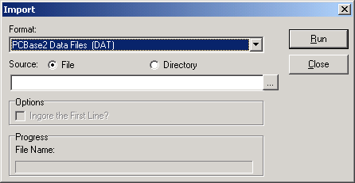
Figure 54. Import window
- Select the import format type from the pull-down combo box.
- Select the individual data file or a directory where the files are located.
- Click Run button to start importing data.
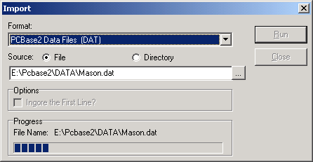
Figure 55. Import progress

Import parameters
- Format - Select the import format type. XC DataView can import PCBase2 Data Files (DAT), XML Files (XML), and Comma-separated Values (CSV).
- Source - Select a single file to import or select an directory. Selecting a directory conveniently allows the user to import all the data files at once.
- Options
  - Ignore the First Line? - If CSV files are selected, the first line in the file may be a header. If so, check this option to skip the first line and start importing data from the second line.
Data can be left in the binary data files and viewed using XC DataView. The binary data does not necessary need to be imported. Create another data source pointing to the binary data file directory. XC DataView can easily switch between the different data sources.

Exporting data
XC DataView can easily export the data in the graph or list view. The user can export to XML files, comma-separated values (CSV) files, or Excel files. To export data:
- Click on the XC DataView icon
- Select sensors and a time range. Click Retrieve to display data.
- From the File menu, select Export.... If on the Graph tab, the user can select the icon above the graph.
- Select the Export format and destination and click OK.

Troubleshooting

Troubleshooting tips

Database configuration
In general, most errors in XC DataView are related to the Data Source (ODBC) configuration. Ensure that no changes have occurred since the original configuration of the Data Source (ODBC) in the Windows Control Panel applet.
- For Access database types, verify the Access file (.MDB) has not been moved from its original directory location or is not currently open while XC DataView is trying to retrieve data.
- For Oracle/SQL Server database types, verify the network PC where the database is installed is functioning properly and can be seen by the Windows Network Neighborhood. Verify the user name and password have not changed.
- Verify the database configured in the Data Sources (ODBC) control applet, is an XConnect database. Consult your network administrator to verify the data table structure.

PcBase2 binary files
- Ensure the directory location of the Pcbase2 binary files has not changed.
- If XC DataView cannot read the Pcbase2 binary file header, it will not display it in the list. For a corrupted header, please contact a Sutron for assistance.

No data displayed in graph or list view
- Verify there is data for the selected display times. When using PcBase2 binary files, the Start Time and End Time for each sensor is displayed in the Data Retrieval list when it is selected. When using database storage option, the Last Update time for the station will be displayed in the Data Retrieval list when the sensor is selected.
- XC DataView can display only display a maximum of 86400 data values. Hopefully, none of our users will encounter this error message. If so, please reduce the senors or time range selected to display
- In a conventional system (i.e., radio, telephone, 2-way communications) and storing data to a database, the Approx times flag may need to be checked if you have selected to view an Interval and not All Data. Remember, real-time data stored in a database has the exact date and time (to the seconds) when the data was received by XC Rtu. As an example, when trying to display Rain values for 5 stations polled at 11:30:00, the time stamps for the stations may be 11:30:12, 11:30:30, 11:30:52. 11:31:01, 11:31:28, respectively. Therefore in the list view, if you specified the Interval as 30 minutes, it would be expecting data time-stamped 11:30:00, and no data would be displayed. In this case, check the enable Approx Times flag and add a +/- value of 2 minutes. XC DataView will then display data that falls from 11:28:00 - 11:32:00 as 11:30 data.

Wrong data displayed
- If the values of the sensors seem to be the wrong magnitudes, verify if any equations or rating tables were used and if they were correct. The equations and rating tables are specified in XC Desktop under the Stations node.
- If the values of the sensors are correct but seem to have incorrect times. Check the computer where XC Decode or XC Rtu is running. If running a satellite system using XC Decode, verify the sensor decoding parameters: Interval, Offset and Round Off in XCDesktop. If running a conventional system using XC Rtu, verify the time of the PC is correct. If XC Rtu is polling for Current data, the sensor time stamp is derived from the PC.

No stations/sensors displayed in Sensor Tree view
- Make sure the data source you are connected to is a valid XConnect database or PcBase2 binary files.
- If data source is valid, delete the XC DataView configurations settings file (XCDataview.XFG) and re-create the data source.
- If using a filter file, make sure the filter conditions apply to the current data source station/sensor list. To verify, from the Filter menu, select the Select Filter option to open the Filters window. Select the filter file and click the Execute button. The stations satisfying the filter conditions will be displayed in the Data list box. The Execute button allows the user to see the filter list before using and applying it.

Error messages
Potential error messages generated by XC DataView are:

Error 606: Unable to read data from file filename.

Troubleshooting steps:
Potential reasons for error:
- PcBase2 binary file may be corrupt.

Error 1200: Unable to connect to database.

Troubleshooting steps:
Potential reasons for error:
- The database configuration has changed on the current machine/network PC or has XConnect been installed on a new PC where the Data Source is not configured.
Verify the Data Source (ODBC) settings for XConnect database.
Check settings in Data Sources control applet either in the Control Panel or in Administrative Tools.
Verify user name and password are correct for database login.

Error 1401: Error loading station sensors.

Troubleshooting steps:
Potential reasons for error:
- XC DataView was unable to update the Sensor Tree view with station/sensor list.
Memory problems will attribute to the failure of refreshing the display. If XC DataView had previous errors, memory may be corrupted. Close XC DataView and re-open the application.

Error 1402: Invalid sensor settings file.

Troubleshooting steps:
Potential reasons for error:
- Sensor settings files are ASCII files where data is organized like Windows ini (.INI) files. The sensor names are listed under a specific topic name. The topic name was not present.
Recall another sensor settings file (.SFG) or re-create the SFG file.

Error 1403: Crystal Reports file filename does not exist.

Troubleshooting steps:
Potential reasons for error:
- XC DataView has 5 Crystal Reports files (.RPT) that are used to display/export data. The required file is not present in the XConnect installation directory.
Make sure the required file is in the XConnect directory.
Re-install the reports from the XConnect installation CD.

Error 1404: Too many columns. Columns must be less than 13.

Troubleshooting steps:
Potential reasons for error:
- The maximum number of columns of list view data that can be printed is 13. There is not enough room on the paper to accommodate more columns.
Reduce the selected sensors in the Data Retrieval List to 13. The sensors list will have to be broken up and printed separately.

Error 1405: Database not selected.

Troubleshooting steps:
Potential reasons for error:
- User did not select a database on the Database Login window.

Error 1406: XC DataView can only display a maximum number of 86400 records.

Troubleshooting steps:
Potential reasons for error:
- XC DataView cannot display more then 86400 data values at once.
Please reduce the time range (start and stop time) or reduce the number of sensors selected.

Error 1407: Unable to delete filename. Check file attributes.

Troubleshooting steps:
Potential reasons for error:
- While trying to save the sensor selections to and existing sensor settings file (.SFG), XC DataView was unable to delete the original file first.

Error 1408: Unable to export graph data to XML file.

Troubleshooting steps:
Potential reasons for error:
- XC DataView encountered an unexpected error while trying to create the XML file and then writing the data.
Ensure the destination directory has the proper read and write privileges.

Error 1409: Unable to export graph data to CSV file.

Troubleshooting steps:
Potential reasons for error:
- XC DataView encountered an unexpected error while trying to create the CSV file and then writing the data.
Ensure the destination directory has the proper read and write privileges.

Error 1410: The starting time must be earlier than the ending time.

Troubleshooting steps:
Potential reasons for error:
- The starting time to select your data is later than the ending time.
Ensure the starting time is earlier than the ending time.

Error 1411: Database error - %p.

Troubleshooting steps:
Potential reasons for error:
- XCDataView has an error when accessing data in database. The message follows is the detailed error code returned from database engine.
Ensure the database is online.
Ensure the username and password is correct.
Try to restart the XCDataView and repeat the last operation.

Error 1412: The min must be less than the max.

Troubleshooting steps:
Potential reasons for error:
- In Graph Options, the value of the min range is equal to or greater than the max range.
Ensure the value of the min range is less than the max.

Index

3
3D 21
4
4-tabbed 9
A
Access 85
Add
Data Retrieval list 14
Retrieval List 76
Retrieval List menu 14
Add 14
Add 76
Add All
Retrieval List 4, 76
Add All 4
Add All 76
Add button 69
adjust
Y-axis min 21
adjust 21
Administrative Tools 87
Administrative Tools|Data Sources 11
applies/removes 4
Apply Filter 4, 69
Applying
Filter 69
Applying 69
Approx Times
enable 47
Approx Times 47
Approx Times 85
Auto Range Adjustment 21
Axis Style 21
A-Z 8
B
Batch 47
Best View 21
bitmap 6, 21
C
Change Data Source 4, 11
Checking
Batch 47
Edit 47
Checking 47
Clear button 14
Clicking
Retrieve button 14, 77
Clicking 14
Clicking 77
Configuring
data source 11
Configuring 11
Connect button 11
Copy button 21
Copying
Graphs 21
Copying 21
corresponding
From 77
corresponding 77
Count - Computes 47
Crystal Report 47
CSV 4, 21, 47, 83
D
data
same range 14
data 14
Data Markers 21
Data Pointer 21
Data Points 21
Data Points toolbar button 21
Data Retrieval list
adds 14
subnodes 14
Data Retrieval list 4, 6, 8
Data Retrieval list 14
Data Retrieval list 76
Data Retrieval list 77
Data Retrieval list 85
data source
Configuring 11
data source 7
data source 11
data source 81
data source 87
Data Source Explorer window 11
Data Under Cursor 4
Database Login window 87
Day 47
Delete All From Retrieval List 4
Delete From Retrieval List 4
Delta - Computes 47
Display Area
XC DataView 9
Display Area 9
Displaying
sensor database parameters 19
station database parameters 20
Displaying 19
Displaying 20
E
Edit Mode 47
enable
Approx Times 47
enable 47
Excel 21, 47, 83
Execute button 69, 85
Expand Tree 4
Export button 21, 47
Exporting
Graphs 21
Sensor Statistics 47
Exporting 21
Exporting 47
Exporting 83
Extended Graph Display Options 21
F
Field 69
Filter
Applying 69
Filter 69
Filter Files
Select 69
Filter Files 69
Filter Files 85
Filter menu 69
filter/reduce
site/sensor list 69
filter/reduce 69
Filters window 69
First Line
Ignore 81
First Line 81
FLT 69
G
Graph Display Options 21
Graph Options 4
Graph Styles 4
Graphs
Copying 21
Exporting 21
Printing 21
Graphs 14
Graphs 21
H
Highlight
tree node 76
Highlight 76
Hour 47
I
Ignore 81
Individual Axis Range 21
Interval
select 47
Interval 47
Interval 85
L
Last Month 8, 14
Last Update 85
Last Week 8, 14
M
Max 21, 47
Menu Bar 3, 4
Min 21, 47
Minute 47
Modify Data Points toolbar button 21
Modify/edit 47
Month 47
Moving
around 3
Moving 3
Multi-Axis 4, 21
N
New button 11
Now
Yesterday 14
Now 14
Now 77
O
Offset 85
Open button 69
Open Sensor 77
Open Sensor Settings 4
Oracle/SQL Server 85
P
Panning 21
PcBase2 65
Pcbase2 Binary Files 11
Post Processed Data 4
Post-Processed data 80
Print button 21
Print Preview window 21
Print Setup 4
Printing
Graphs 21
Sensor Statistics 47
Printing 21
Printing 47
R
Retrieval List
Add 76
Add All 4, 76
Retrieval List 4
Retrieval List 76
Retrieval List menu
Add 14
Retrieval List menu 14
Retrieve button
Clicking 14
Retrieve button 14
Retrieve button 77
Round Off 85
S
Save button 69
Save Sensor 77
Save Sensor Settings 4
select
Filter File 69
Interval 47
select 7
select 47
select 69
Select Filter 4, 69
select Import 81
Select menu 14, 19, 20, 76, 80
Sensor 6, 8
sensor database parameters
Displaying 19
sensor database parameters 19
sensor decoding 85
Sensor Properties 4, 19
Sensor settings file 77
Sensor Statistics
Exporting 47
Printing 47
Sensor Statistics 47
Sensor Tree
sort 65
Sensor Tree 65
Sensor Tree 76
Sensor Tree view
Sorting 65
Sensor Tree view 7
Sensor Tree view 65
SFG 4, 6, 77
SFG file 77
Show Data Markers 21
Show Line Pointer 21
Single/Multi-Axis 21
Single/Multi-Axis button 21
site/sensor list
filter/reduce 69
site/sensor list 69
Sorting 65
SQL 69
Station 20
station database parameters
Displaying 20
station database parameters 20
Station Properties 4, 20
Statistics 47
Stats button 47
Status Bar 10
Std 47
subnodes
Data Retrieval list 14
subnodes 14
Sum - Computes 47
T
tips
Troubleshooting 85
tips 85
Today
Yesterday 77
Today 77
Troubleshooting
tips 85
Troubleshooting 85
TXT 4
V
View By Basin 65
View By City 65
View By Country 65
View By County 65
View By Data Files 65
View By District 65
View By Primary Channel 65
View By Random Channel 65
View By Sensors 65
View By State 65
View By Stations 65
W
Windows Control Panel applet 85
X
XC DataView
Display Area 9
XC DataView 9
XC DataView 11
XC Desktop 19
XC_DATA1 4
XC_PPDATA1 4
XLS 47
XML 47, 83
Y
Y-axis 21
Y-axis min
adjust 21
Y-axis min 21
Yesterday
Now 14
Today 77
Yesterday 8
Yesterday 14
Yesterday 77

