Oracle Replication Setup Notes

- Create two new DBs. We assume the first name is XCMAS, the second is XCSLV. Usually XCMAS is the primary database with all updates from XConnect applications. XCSLV is a backup DB and worked with all read-only viewing applications (XCDataView/XCReports). However, in case the primary DB not available or node has problems, XCSLV can run the same copy of XConnect and the data can replicate back to XCMAS.

- Launch SQLPlus; connect using SYS to XCMAS and run all XC scripts. Note, you may need to change path of your table space file name.

- Launch SQLPlus; connect using SYS to XCSLV and run all XC scripts. Note, you may need to change path of your table space file name.

- Launch Oracle Enterprise Manager. Using standalone mode and connect to two DB using SYS.
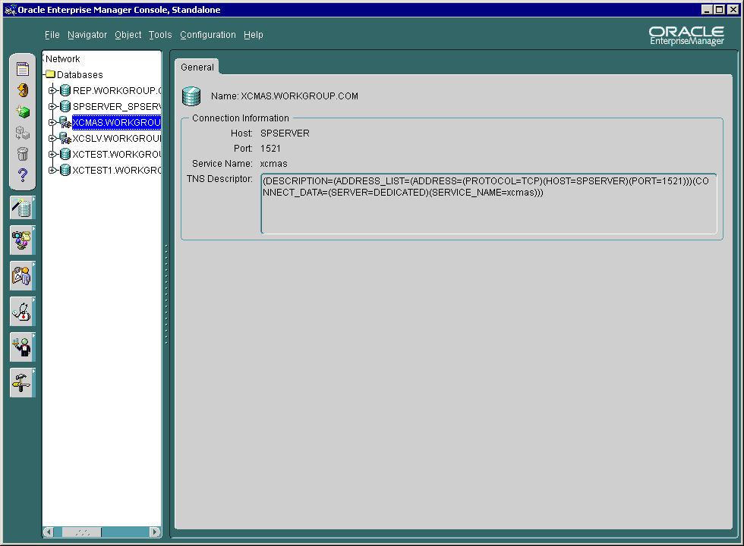

- Expand the node of XCMAS and right click on node Multimaster Replication. Select Setup Master Sites… from the menu.
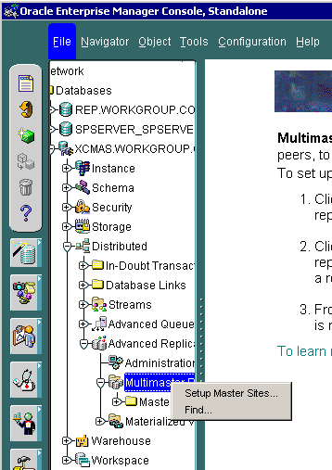

- In Setup Wizard, click Add. Select XCMAS and XCSLV from the site combo box and enter password of SYSTEM. Click Add to add those two sites. Click OK to close the dialog and back to Setup Wizard.
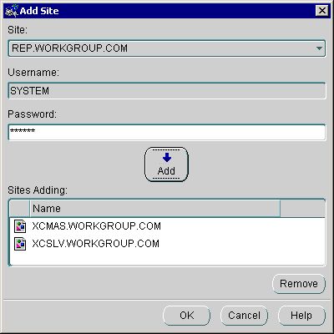

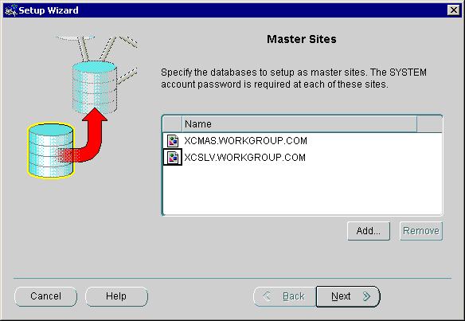

- Click Next and accept the default user REPADMIN as admin to manager replication. NOTE: Change the REPADMIN’s password as you wish here.
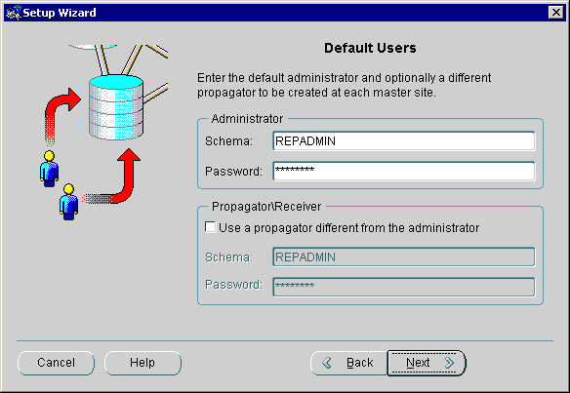

- Click Next on Master site Schemas screen.
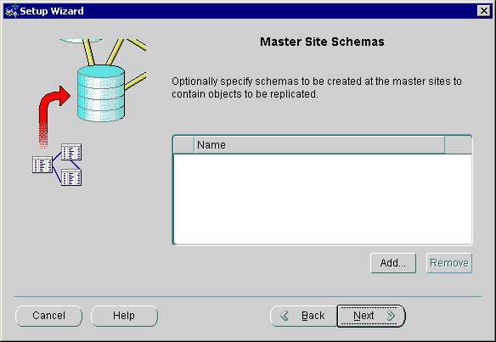

- Set Default Link Scheduling. This value is depending on your server and requirements. We use 5 minutes here.
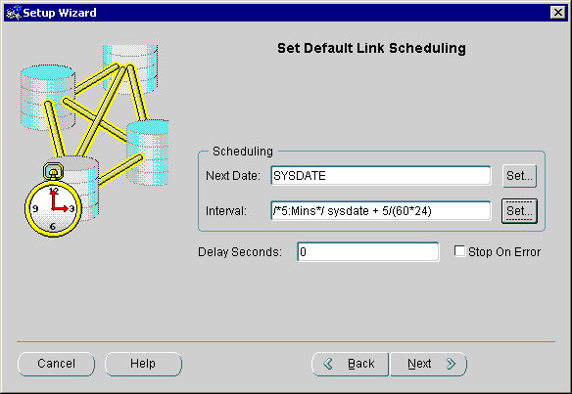

- Set Purge Job Scheduling. We leave it default to 1 hour.
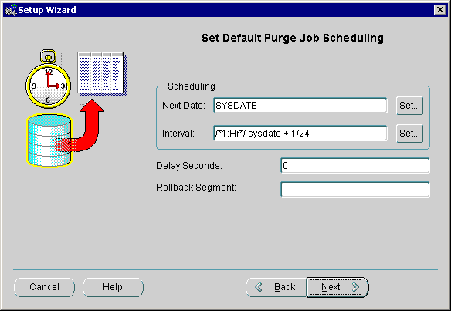

- Click Next on Customize Master Sites.
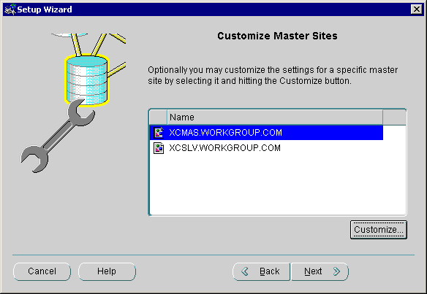

- Click Finish
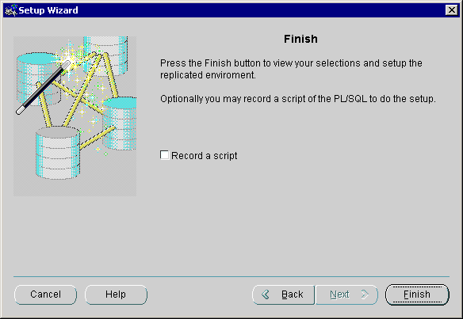

- Confirm your settings and click OK to setup master sites.

- Right click on XCMAS and XCSLV and connect using REPADMIN. IMPORTANT: This is required, because REPADMIN is the owner of all replication schemas.

- Create the master Group. First right click on Master Groups and select Create.
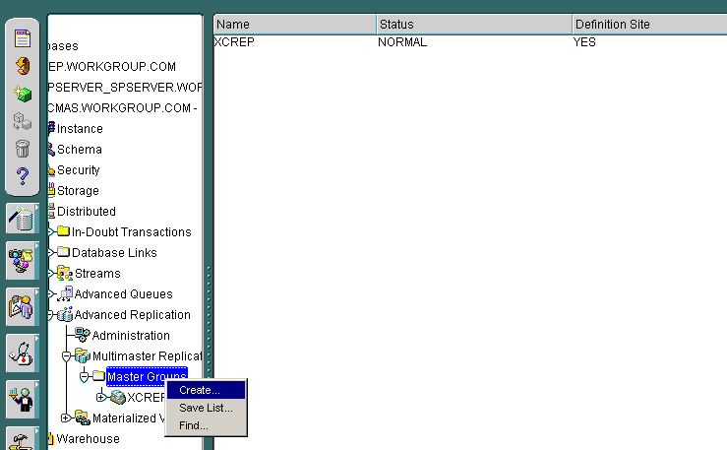

- Name the group XCREP.
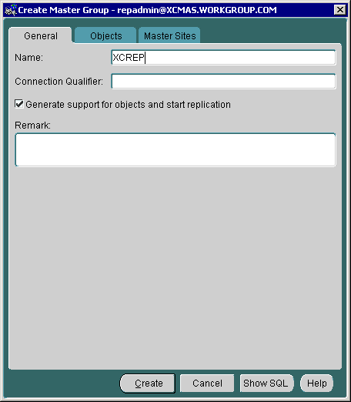

- Go to second tab Objects. Click Add. Select Schema to XCManager and add all its indices and tables.
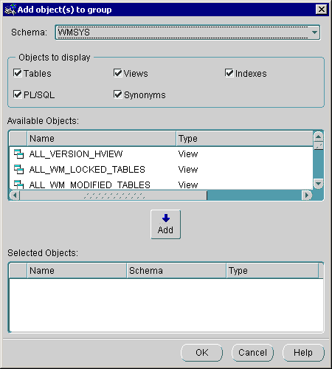

- Go to the third tab, and select XCSLV to the master sites.
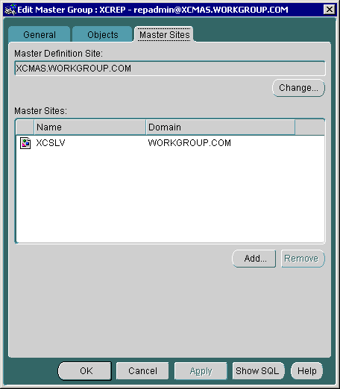

- Click OK to finish the master group XCREP setup.

- Select XCREP, go the second tab Objects. Select all tables and click Generate Replication Support. The Generation Status should appear as GENERATED.
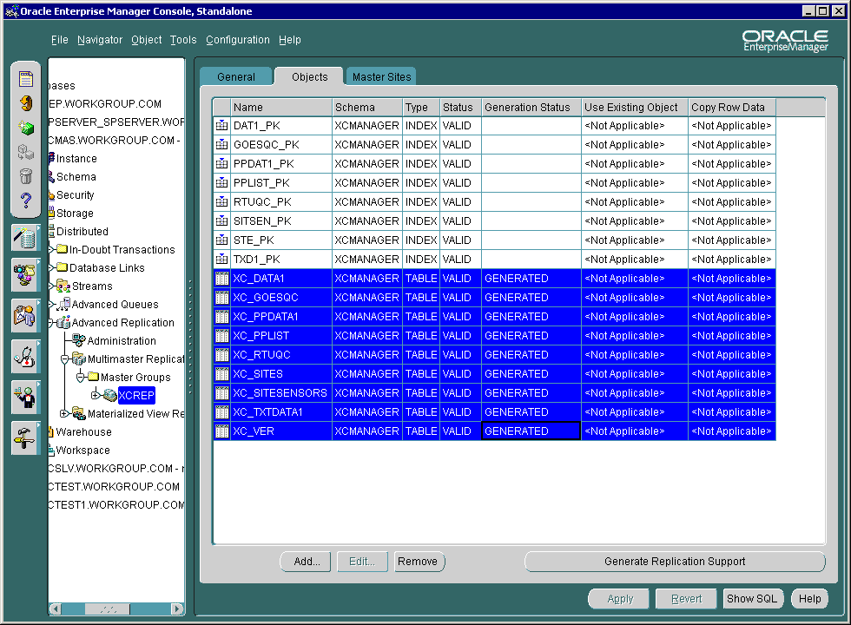

- Go to the first tab General, click on Submit Start Request… or Submit Stop Request to stop the replication. Note: The XC tables are not updated until the replicated are started. The other server doesn’t need to be online, but the service need to be started in order to access XC tables.
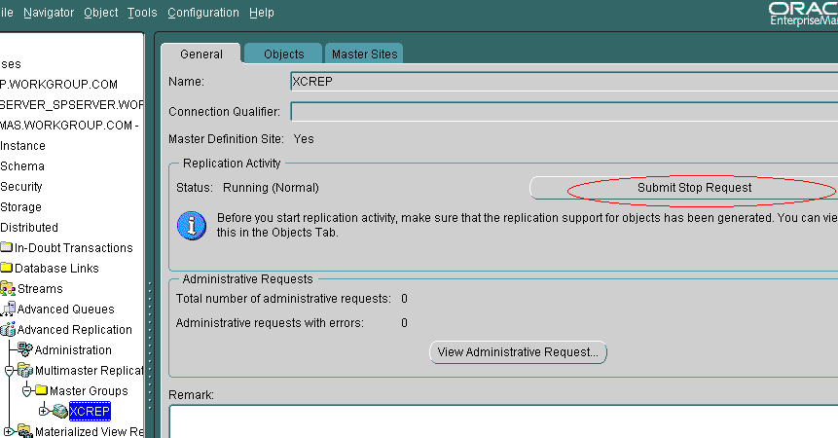

- Click on node Administration, check the Topology and it should consists of two sites: XCMAS and XCSLV.
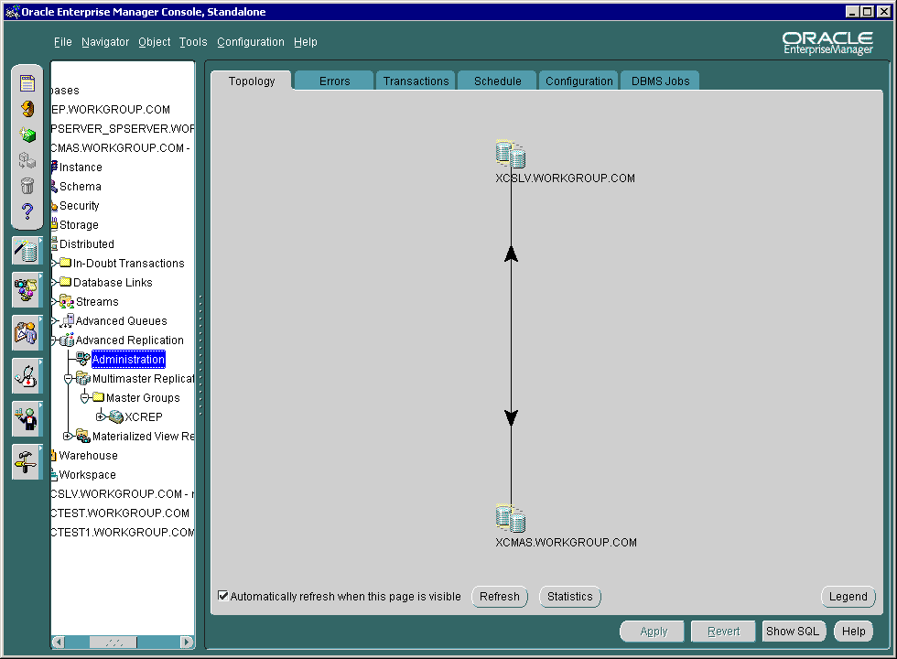

- Insert a record to XC_SITES on XCMAS. Within 5 minutes, it should be replicated to the XCSLV. Check the existence of the replicated records.

Pending Issue: We assume XCSLV is almost always in a read-only mode, except when XCMAS is not available. However, if two are updated at the same time, an update conflict may happen. The conflict resolution method is not defined in this setup. Some method like site priority, last update timestamp can be used. This is not covered in this document.

