
XC Reports Scheduler


Sutron Corporation
21300 Ridgetop Circle
Sterling, Virginia 20166
TEL: (703) 406-2800
FAX: (703) 406-2801
WEB: http://www.sutron.com
Table Of Contents
 Welcome to XC Reports Scheduler 1
Using XCReports Scheduler 3
Moving around in XC Reports Scheduler 3
The Menu Bar 4
The XC Reports Toolbar 4
The Detail Panel 4
Detail level: Low only errors are displayed 5
Detail level: Medium errors, warnings and are important messages are displayed 5
Detail level: High errors, warnings and status messages are displayed 5
The Status Window 5
The Status Bar 5
Changing the database source 6
Creating a new Report Group 7
Report Group Setup parameters 11
Report Group parameters 12
Copying a Report Group 15
Deleting a Report Group 16
Manually Start Process Now 17
Stopping Process 17
Status messages 17
Logging status messages 19
Troubleshooting 21
Troubleshooting tips 21
Error Messages 22
Error 8: Invalid License Key. Please verify XConnect is properly installed. 22
Error 9: Invalid License Key. Exiting now... 22
Error 1700: General Report Error. 22
Error 1701: Value is not a number. 22
Error 1702: Unable to connect to database - XConnect. 22
Error 1703: Unable to set Crystal Reports run parameters. 23
Error 1704: Param not defined. Check setup again. 23
Error 1705: Report not enabled. 23
Error 1706: Run file BatchFile does not exist. 23
Error 1707: Error running program BatchFile. 23
Index 25

Table of Figures
Figure 1. XC Reports Scheduler main window 3
Figure 2. Database Login window 6
Figure 3. Setup parameters window 7
Figure 4. Select Report window 8
Figure 5. Select parameter inputs for reports window 9
Figure 6. Setup parameters window 11
Figure 7. Select Reports window 12
Figure 8. Select parameter inputs for reports window 14
Figure 9. Setup parameters window 15
Figure 10. Setup parameters window 16
Figure 11. Group select window 17

Welcome to XC Reports Scheduler
XConnect is Sutron Corporation's latest data collection, data processing and data storage software. Built on the strong principles of PcBase2, XConnect is compliant with today's 32-bit Windows operating systems and provides new tools and options for the user.
XConnect is a collection of executables designed to provide a complete solution for data collection, data handling, data viewing and data storage
The XC Reports Scheduler provides the convenience to the user of automatically generating commonly used reports on a user-defined schedule. Typically, diagnostic reports will be run every morning to assess the RTU network. The XC Reports Scheduler can run the report prior to your arrival at work and have it ready.
XC Reports Scheduler works with XC Reports. It reads in the report library from XC Reports and automatically generates reports to files or printers based on the schedule.
XConnect is installed with an array of reports displaying system, data and diagnostic data. XC Reports Scheduler is designed for the database storage option in XConnect. Using the power of Crystal Reports to generate new reports, XConnect now has the mechanism to add new reports easily to its library to fill the demands of changing customer requirements.

Using XCReports Scheduler

Moving around in XC Reports Scheduler
The XC Reports Scheduler application consists of these main areas:
- The Menu Bar provides access to all user-controllable functions within the application.
- The Toolbar provides one-click access to important functions.
- The Status Window provides error messages, warning messages and status messages generated by the application.
- The Detail Panel controls the messages displayed in the status window.
- The Status Bar displays parameter hints

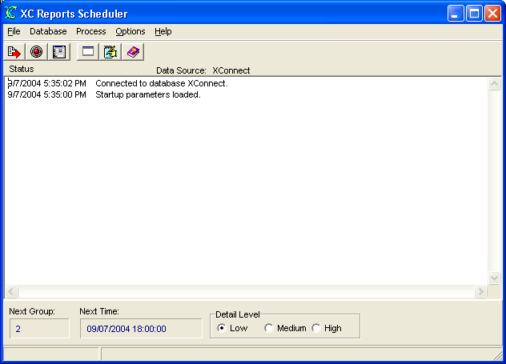
Figure 1. XC Reports Scheduler main window

The Menu Bar
The Menu Bar provides access to the following menus:
File | - Exit -- terminates the application.
Database | - Connect -- opens a dialog box to select database source as defined in Data Sources (ODBC) control applet.  - Disconnect -- disconnects from current database source.
Process | - Start Process -- start the report groups and generate reports immediately.  - Stop Process -- Stop the report groups that are running.
Options | - Edit Setup Parameters -- Edit report groups, schedules, outputs and all parameters.  - Clear Status Messages -- clears the status window.  - Log Status Messages -- logs all status messages to a disk file.
Help | - Help -- access this help system an defaults to Index tab.  - Contents -- access this help system an defaults to Contents  - About -- get version information for this application.

The XC Reports Toolbar
The toolbar area allows you to quickly access various XC Reports Scheduler functions.

 | Manually select a report group and run the report immediately.
 | Stop the current report schedule.
 | Edit the setup parameters for XC report scheduler.
 | Clear status messages in status windows.
 | Log all status messages in log file.
 | Open the on-line help (this document).

The Detail Panel
The Detail panel shows the next report group and allows the user to control the level of messages displayed in the status windows.
The Next Group and Next Time fields show the next scheduled export poll group and the time the poll group will trigger.
Message Detail options are:
- Low - indicates only error messages will be displayed.
- Med - indicates error messages, warning messages and brief status messages will be displayed.
- High - indicates all messages will be displayed. In High detail, actual retrieved values and their corresponding time stamps will be displayed.

Detail level: Low only errors are displayed
Error messages are usually caused by the database being offline, or by a network file server error. If the database is offline then no data will be exported. However, the program will try to connect again to the database the next time data export is due.

Detail level: Medium errors, warnings and are important messages are displayed
Warning messages usually result if there was no data found for the date and time specified.
9/9/2004 4:19:54 PM Connected to database XConnect.
9/9/2004 4:19:51 PM Startup parameters loaded.

Detail level: High errors, warnings and status messages are displayed
9/9/2004 5:03:53 PM Thread freed. Group: 2 Report Name: 023 Data For Selected Time Range-Stations-Sensors
9/9/2004 5:03:52 PM Thread stopped. Group: 2 Report Name: 023 Data For Selected Time Range-Stations-Sensors
9/9/2004 5:03:51 PM Finish the report.
9/9/2004 5:03:51 PM Now ready to run the report.
9/9/2004 5:03:51 PM File Name: C:\Temp\023.DOC
9/9/2004 5:00:44 PM Output to file. Group: 2 Report Name: 023 Data For Selected Time Range-Stations-Sensors
9/9/2004 5:00:05 PM Open report files. Group: 2 Report Name: 023 Data For Selected Time Range-Stations-Sensors
9/9/2004 5:00:04 PM Thread started. Group: 2 Report Name: 023 Data For Selected Time Range-Stations-Sensors

The Status Window
The Status window gives a list of exporting events performed by the XC Export program.
This list of status messages is in time order with each entry stamped with the date and time. Newest messages will appear at the top. Scroll bars will appear as needed to allow an operator to view parts of the display that may not fit in the window.

The Status Bar
The Status Bar is divided in two sections. The left-hand panel displays status messages. The right-hand panel displays parameter hints.

Changing the database source
XC Reports Scheduler displays the data from a database. Easily the database can be changed, as long as it is defined in the Data Sources (ODBC) control applet. To change data sources:
- Start XC Reports Scheduler from the Start Menu or from a desktop icon.
- From the Database menu, select Disconnect or from the toolbar click on the icon to disconnect from the current data source.
- Next, from the Database menu, select Connect or from the toolbar click on the icon to select a new data source.
- The XC Report Scheduler Database Login window will appear.
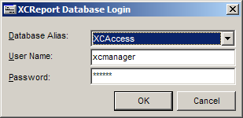
Figure 2. Database Login window
- Click on the Database Alias list box to select the new data source.
- Enter User Name and Password for data source and click OK.
- XC Reports will attempt to connect to selected data source using the user name and password entered.

Creating a new Report Group
Follow these steps to create a new report group.
- Click the XC Report Scheduler icon on the desktop. The XC Report Scheduler application starts.
- From the Options menu, select Edit Setup Parameters or from the toolbar click on the icon.
- The Setup window will appear.
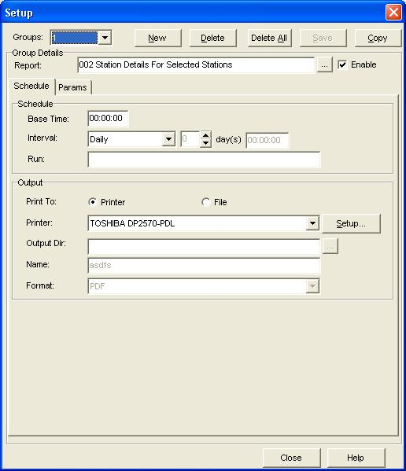
Figure 3. Setup parameters window
- Click on the New button to create a new report group. XC Report Scheduler will automatically assign the next available report group number. The first Poll group will be 1. The poll group number will increment automatically as you add more report groups. Right clicking on the Poll Group list and clicking on the New menu option will also create new poll groups.
- Check Enable so that this report group will be run on schedule. By default, Enable is not checked.
- First, select an available report from the list by click . A new dialog will appear and select the report from the list.
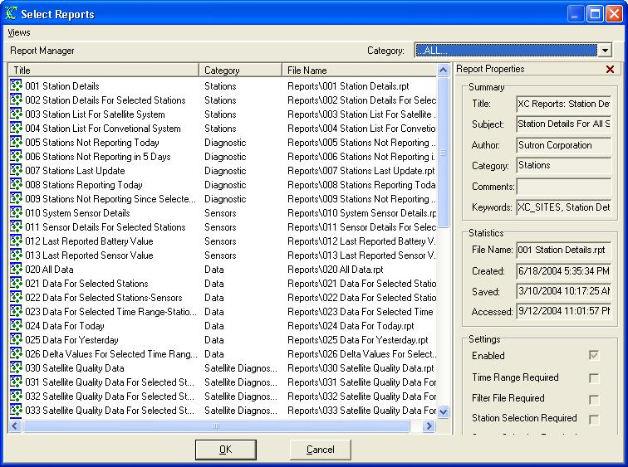
Figure 4. Select Report window
- Next, set the Base Time and Interval for the report group. The Base Time represents an offset into the hour. The Interval sets the time between reports. It must be greater than zero. As an example, if the Base Time is 00:05:00 and Interval is 00:30:00, then XC Report Scheduler will execute the report group for data 00:05:00, 00:35:00, 01:05:00, 01:35:00...etc.
- Select the Output format. It can be Printer or File.
- If Printer is selected, select the printer from the combo box.
- If File is select, specify the Output Dir and Name: Here, you can Browse for the directory. The output file can be named with the date and time as well. Tips on file name convention .
The lower case letters "yy", "yyyy", "mm, "dd", "hh", "mi" can be included in the name to instruct the software to created separate minute, hourly, daily, monthly, or yearly files. Optionally, "#nn: can be added to specify that a new file should be created every nn minutes (when using "mi") or hours (when using "hh"), or days (all other). The "#nn" can appear anywhere in the string, where nn must be two digits with leading zeros, if necessary.
The dating of output files is important for easy backup, purging or distribution of output files.
Example 1:
MYDATdd.TXT would create the file MYDAT01.TXT on the first day of the month, MYDAT02.RAW on the second day, and so on until the next month MYDAT01 would be used again. NESmm.TXT would create the file NES01.TXT to contain all the data for January, NES02.TXT to contain all the data for February, and so on until the next month.
Example 2:
yymmddhh.CSV#02 would create a new output file every 2 hours. If the "#02" was left off, a new file would be created every hour. As well, mmddhhmi.CSV#15 would create a new output file every 15 minutes.
- Go to Params tab.
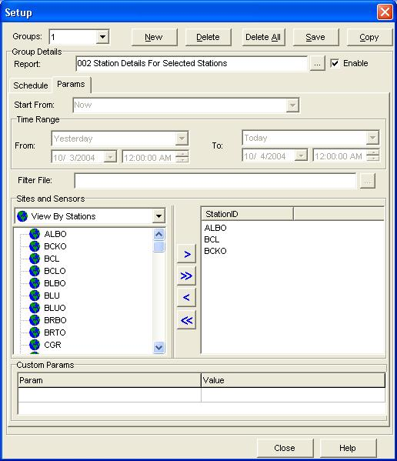
Figure 5. Select parameter inputs for reports window
- Specify Start, which define the start date and time for report data. The Start field will automatically be updated to the date and time of the last data received.
- Add site-sensor combinations to the Site-sensor list box. Click or highlight a site/station in the Sites list box. The sensors associated with the site will be displayed in the Sensors list box. Add the site-sensor combination by double clicking on the sensor or highlighting the sensor and click the Add button. It is possible to select multiple sensors and add all of them to the Site-sensor list. You can also remove the site-sensor combination by clicking on the Remove button.
- Click Save button to save all poll group changes. This is very important. You can also right click and select the Save menu option to save the poll group details.
- You can now do a test run by manually executing the report group.

Report Group Setup parameters
In setting up XC Report Scheduler, report groups must be defined. These report groups are comprised of report schedule, sites and sensors based on some defined selection criteria (e.g. all sites with the rain gauge sensor, or all sites in a particular basin or latitude etc.). The sites and sensors belonging to a report group are all polled for data from the database at the same time and then displayed in the report. To set these parameters:
- Click the XC Report Scheduler icon on the desktop. The XC Report Scheduler application starts.
- From the Options menu, select Edit Setup Parameters or from the toolbar click on the icon.
- The Setup parameters window will appear.
Figure 6. Setup parameters window
From this window you can create and make changes to all report groups. When you are finished, click the Save button to save changes. Clicking Close will only close the window without saving changes.

Report Group parameters
- Groups - List of current report groups. Select from the list to display the report group parameters associated with the group.
- New - Click this button to create/add an report group. The first poll group will be 1. The report group number will increment automatically as you add more report groups. Right clicking on the report group list and clicking on the New menu option will also create new report groups.
- Delete - Click this button to delete the currently displayed report group.
- Delete All - Click this button to delete all report groups. Use with caution!
- Save - Click this button to save all report parameters for currently displayed report group.
- Enable - This flag indicates the poll group is active and ready to be polled/run. Poll groups can be created but left "inactive" until a later date.
- Report: Select an available report from the XC Reports library by clicking . A new dialog will appear and select the report from the list.
Figure 7. Select Reports window
- Schedule Tab
  - Base Time - Used in conjunction with the Interval, this indicates how often XC Report Scheduler will dispatch the report groups and run the reports. The Base Time represents an offset into the hour. As an example, if the Base Time is 00:05:00 and Interval is 00:30:00, then XC Report Scheduler will run report groups at 00:05:00, 00:35:00, 01:05:00, 01:35:00...etc.
  - Interval - Used in conjunction with the Base Time, this indicates how often XC Report Scheduler will dispatch the report group and run the reports. The Interval represents how often the report is run. As an example, if the Base Time is 00:05:00 and Interval is 00:30:00, then XC Report Scheduler will run reports at 00:05:00, 00:35:00, 01:05:00, 01:35:00...etc.
  - Run - An optional list of programs to run when the report group is completed. If the application does not reside in the XConnect home directory, list the file path with the executable name (i.e., c:\myapp\myapp.exe). Parameters to be passed to the program must be in double quotes (i.e., Notepad “MyExport.txt”).
  - Output - This indicates the output for the reports. It can be either Printer or File.
  - Printer - If output is printer, select the printer for the reports. Click Setup to choose printer setup params.
  - Output Dir - If output is file, select the output directory. This is the directory to store all report files.
  - Name - Specify the output filename or filename pattern for the exported data. Using the filename pattern, the output file can be named with the date and time as well. Tips on file name convention .
The lower case letters "yy", "yyyy", "mm, "dd", "hh", "mi" can be included in the name to instruct the software to created separate minute, hourly, daily, monthly, or yearly files. Optionally, "#nn: can be added to specify that a new file should be created every nn minutes (when using "mi") or hours (when using "hh"), or days (all other). The "#nn" can appear anywhere in the string, where nn must be two digits with leading zeros, if necessary.
The dating of output files is important for easy backup, purging or distribution of output files.
Example 1:
MYDATdd.TXT would create the file MYDAT01.TXT on the first day of the month, MYDAT02.RAW on the second day, and so on until the next month MYDAT01 would be used again. NESmm.TXT would create the file NES01.TXT to contain all the data for January, NES02.TXT to contain all the data for February, and so on until the next month.
Example 2:
yymmddhh.CSV#02 would create a new output file every 2 hours. If the "#02" was left off, a new file would be created every hour. As well, mmddhhmi.CSV#15 would create a new output file every 15 minutes.
  - Format - Specify output file format. This can be PDF, XLS, HTML, WORD, CSV and XML.
- Params Tab
  - Start Time - Specify start time for requesting data from the database. The Start field will automatically be updated to the date and time of the last report is run.
  - Time Range - Specify the start time and end time for the report if those params are required in the configuration of the report.
  - Sites and Sensors- List of sites and sensors available in database. The control will be enabled if the report need sites and sensors parameters.
  - Add - Click this button to add the highlighted site-sensor pair to the Sites-Sensors Selected list box. Only sensors listed here will be exported from the database. Double-clicking on the sensor name will also add the site-sensor pair.
  - Remove - Click this button to remove the highlighted site-sensor pair from the Sites-Sensors Selected list box.
  - Sites-Sensors Selected - List of sensor that will be used in this report group.
  - Custom Params - If in the report selected, there are any unrecognized user-defined parameters, they will be listed in this list. Click on the right site to enter the values, so that it will be passed to the report alone with other parameters .
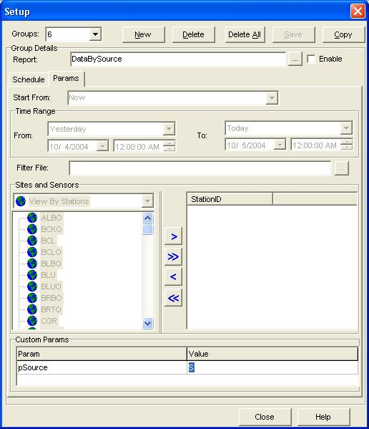
Figure 8. Select parameter inputs for reports window

Copying a Report Group
Follow these steps to create a new report group.
- Click the XC Report Scheduler icon on the desktop. The XC Report Scheduler application starts.
- From the Options menu, select Edit Setup Parameters or from the toolbar click on the icon.
- The Setup window will appear.
Figure 9. Setup parameters window
- Select the Group Index from Groups box.
- Click Copy to copy the current report group. The new group will have a new group index and be displayed as current report group.

Deleting a Report Group
Follow these steps to create a new report group.
- Click the XC Report Scheduler icon on the desktop. The XC Report Scheduler application starts.
- From the Options menu, select Edit Setup Parameters or from the toolbar click on the icon.
- The Setup window will appear.
Figure 10. Setup parameters window
- Select the Group Index from Groups box.
- Click Delete to drop the current report group.

Manually Start Process Now
XC Report Scheduler will automatically run the reports based on the Base Time and Interval of the active report groups. However, if the user does not want to wait for the Next Report Time as displayed in the detail panel of the status window, the user can trigger any report group at any time. To trigger an on-demand process:
- Click the XC Report Scheduler icon on the desktop. The XC Report Scheduler application starts.
- From the Process menu, select Start Process Now or from the toolbar click on the icon.
- The Select Groups window will appear.
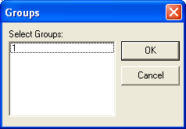
Figure 11. Group select window
- Select desired report group number to manually trigger and click Ok.

Stopping Process
XC Report Scheduler will stop all active report groups that are running and wait to the next report scheduler if Stop Process is used:
- From the Process menu, select Stop Process or from the toolbar click on the icon .

Status messages
Below are the status messages XC Decode will display in the decoding status window as it decodes data from the raw files:
- Are you sure you would like to disconnect from current ODBC source?
XC Report Scheduler confirms the user would like to disconnect from the current database source. Disconnecting from a data source prevents any reports from being run.
- Connecting to database...
XC Report Scheduler is attempting to connect to the database (ODBC) source.
- Connected to database ODBC source.
XC Report Scheduler has successfully connected to the user selected database (ODBC) source.
- Save all current parameters?
XC Report Scheduler confirms the user would like to save all the parameters.
- Are you sure you want to delete this group?
XC Report Scheduler confirms the user would like to remove the report group.
- Are you sure you want to delete all the Groups?
XC Report Scheduler confirms the user would like to remove all the report groups.
- Disconnected from database.
XC Reports has disconnect from the current database (ODBC) source.
- Database NOT connected.
All raw files have been checked for new satellite messages and decoded.
- Reading xxx.XFG.
XC Reports is reading the default configuration file which contains user's last program settings.
- Startup parameters loaded.
XC Report has complete reading and applying all the startup parameters and is ready to generate reports.
- Thread started. Group: xxx Report Name: yyyy
XC Report has started a new thread to process the report for group xxx and report name yyy.
- Open report files. Group: xxx
XC Report has opened the report file for group xxx.
- Output to printer. Group: xxx
XC Report has set the output of report group xxx to printer.
- Output to file. Group: xxx
XC Report has set the output of report group xxx to file.
- Now ready to run the report.
XC Report is ready to run the report with the parameters and output defined in report group.
- Finish the report.
XC Report is finished process the report.
- Thread stopped. Group: xxx Report Name: yyyy
The thread used to run the report has been stopped for group xxx and report name yyyy.

- Thread freed. Group: xxx Report Name: yyyy
The thread used to run the report has been freed for group xxx and report name yyyy.

Logging status messages
The purpose of the Log Status Messages is for troubleshooting. Logging all messages, will provide Sutron customer support a historical log of all events to help troubleshoot any problems. To log all status messages:
- Click the XC Report Scheduler icon on the desktop. The XC Report Scheduler application starts.
- From the Options menu, select Log Status Messages or from the toolbar click on the icon. XCRptSchedule.log will be used to append status messages.

Troubleshooting

Troubleshooting tips
Network errors can potentially be the source of most errors in XC Report Scheduler. In most cases, databases are stored on separate network servers. If a sudden loss of network connectivity should occur, reports will fail to generate. Ensure network access is available to the network database server as well as the correct login privileges. Again, in a large network where the database is on a separate server, verify your database login name and password with you network administrator.
On small systems using Access as you database, the Access database (.MDB) may or may not be stored in the same PC. Make sure, for all Data Sources configurations, the data source is configured as a system resource (System DSN) and not as a user resource. Access, based on the data source configuration, may or may not require a password. Verify any login parameters.
There is a chance that the Crystal Report file (.RPT) may become corrupt. If so, the user can copy or re-install the file from the XConnect installation CD.

Error Messages
Potential error messages generated by XC Reports are:

Error 8: Invalid License Key. Please verify XConnect is properly installed.

Troubleshooting steps:
Ensure that:
- Current XConnect application is part of the purchased XConnect license.
Refer to the original purchase order.

Error 9: Invalid License Key. Exiting now...

Troubleshooting steps:
Potential reasons for error:
- Current XConnect application is not valid for use with existing XConnect license.
Call Sutron Sales to upgrade XConnect license.

Error 1700: General Report Error.

Troubleshooting steps:
If any error happens during the process of the report, this error may be shown with a detailed error message appended.
Potential reasons for error:
- The database configuration has changed on the current machine/network PC or has XConnect been installed on a new PC where the Data Source is not configured.
Verify the Data Source (ODBC) settings for XConnect database.
Check settings in Data Sources control applet either in the Control Panel or in Administrative Tools.
Verify user name and password are correct for database login.
- Report file is missing or corrupt.
The report engine in XC Report Scheduler can not read in the report, either because it's missing or the file is corrupt. Please verify the report file.

Error 1701: Value is not a number.

Troubleshooting steps:
Potential reasons for error:
- The parameter is expecting a number, but the input can not be converted to the number. Please verify the input parameters.

Error 1702: Unable to connect to database - XConnect.

Troubleshooting steps:
Potential reasons for error:
- XC Report Scheduler can not connect to the database. Please verify the network connection, user name, password and database status.

Error 1703: Unable to set Crystal Reports run parameters.

Troubleshooting steps:
Potential reasons for error:
- XC Report Scheduler can not set the Crystal Report file's parameters. It could be the corrupt report file or unsupported version of report. Please verify the report file.

Error 1704: Param not defined. Check setup again.

Troubleshooting steps:
Potential reasons for error:
- The Crystal Report file is expecting certain parameters, but it's not found in the setups. Please check the report group parameters again.

Error 1705: Report not enabled.

Troubleshooting steps:
Potential reasons for error:
- This error is displayed if you are trying to manually run the report group without first enabled it. Please enable the report group in setups.

Error 1706: Run file BatchFile does not exist.

Troubleshooting steps:
Potential reasons for error:
- After completing the report, it is trying to run the programs that are defined on the Run line. But they couldn't be found. Check the program Run line and path.

Error 1707: Error running program BatchFile.

Troubleshooting steps:
Potential reasons for error:
- After completing the report, it is trying to run the programs that are defined on the Run line. But the programs returns any error code back to XC Report Scheduler.

Index

A
Adding
new Report 10
Adding 10
Apply button
clicking 23
Apply button 23
Apply Filter 28
Apply Filter button
selected 28
Apply Filter button 28
ASCII 28
Available Categories 10
C
Category list 10, 28
changes
database source 9
XCReports.XFG 28
changes 9
changes 28
Check
Enabled 28
Check 10
Check 28
Connect 9
Contents 4
Control Panel 28
Crystal Report 1, 10, 28
Crystal Report Viewer 4
Crystal Reports file 10, 27, 28
D
Data Sources 4, 5, 9, 27, 28
Database Alias list 9
Database menu 9
database source
Changing 9
database source 9
Details 28
Disconnect 9
display
Report Properties 4, 5
display 4
display 5
E
Enabled - Check 10
Error Messages 28
existing
XConnect 28
existing 28
Exporting
reports 21
Exporting 21
F
Filter File Required 10
M
machine/network PC 28
Menu Bar 3, 4
Moving
around 3
Moving 3
N
Name 10
new Report
Adding 10
new Report 10
O
ODBC 4, 5, 9, 23, 28
P
Password 9
PC 27, 28
Print Setup 4
R
Register Report 4, 10
Reload Last Report 4
Remove Report 4, 25
report
Exporting 21
Removing 25
Report Manager 4, 5, 28
report 4
report 5
report 21
report 25
report 28
Report Manager 3, 4, 5, 7, 10, 28
Report Manager list 23, 25
Report Manager/Report Viewer 3
Report Properties
display 4, 5
Report Properties 3
Report Properties 4
Report Properties 5
Report Setup 4
Report Setup Parameters 10
Report Setup window 10
Report Title 23, 28
Report Viewer 3, 4, 7, 21
Report Wizard 23, 28
Reports menu 10, 25
RPT 10, 25, 27, 28
Run Report 4, 21
run/generate 28
S
Sensor Selection Required 10
Setup Requirements 10
Show Report Manager 5
Show Report Viewer 5
Start Menu 9, 10, 21, 25
Station Selection Required 10
Status Bar 8
System DSN 27
T
Time Range Required 10
tips
Troubleshooting 27
tips 27
Title - Title 10
Troubleshooting
steps 28
tips 27
Troubleshooting 27
Troubleshooting 28
X
XC Reports
Welcome 1
XC Reports 1
XC Reports 3
XC Reports 5
XC Reports 7
XC Reports 9
XC Reports 10
XC Reports 21
XC Reports 23
XC Reports 27
XC Reports 28
XConnect 1, 27, 28
XCReports.XFG
changes 28
XCReports.XFG 28
XCReports.XFG file 28

