XC INSAT Mux
Table Of Contents
Welcome to XC Mux 1
Using XC Mux 3
Moving around in XC Mux 3
Click an area on the image below for more information. 3
The Menu Bar 4
The XC Mux Toolbar 5
The following tools are provided: 5
The Last Message panel 6
The Status Window 8
The Status Bar 9
Data Flow 10
RAW files 11
Messages in the status window 12
Clearing the status window 14
Editing setup parameters 15
XC Mux Setup Parameters 15
XC Mux Demod Setup Parameters 17
Opening and Closing the port 18
Configuring demods in receive site 19
If this is the first time you are changing demod settings: 19
Modifying/setting demod settings 19
Setting the DDRGS clock 20
Resetting the DDRGS 21
Index 23

Welcome to XC Mux
XConnect is Sutron Corporation's latest data collection, data processing and data storage software. Built on the strong principles of PcBase2, XConnect is compliant with today's 32-bit Windows operating systems and provides new tools and options for the user.
XConnect is a collection of executables designed to provide a complete solution for data collection, data handling, data viewing and data storage
The role of XC Mux within an XConnect data collection system is to retrieve DCP messages from a Sutron receive site multiplexor/digitial direct readout ground station (DDRGS) and store them in ASCII files. XC Mux interfaces with the Sutron receive site (DDRGS) via a standard serial port connection.
These ASCII files are called Raw files because that contain raw (undecoded) satellite messages. Actual decoding and processing of the messages is performed by the XC Decode program.
Note: Throughout the help text, receive site muiltiplexor, mux, DDRGS will used interchangeably.

Using XC Mux

Moving around in XC Mux
The XC Mux application consists of these main areas:
- The Menu Bar provides access to all user-controllable functions within the application.
- The Toolbar provides one-click access to important functions.
- The Status Window provides the user with informational or error messages.
- The Latest Message panel displays information about the most recently received message.

Click an area on the image below for more information.
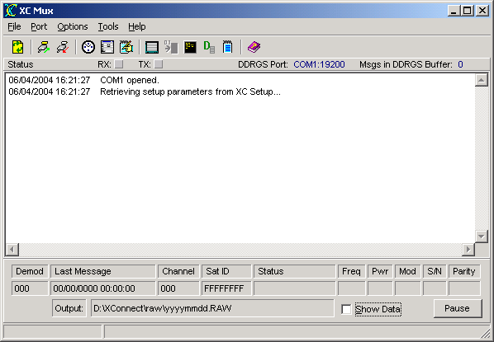

The Menu Bar
The Menu Bar provides access to the following menus:
File | - Open -- selects a DDRGS Mux (.MUX) output file to process.  - ReInitialize -- sends an application ReInitialize message to all applications (other XConnect programs and other client programs) connected to XC Setup controlling or using communcations ports (XC Mux and XC Rtu). Applications are instructed to flush their local buffers, reload the latest setup information from XC Setup and Reinitialize the communication ports by releasing the com port and opening it with new port parameters.  - Login -- user login for XConnect system.  - Exit -- terminate the application.
Port | - Open Mux Port -- connect XC Mux to its assigned serial port.  - Close Mux Port -- disconnect XC Mux from the current serial port.
Options | - Reset Mux -- send reset commands to the DDRGS.  - Set Time -- send a SetClock command to the DDRGS to synchronize the DDRGS clock with the PC clock.  - Edit Setup Parameters -- edit the setup parameters for XC Mux.  - Clear Status Messages -- clear the status window.  - Log Status Messages -- log all status messages to a disk file.
Tools | - Protocol Analyzer -- opens Protocol Analyzer window to monitor communication over the serial port.  - Send Demod Settings -- opens Demod Settings window to assist user in configuring demod settings in DDRGS.  - Terminal Mode -- opens Terminal Mode window that allows user to manually send configuration commands to the DDRGS.  - Demod Summary -- opens Demod Summary window to view real-time update of each demodulator.  - Station Summary -- opens Station Summary window and generate a report on one or more satellite IDs.
Help | - XC Mux Help -- access this help system and defaults to Index tab.  - XC Mux Contents -- access this help system an defaults to Contents tab.  - About -- get version information for this application.

The XC Mux Toolbar
The toolbar area allows you to quickly access various XC Mux functions.

The following tools are provided:
 | Reinitialize application. Flush local buffers and reload the latest setup information from XC Setup. Additionally, XC Mux will release the port and obtain new port information and then re-open the port.
 | Connect XC Mux to its assigned serial port.
 | Disconnect XC Mux from the current serial port.
 | Send a SetClock command to the DDRGS to synchronize the DDRGS clock with the PC clock.
 | Edit the setup parameters for XC Mux.
 | Log all status messages to a disk file.
 | Open the protocol analyzer to monitor communication over the serial port.
 | Open a window to assist user in configuring demod settings in DDRGS.
 | Open an interactive terminal to manually send configuration commands to the DDRGS.
 | Open the demod summary window to view real-time update of each demodulator.
 | Generate a report on one or more satellite IDs.
 | Open the on-line help (this document).

The Last Message panel
The latest message panel displays the following information about the most recently received DCP message:
- demod number
The demod number indicates what demodulator received the transmission.
- date and time
The date and time of when the message was received in Greenwich Mean Time (GMT).
- channel
The channel the message was received on.
- satellite ID
Satellite ID, Platform ID, NESDIS ID or DCP Address.
- status
Status of message. Possibilities are:
  - Good - Good message
  - Short Msg - Short message received
  - Bad Chan - Message received on wrong channel
  - Parity Err - Errors in message
- frequency
Frequency Offset in 50 Hz increments of message.
0=0-49 Hz, 1=40-99 Hz, ... 8=400-449 Hz, A=500-549 Hz
A minus sign indicates the same range only below the center frequency.
- power
Signal Strength of received message in dB. Normal operation is 44 to 48. Reliable data can be received as low as 37 if no other signal problem exists.
- modulation
Modulation Index or Phase Deviation.
  - N = Normal, 60 +/- 5 degrees
  - H = High, > 70 degrees
  - L = Low, < 50 degrees
- signal to noise
Signal to Noise quality.
  - N = Normal, error rate better than 1 x 10-6
  - F = Fair, error rate between 1 x 10-4 and 1 x 10-6
  - P = Poor, error rate worse than 1 x 10-4
- parity errors
Number of parity errors in the message.

In addition, the panel also contains the following elements:
- The name of the Output file where the DCP messages are being written.
- A Show Data Control to toggle display of satellite data in the status window.
- A Pause button to halt display of status messages in the status window.

The Status Window
The Status Window gives a list of events performed or detected by the XC Mux program.
The RX and TX status lights will blink as data is being transmitted and received by XC Mux from the receive site multiplexor.
The DDRGS Port displays the communication port the XC Mux uses to communication to the receive site multiplexor.
The Msgs in DDRGS Buffer indicates the number of satellite messages stored in the receive site buffer waiting to be downloaded by XC Mux.
This list of status messages is in time order with each entry stamped with the date and time. Newest messages will appear at the top. Scroll bars will appear as needed to allow an operator to view parts of the display that may not fit in the window.

The Status Bar
The Status Bar is divided in two sections. The left-hand panel displays the user logged in and his/her privileges. The right-hand panel displays parameter hints.
If no users are defined, the user logged in will be NONE and the privileges will be FULL. As soon as a user is defined in XC Desktop, the user and privileges displayed will be NONE and NONE.

Data Flow
Data flow in satellite systems using XC Mux is represented below.
- XC Mux and XC Decode retrieve setup information from XC Setup.
- XC Mux receives satellite messages from DDRGS
- XC Mux saves messages into Raw files
- XC Decode reads Raw files and processes the data based on setup and sensor information
- XC Decode stores data to data storage option

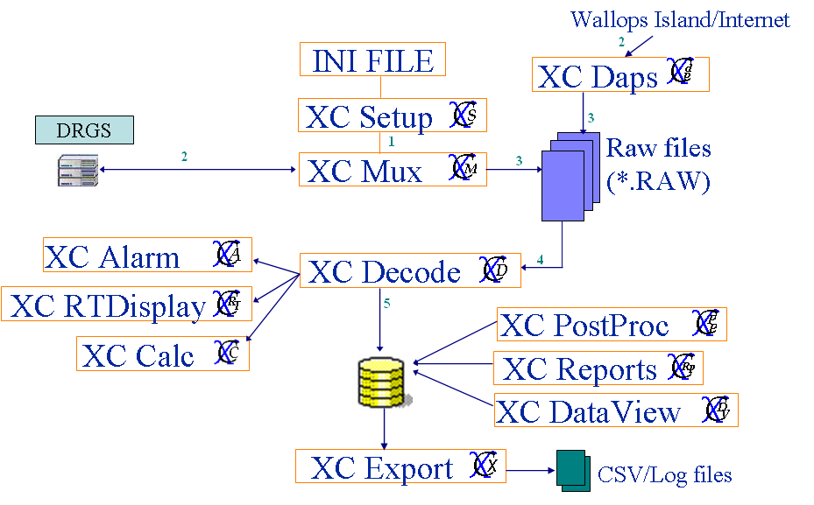

RAW files
All satellite messages received by XC Mux are stored into raw files. It is good practice to backup/archive all raw files on CD or tape. Because they contained the original measured data values, they can always be re-read or re-processed by XC Decode to create any final data storage output.
If ever a new equation or rating/look up table to older data, having the original raw files allows XC Decode to apply whatever adjusted equation to the data. In many cases, the original satellite messages are transmitted in ASCII, so can easily be exchanged with other organizations to share data history.

Messages in the status window
Below are the status messages XC Mux will display in the status window as it processes data from the receive site:
- WARNING: Garbage line received xxx.
All messages from the receive site start with a 'H', '+' or '-'. Any other line is considered garbage. If repeated garbage lines occur, use the Protocol Analyzer to capture the messages from the DDRGS.
- WARNING: Received partial message from Mux - xxx.
All messages from the a receive site will end with a line starting with a '-'. If an an ending line is not received, then it is considered a partial message. If repeated partial messages occur, use the Protocol Analyzer to capture the messages from the DDRGS.
- Correcting PC time to xxx.
The PC time will be corrected as displayed. This applies if there is a True Time clock receiver connected to the DDRGS and it is synchronizing the PC time.
- Current Mux time is xxx.
Hourly, XC Mux will check the time of the DDRGS, if the PC is responsible for time synchronization. If a correct is needed, it will first display the Current Mux time.
- Correcting Mux time, was xxx.
The DDRGS time will be corrected as displayed. In most cases, the PC will maintain the time synchronization. A PC time sync application will, via the WWW, requested the time from one of many time sources. Hourly, the PC will verify the time of the DDRGS.
- No time correction required.
Hourly, XC Mux will check the time of the DDRGS, if the PC is responsible for time synchronization. If no time changes are required, this message will be displayed.
- Resetting Mux hardware.
XC Mux will send reset the DDRGS/Mux hardware upon application start up or when the user manually selects the Reset Mux option from the Options main menu.
- CAUTION! Correctable error detected in header.
The format of a message received by XC Mux is very specific. In some cases, if some characters are missing in the header portion, they can be corrected.
- WARNING! Mux buffer may have overflowed resulting in loss of data.
The receive site hardware has a limitation on the number of messages that can be stored in its' buffer before being downloaded by XC Mux. If the number of messages exceeds the buffer limit, new messages received by the DDRGS will overwrite existing messages in the buffer, resulting in a loss of data.
Ensure that XC Mux is running while the DDRGS is powered up and receiving satellite messages. XC Mux is always clearing and saving messages from the DDRGS buffer to raw files.
- Checking Time...
XC Mux is performing its hourly time check with the DDRGS.
- DDRGS is set to Listen mode. Do you still want to continue?
If XC Mux is set to listen mode, then that indicates another XC Mux running on another PC is in the primary role of communciation commands to the DDRGS. This warning will be displayed each time an option is selected that will send a command to the DDRGS on the XC Mux set to listen mode.
- DDRGS will be switched from data collection mode to data configuration mode. Do you still want to continue?
When using the Terminal mode, the DDRGS will be changed from data collection mode to data configuration mode. This will stop the receiving of messages by XC Mux. The DDRGS will start to buffer the satellite messages.
Make sure when you are finished to return the DDRGS to data collection mode before closing the terminal window . Otherwise, no new messages will be saved to raw files.
- Please make sure DDRGS is in Normal Mode. Continue?
Before exiting the Terminal mode window, you will be reminded to make sure the DDRGS is in Normal mode to resume receiving of satellite messages. Use the Help panel to enter the correct command for Normal mode.
- Finishing download of current message...
Upon exiting, XC Mux will complete downloading of current message before closing.

Clearing the status window
The purpose of the status window is for XC Mux to display the informational and warning messages. To clear the window of existing messages:
- Click the XC Mux icon on the desktop. The XC Mux application will start minimized.
- From the Options menu, select Clear Status Messages or from the toolbar click on the icon.

Editing setup parameters
In setting up and maintaining a GOES receive site there are a number of critical parameters that must be configured properly. To set these parameters:
- Click the XC Mux icon on the desktop. The XC Mux application will start minimized.
- From the Options menu, select Edit Setup Parameters or from the toolbar click the button.
- The Edit Mux Setup Parameters window appears.
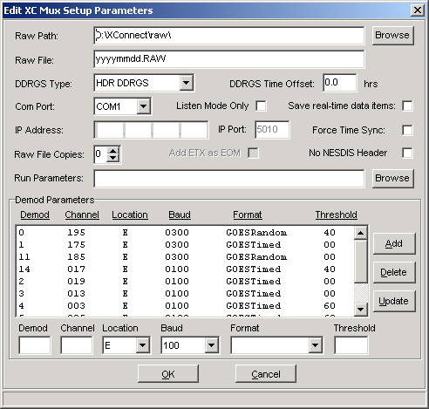
From this window you can make changes to the mux setup as described below. When you are finished, click the OK button to save changes. Changes will be saved to XC Setup. Clicking Cancel will close the window without saving changes.
This parameters are the same as viewed and edited in XC Desktop - XC Mux Setup window. The user has the option to edit the parameters within XC Mux or in XC Desktop.

XC Mux Setup Parameters
- Raw Path - The directory to store the raw NESDIS files as the satellite messages are received by the DRGS hardware.
- Raw File - The naming pattern of the raw data output files. The pattern contained in this field determines the name of the file which XC Mux will create and/or append to as messages are received from the multiplexor. Tips on raw file naming convention.
The lower case letters "yy", "yyyy", "mm, "dd", "hh", "mi" can be included in the name to instruct the software to created separate minute, hourly, daily, monthly, or yearly files. Optionally, "#nn: can be added to specify that a new file should be created every nn minutes (when using "mi") or hours (when using "hh"), or days (all other). The "#nn" can appear anywhere in the string, where nn must be two digits with leading zeros, if necessary.
The dating of raw files is important for easy backup, purging or distribution of raw data; and reprocessing of raw data through XC Decode. If the files are allowed to grow too large, these processes will become more difficult or require excessive time to perform. The default setting of yyyymmdd.RAW creates a separate file each day.
Example 1:
MYDATdd.RAW would create the file MYDAT01.RAW on the first day of the month, MYDAT02.RAW on the second day, and so on until the next month MYDAT01 would be used again. NESmm.RAW would create the file NES01.RAW to contain all the data for January, NES02.RAW to contain all the data for February, and so on until the next month.
Example 2:
yymmddhh.RAW#02 would create a new output file every 2 hours. If the "#02" was left off, a new file would be created every hour. As well, mmddhhmi.RAW#15 would create a new output file every 15 minutes.
- DDRGS Type - This indicates whether the receive site multiplexor is a DDRGS or a HDR DDRGS. If your receive site can receive satellite messages at 100, 300 and 1200 baud, select HDR DDRGS.
- DDRGS Time Offset - Hourly XC Mux will check the time of the DDRGS. If it has differed from the PC clock, a time correction will be sent. It is important to keep the PC clock synchronized. The DDRGS Time Offset will be subtracted from the PC time before being sent to the DDRGS.
- Com Port - the PC port number to which the receive site multiplexor is physically connected. (eg, COM1...COM9).
- Listen Mode Only - If two PCs are connected to the same receive site multiplexor, then only one can be considered the primary controlling PC. The other PC, secondary, will have XC Mux configured to Listen mode, receiving and storing messages, but not controlling the DDRGS.
- Save real-time data items - XC Mux will store all data values it keeps in its internal real-time database. The real-time database is used by clients requesting DDE or COM sensor data. If using Wonderware or other HMIs, saving the data items and loading them on start-up will initialize all DDE points used on the HMI. If not used client software, this flag should remain unchecked.
- IP Address - This parameter is used only for the DSR DRGS. IP address of the DSR DRGS computer. Ensure the IP address matches the port number set in the DSR DRGS configuration software. Go to the Properties main menu of the DCP Monitor software provided by the DSR DRGS manufacturer. Select the General option from the Properties main menu. Verify the IP address parameter.
- IP Port - IP port of the DSR DRGS. Ensure the port number matches the port number set in the DSR DRGS configuration software. Go to the Properties main menu of the DCP Monitor software provided by the DSR DRGS manufacturer. Select the General option from the Properties main menu. Verify the Port number parameter.
- Force Time Sync - Check this option to force the time synchronization between the PC time and the DDRGS time. XC Mux synchronizes the DDRGS time with the PC hourly. If the time difference between the DDRGS and the PC is greater than 2 seconds, XC Mux will send a time command to the DDRGS.
- Raw File Copies - Alternate copies of the raw files will be created. Alternate copies will be created in subdirectories of the Raw Path named Copy1, Copy2, Copy3...etc. The alternate copy is created after the raw file is closed .
Using the raw file naming convention, files will be created daily, hourly or as the user-defines. Thus, when the day ends or the hour is over, the current raw file will be closed and a new one opened.
Upon closing the current raw file, a copy of the file will be made and moved to each Raw File Copy subdirectory.
- Add ETX as EOM - Used with DSR DRGS, if checked, three ETX characters will be appended to each raw messages when written to the raw files. This aids as a delimiter marker for the end of a raw message for other decoding programs.
- No NESDIS Header - Check this flag if you would prefer to strip off the NESDIS header (first 37 characters) from the satellite message before storing to the raw file. This flag is rarely used. This may be useful if the transmitted message is a complete formatted text message (i.e. WMO message) that just needs to be stored to disk.
- Run Parameters - An optional list of programs to run when the XC Mux program is started. These programs will be started before XC Mux begins processing messages. If the application does not reside in the XConnect home directory, list the file path with the executable name (i.e., c:\myapp\myapp.exe).
As an example, a custom client program may used to display decoded data in a specific layout. To ensure the client program is automatically running when XC Decode starts, add the client program executable name to the Run parameter list.

XC Mux Demod Setup Parameters
- Demod - Each demodulator in the receive site will must have a unique id number. For the HDR DDRGS the range of demods is 00-15. For all other DDRGS models, the range of demods is 00-07. Enter the number for the demod whose settings are to be added or updated.
- Channel - This indicates which channel the demod is set to. The Channel should always be 3 digits long, 000 -199 and is assigned to you with the satellite id.
- Location - Select from the drop-down the geographic location for the satellite. E should be used for GOES East, W for GOES West, and C for GOES Central.
- Baud - Select from the drop-down list the data rate (bps) for this demod (used for HDR DDRGS only).
- Threshold - Saturation threshold for each demod (used for HDR DDRGS only). Value is as a sensitivity or noise threshold.
Typical threshold settings for the DDRGS are 40 dB for 100 baud channels and 60 dB for 300 and 1200 baud channels.
Note: After adding or making changes to any of the demod fields, click on either the Add button (for a new demod) or Update button (for an existing demod).

Opening and Closing the port
XC Mux communicates with the DDRGS via one of the PC serial ports. Should it become necessary to change to a different port, you can do so simply by closing the existing port and opening a new port. Do the following:
- Click the XC Mux icon on the desktop. The XC Mux application will start minimized.
- From the Port menu, select Close Mux Port or click the button on the toolbar.
- To connect to a port go to the Port menu and select Open Mux Port or click the button on the toolbar.

Configuring demods in receive site
Channels must be configured in the DDRGS. A DDRGS has demodulators that must be configured to channels. These channels are the channels assigned with the satellite IDs.
To set/modify demodulator settings:
- Click the XC Mux icon on the desktop. The XC Mux application will start minimized.
- From the Tools menu, select Send Demod Settings or from the toolbar click on the button. The "Send Demod Settings to DDRGS" window appears.

If this is the first time you are changing demod settings:
- From the Retrieve menu, select Retrieve Demod Setting. Select the demod to retrieve settings for. Repeat for each demod. The current settings for all demods are listed in the display.

Modifying/setting demod settings
- Click on the demod you want to modify from the list.
- From the Options menu, select Edit Demod Setting. The "Edit Demod Settings" panel appears.
- Make the desired edits to any of the fields and click OK.
- From the Options window select Save Demod Setting. This causes XC Mux to send the updated settings to XC Setup.
- From the Send menu, select Send Channel Settings. For HDR DDRGS, also select Send Baud Rate Settings, and Send Threshold Settings, if necessary. This causes XC Mux to send the appropriate Set command to the demod hardware. These are displayed at the bottom of the window along with the demod response.
- Repeat steps 1-5 for each demod to be configured.

Setting the DDRGS clock
XC Mux will automatically send a set-time command to the receive site once per hour. The purpose of the set-time command is to synchronize the PC and multiplexor clocks. XC Mux will first wait for all the current message to be downloaded before sending the set-time command.
To manually set the receive site hardware clock:
- Click the XC Mux icon on the desktop. The XC Mux application will start minimized.
- From the Options menu, select Set Time or from the toolbar click the button.

Note: In either the automatic or manual case, sending a set-time command will result in one of two different actions depending on the hardware that is present. If there is a TRUE TIME clock connected to the receive site multiplexor, XC Mux will set both the receive site clock and PC clock to match the TRUE TIME clock. If there is not a TRUE TIME clock, the action is to set the multiplexor clock to match the PC time.
XC Mux will send the time command. Next, it will request the time to verify the prior time command was received and accepted. It will test to ensure the difference between the DDRGS time and the PC time is within 2 seconds. If not, XC Mux will send another time command. XC Mux will try up to 10 times to ensure the time difference is less than 2 seconds.

Resetting the DDRGS
The Sutron receive site multiplexor (DDRGS) will perform a firmware reset whenever it receives the reset command over the serial port. Normally, XC Mux will automatically issue this command shortly after it starts. (If there are messages present in the multiplexor, XC Mux will first process these messages.)
However, it is possible to manually issue a reset command to the multiplexor at any time using XC Mux. To reset the multiplexor:
- Click the XC Mux icon on the desktop. The XC Mux application will start minimized.
- From the Options menu, select Reset Mux.
Warning: Manually issuing a reset command while DCP messages are buffered in the multiplexor will result in the loss of these messages!

Index

A
Around
Moving 3
Around 3
C
Clearing
status window 14
Clearing messages 14
Closing
port 18
Closing 18
Com Port 15
Configuring
demods 19
Configuring 19
D
DDRGS Time Offset 15
DDRGS Type 15
Demod
Parameters
Baud 15
Channel 15
Demod number 15
Threshold 15
Demods
Configuring 19
Demods 19
E
Edit Demod Settings 19
Editing
setup parameters 15
Editing 15
I
IP Address 15
IP Port 15
L
Latest Message panel 6
Listen Mode Only 15
M
Menu Bar 4
Messages
clearing 14
Messages 12
Messages 14
Moving
around 3
Moving 3
Multiplexor
Resetting 21
Multiplexor 21
Multiplexor clock
Setting 20
Multiplexor clock 20
O
Opening
Port 18
Opening 18
P
Port
Closing 18
Opening 18
Port 18
R
Raw File 15
Raw File Copies 15
Raw Path 15
Resetting
multiplexor 21
Resetting 21
S
Send Baud Rate Settings 19
Send Channel Settings 19
Send Demod Settings 19
Setting
multiplexor clock 20
Setting 20
Setup parameters
Editing 15
Setup parameters 15
Status window
Clearing 14
Status window 8, 12
X
XC Mux 1, 3

