S. No | Photograph | Photograph | Technologies  Crop varieties | Descriptions | Expected benefit | Impact
1. | 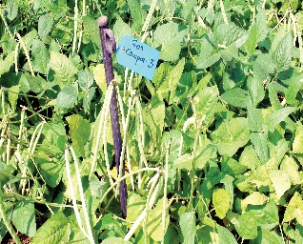 | 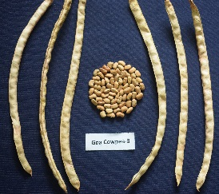 | Goa Cowpea-3 | Bold semi spreading, light brown seeded variety of Goa Cowpea 3 maturing in 90-100 days and a yield potential yield of 16 to 18 q/ha | Additional income of Rs 25000-30000/ha. | Area covered ≈ 260 ha  Employment ≈ 12000 man-days  Estimated addition in GDP of Goa - Rs 5.1 crores.
2. | 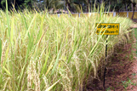 | 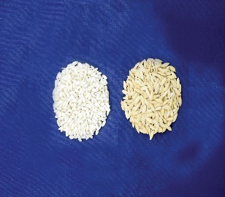 | Goa Dhan 1 | Salt tolerant short bold seeded variety of paddy maturing in 135 days and a yield potential of 30-35 q/ha under moisture stress and about 50 q/ha in normal situation of rainfall and soil temperature. | Yield advantage 35-40% over check variety | Area covered ≈900 ha  Employment ≈ 1 lakh man-days  Estimated addition in GDP of Goa - Rs 4.8 crores.
3. | 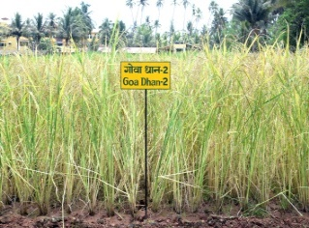 | 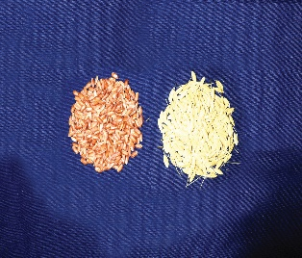 | Goa Dhan 2 | Salt tolerant long bold seeded variety of paddy maturing in 135 days with a yield potential of 30-35 q/ha under moisture stress and about 40 q/ha in normal situation of rainfall and soil temperature | Yield advantage 35-40% over check variety | Area covered ≈ 350 ha area  Employment ≈ 40 thousand man-days  Estimated addition in GDP of Goa - Rs 1.7 crores.
4. | 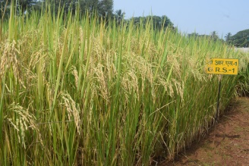 | 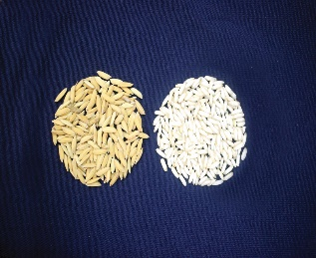 | Goa Dhan 3 | Salt tolerant long bold seeded variety of paddy maturing 125 days with a yield potential 30-35 q/ha under moisture stress and about 40 q/ha in normal rainfall and soil temperature. | Yield advantage 35-40% over check variety | Area covered ≈ 900 ha  Employment ≈ 1.05 lakh mandays  Estimated addition in GDP of Goa - Rs 5.6 crores.
5. | 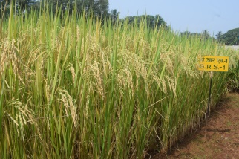 | 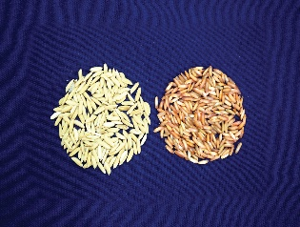 | Goa Dhan 4 | Salt tolerant long bold seeded variety of paddy maturing in 125 days with a yield potential 30-35 q/ha under moisture stress and about 55 q/ha in normal situation of rainfall and soil temperature | Yield advantage 35-40% over check variety | Area covered ≈ 700 ha  Employment ≈ 78 thousand man-days  Estimated addition in GDP of Goa - Rs 4 crores
6. | 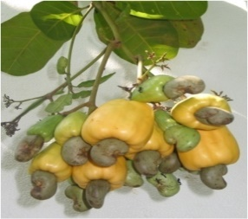 | 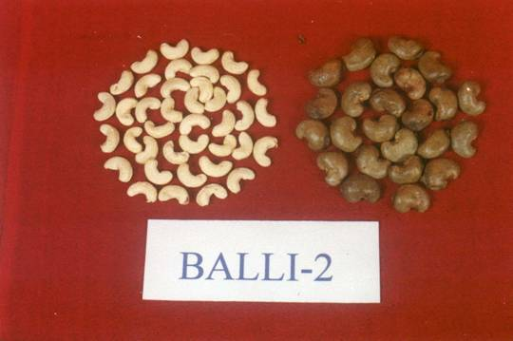 | Goa Cashew 1 | High yielding variety of cashew having bold exportable kernels, bigger and juicy apples of 74.18 g, average nut yield 7.3 kg/tree (2 t/ha) and nut weight 7.8 g. | Productivity 3.8 times higher than  Goa state’s average of 525 kg/ha. | Area covered ≈ 1417 ha area  Employment ≈ 41000 man-days and  Estimated addition in GDP of Goa – 561.1 crores
7. | 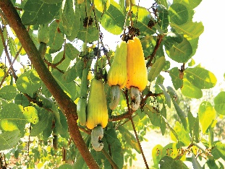 | 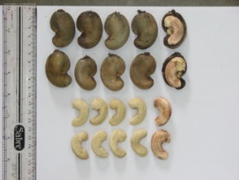 | Goa Cashew 2 | Early season variety of cashew having traits of high kernel recovery, bigger apple size (95-100 g) and nut yield of 16 q/ha. | Productivity 3 times higher than  Goa state’s average yield of 525 kg/ha. | Area covered ≈ 110 ha  Employment of ≈ 3000 man-days and estimated  Estimated addition in GDP of Goa – 43.8 crores
8. | 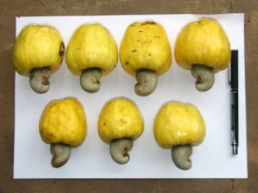 | 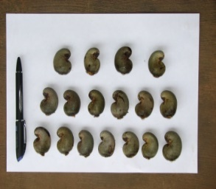 | Goa Cashew 3 | A mid-season variety of cashew distinguished by bold nuts, high shelling percentage and cashew nut yield of 35 q/ha. | Productivity 6.6 times higher than  Goa state’s average yield of 525 kg/ha. | Area covered ≈ 30 ha  Employment of ≈ 900 man-days and  Estimated addition in GDP of Goa – 12.7 crores
9. | 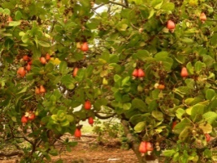 | 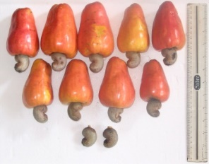 | Goa Cashew 4 | Other high yielding cashew variety of bunch bearing with average potential yield of 25 to 30 q/ha. | Productivity 5 times higher than  Goa state’s average yield of 525 kg/ha. | Area covered ≈ 50 ha  Employment of ≈ 1500 man-days and  Estimated addition in GDP of Goa – 19.5 crores
10. | 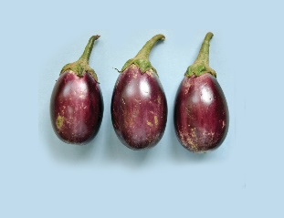 |  | Goa Brinjal-1 | A bacterial wilt resistant variety of Brinjal differentiated from other by medium size, oval shaped, purple colored fruits having good keeping quality and very less seeds | Average yield 27.5 t/ha. | Area covered ≈ 50 ha
11. | 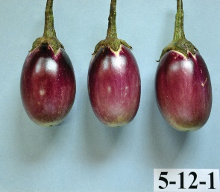 |  | Goa Brinjal-2 | A high yielding bacterial wilt resistant variety of Brinjal differed from others by purple colored fruit having good keeping quality and less seeds. | Average yield 20.5 t/ha. | Area covered ≈ 50 ha
12. | 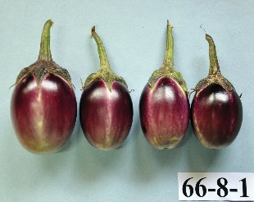 |  | Goa Brinjal-3 | Other high yielding bacterial wilt resistant variety of brinjal having small, oval shaped and purple fruits | Average yield 15 t/ha | Area covered ≈ 50 ha
13. | 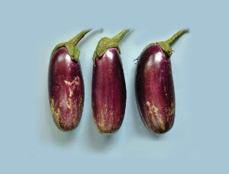 |  | Goa Brinjal-4 | Other high yielding bacterial wilt resistant varieties of brinjal characterized by medium size, long shape fruits having good keeping quality and less seeds | Average yield 25 t/ha. | Area covered ≈ 50 ha
14. | 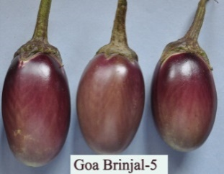 |  | Goa Brinjal-5 | A high yielding bacterial wilt resistant brinjal variety distinguished by medium size, oblong shape, purple colored fruits with good keeping quality and less seeds. | Average yield 25.2 t/ha | Area covered ≈ 50 ha
15. | 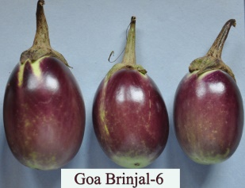 |  | Goa Brinjal-6 | Other bacterial wilt resistant high yielding variety of brinjal differed from others by medium size, oblong shape and purple colour fruits | Average yield 23.0 t/ha. | Area covered ≈ 50 ha
16. | 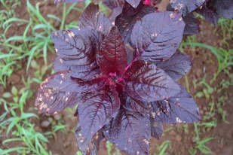 | 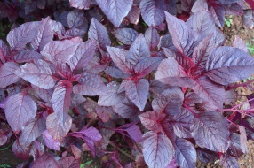 | Goa Tambdi Bhaji 1 | A highly palatable, rust tolerant leafy vegetables of Bhaji matured in 60 days. | Average yield 14.80 t/ha; seed yield – 252 kg/ha
17. | 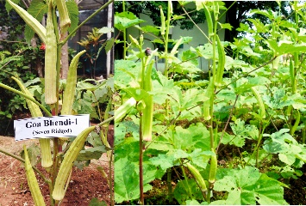 | 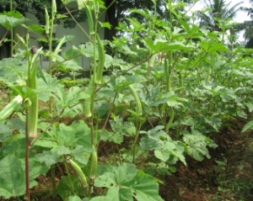 | Goa Bhendi 1 | A seven ridged 20 to 22 cm fibrous long bhendi variety, matured in 75 days. | Average yield 7-8 t/ha
18. | 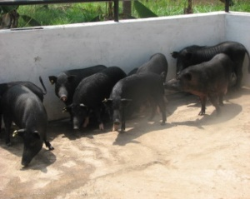 | 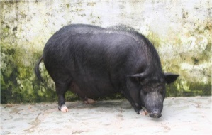 | Agonda Goa | Early maturing pig species supplementing pork supply in the market of hot humid climate of coast, registered as a third pig breed of the country (Id. INDIA_PIG_3500AGONDAGOAN_09003
19. | 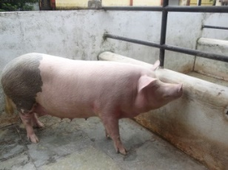 |  | Goya Pig | An improved breed of pig with 75% exotic large White Yorkshire and 25% local Agonda Goan species had better performance and adoptability in the hot humid climate of the coastal region
20. | 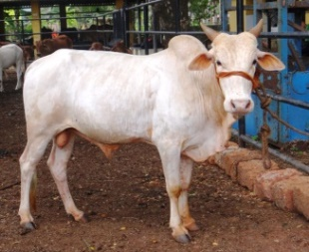 | 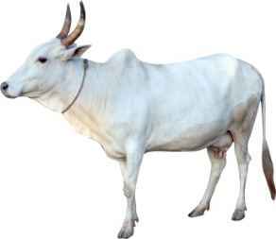 | Shweta Kapila | Indigenous cattle registered in 2020, characterized as short to medium stature, white colored having strong adaptability in hot and humid coastal climate and resistant to diseases.  Daily milk yield - 1.8 to 3.4 kg with (mean 2.8 kg)
21 | 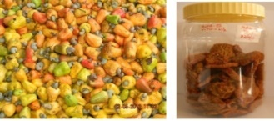 | 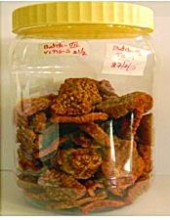 | Cashew apple crunch | It is chewing crunchy bites of cashew apples which could be stored at room temperature for 12 months with simple packing without any synthetic preservatives.
22 | 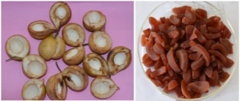 |  | Nutmeg pericarp taffy | A value added product from nutmeg pericarp or rind (Waste to wealth), stored well at room temperature for about 12 months with simple packing without any synthetic preservatives.
23 | 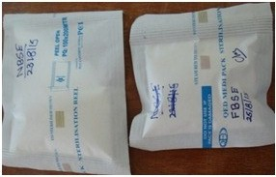 |  | Boar semen extender | Novel Boar Semen Extender (NBSE) which could preserve pig semen at 15-17°C for a minimum period of 3 days.  Patent granted on 1st January, 2021 (Patent No: 355114).
24. | 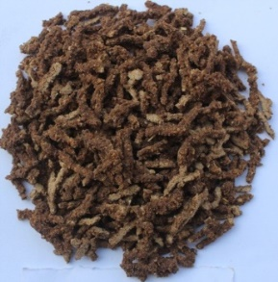 | 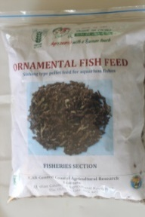 | Ornamental fish feed | A cost-effective fish feed formulation a sinking type pellet (10 minutes for complete sinking, water stability 30-45 minutes) suitable for rearing ornamental fishes. It is used to obtain better growth, and colour in fishes.
25. | 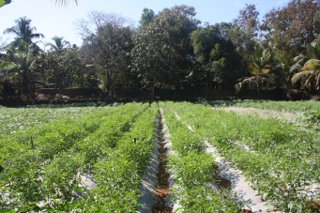 | 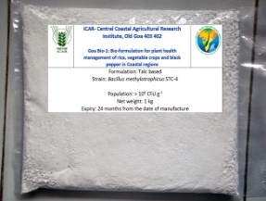 | Goa Bio-1 | A talc based bio formulation of salt-tolerant plant growth-promoting bacteria Bacillus methylotrophic STC-4 with a population >10^8 CFU/g having shelf life of 18 months.
26 | 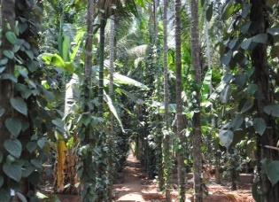 | 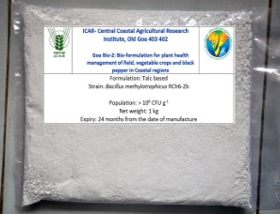 | Goa Bio-2: | A talc-based bio-formulation (Bacillus methylotrophicus RCh6-2b) for plant health management in vegetable crops (Brinjal, tomato, chilli and cucumber).
27 | 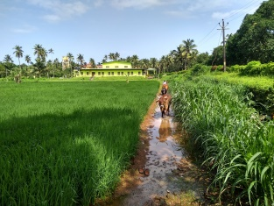 | 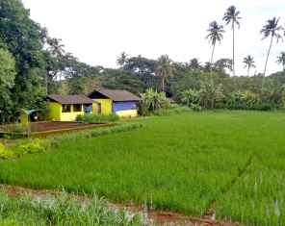 | Rice-based Integrated Farming System (IFS) model for lowland conditions of west coast region | Area -0.5 ha.  Enterprises – rice, pulse, vegetables, fodder crops, livestock, fisheries, etc. and a kitchen garden.  The net return from the 0.5 ha model was Rs. 1.39 lakhs and the highest contribution was from crops (56%) followed by dairy (32%) and fishery (12%). |  | The Institute demonstrated 60 IFS models covering an area of 75 ha, generating employment of ≈1.19 lakh man-days translating to an income generation of Rs. 6.3 crores
28 | 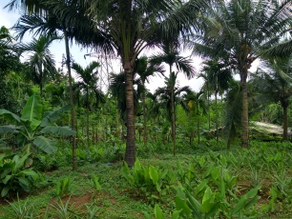 | 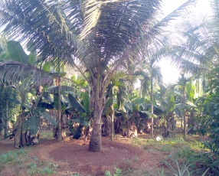 | Plantation crop based IFS model for upland conditions of west coast region | Area 0.8 ha.  Enterprises-Cashew+Pineapple, Coconut+Pineapple+Noni+Tapioca, Arecanut+Banana, Piggery, Poultry, Vermicompost & compost unit. Net return - Rs. 1.18 Lakhs/0.8 ha. Highest contribution from piggery unit (42%) followed by the cashew-pineapple system (25%) |  | The Institute demonstrated 60 IFS models covering an area of 75 ha, generating employment of ≈1.19 lakh man-days translating to an income generation of Rs. 6.3 crores
29 | 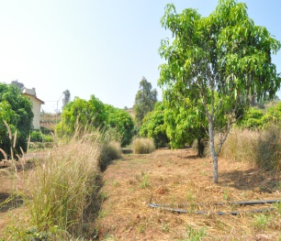 | 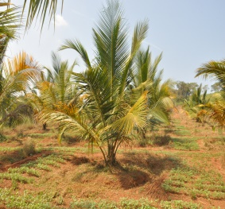 | Soil and water conservation measures on sloping lands of coastal region | Continuous contour trenching + vegetative barrier was standardized to reduce the soil losses by 65.0% and 64.8%, in mango and cashew respectively. The circular trenching in coconut reduced soil and runoff loss by 35.6% and 34.8%. |  | These soil and water conservation measures also improved the soil physical (available soil water), chemical (soil available macronutrients) and biological activity (MBC and soil enzyme activities) in 13 years
30 | 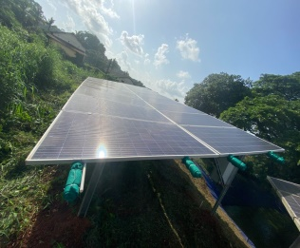 | 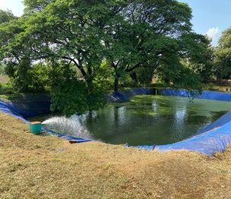 | Low-cost rain water harvesting ponds for lateritic soils in high rainfall areas | Methodology involves smoothening of side slopes and bottom using plaster prepared from locally available garden soil and about 10-15 cm thick layer of paddy straw to avoid damage to the lining material. A 300 GSM thickness silpaulin polyfilm is a recommended as lining material |  | Improved durability of ponds in laterite soils, reduced total cost. Technology has been transferred to farmers’ fields and the cropping intensity of the area increased to 200% from 100% due to the increased water for irrigation
31 | 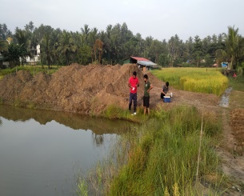 | 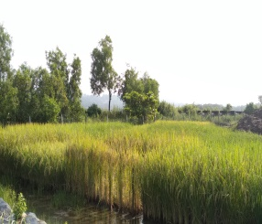 | Package of practices for paddy cultivation under salt-affected soils of coastal region | It includes seed treatment, nursery management and other plant production practices for salt-tolerant rice varieties- Goa Dhan (1, 3 and 4) | The technology has the potential to generate an additional net income of about Rs. 22 crores by covering 18,000 hectares of coastal saline soils in the state of Goa alone | Area-29 ha  Income-Rs.13.12 Lakhs  Net income- Rs. 45,275/ha which amounted to an additional income Rs. 12,413/ha, 38% higher than the farmers’ practice
32 | 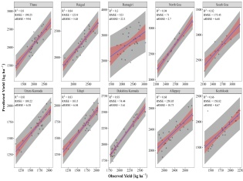 | 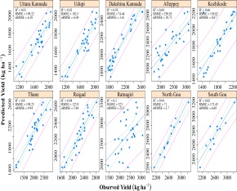 | Weather based forecasting models to predict yield of major crops | Yield of rice, cashew and coconut was projected for the coastal region. Rice-LASSO (2.63) was the best performing model followed by ENET (3.07). In Coconut R² and RMSE of calibration and percentage error of validation were in the order of ELNET >LASSO >SMLR>PCASMLR | These models predict the yield of major crops of the coastal region. It enables to plan technological interventions and formulate need based policy for small and marginal farmers.
33 | 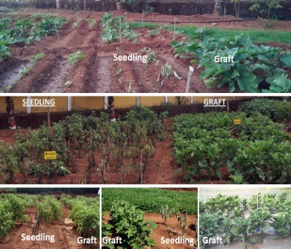 |  | Grafting cultivated brinjal on wild brinjal: a promising technology to manage bacterial wilt | It is a simple eco-friendly management strategy having high disease control efficiency. The grafted plants do not allow the pathogen to grow from inside the system, thus imparting resistance. |  | Field evaluation indicated 100% protection from bacterial wilt in grafts, whereas 60-80% of seedling population was lost due to wilt
34 | 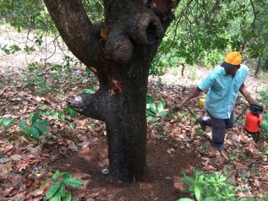 | 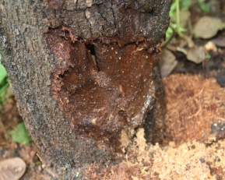 | Management of cashew stem and root borer | Formulated strategy for CSRB management to reduce the loss and revived the cashew trees. It includes Prophylactic measures followed by chemical treatment with Imidacloprid (0.01) and Fipronil (0.005). 50% recovery of infested tress is expected
35 | 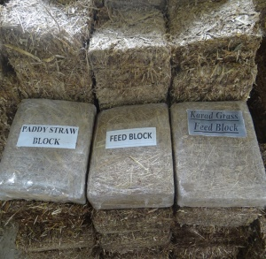 |  | Feed block Technology using locally available livestock feed  resources | Standardized a process of making plain and compound livestock feed blocks using locally available feed resources like wild dry grass (Karad) and paddy straw. | Besides, effective utilization of feed resources, this technology offers other benefits like cheaper storage, easy transportation, easy handling and reduced cost | The technology helps to reduce the use of concentrate as well as maintain the milk yield in cattle yielding around 10 litre milk per day
36 | 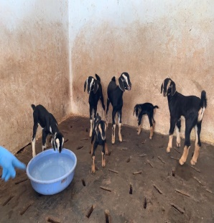 |  | Standardized technology of artificial insemination in pigs, poultry and goats | It is a reproductive technology for rapid genetic improvement of farm animals involving collection of semen from healthy male animal, processing and depositing them into the reproductive tract of a receptive female animal artificially using insemination gun or catheter |  | Currently AI technology in pigs has been performed in and around 40 villages. 734 farmers were benefitted Generating employment of ≈1.37 lakh man-days translating to an income generation to the tune of Rs 9.6 crores
37 | 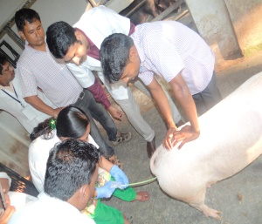 |  | Crossbred pig production technology | Technology includes crossbred pig produced by mating Agonda Goan female and Large White Yorkshire male for producing the crossbred pig. |  | Average birth weight (820.34±38.16g)  Weaning weight at 40 days’ age 5.4 kg  Weight at 10 months’ age 85 to 90kg  Age of puberty 190days,  Age of sexual maturity 220days,  Age of first farrowing (335days) and better pork with (3.36cm) back fat thickness
38 | 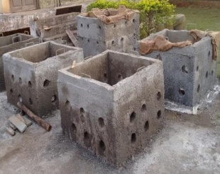 | 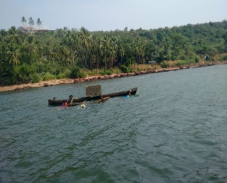 | Artificial fish habitats for fish farmers | The artificial fish habitats (AFH) - to provide refuges and breeding sites. Using underwater visual census (UVC) in Zuary estuary, 50 species were counted and species diversity were higher at deeper AFHs. Oysters, sponges and ascidia was highest on the deeper AFHs |  | Institute technology supported conservation and aquatic diversity, besides increasing fish catch and net incomes of the fish farmers
39 |  |  | Standardization of diagnostics for detection of rotavirus | RT-PCR test was standardized for the detection of the VP4 and VP7 genes of rotavirus. RNAPAGE, AGE methods were standardized for rapid detection of dsRNA of rotavirus from fecal samples
40 | 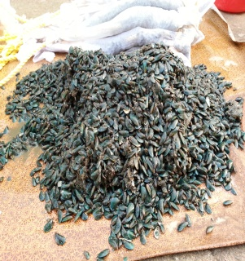 | 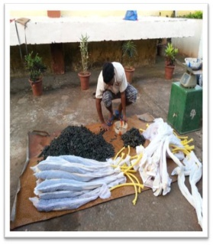 | Low-cost multispecies culture system for coastal region | The culture system is designed to improve fish and mussel production in the coastal region using cage systems.  The size of the cage: 2 m x 1.5 m x 2 m, Culture period: 8-10 months.  Species cultured: Multi-species (red snapper, pearl spot, and green mussel).  Mussel seeds collected from the wild were stocked in cotton mosquito net bags. |  | The net profit and BC ratio of the system was Rs. 34000 and 2.4, respectively
41 | 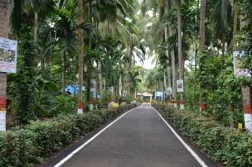 | 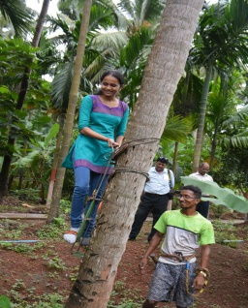 | Standardized scientific practices of Agro-Ecotourism (AET) for the state of Goa | AET center has been developed for demonstrating the various components of components of agro-ecotourism in the state of Goa | Guide line for farmers, policy makers, executors, researchers and students for setting land use plan for sustainable agriculture | Sustainable coastal agriculture
42 | 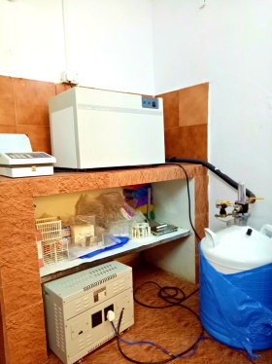 |  | Technology for long term preservation of boar semen | Protocol for long term preservation of boar semen using controlled-rate semen freezing, cryopreservation technology. Method involves controlled rate freezing of pig semen extended using indigenous semen diluent | Successfully evaluated for in-vivo fertility status in female pigs using deep intra-uterine insemination procedure and viable piglets were born from frozen semen AI | Overall conception rate increased by 47.37% and farrowing rate by 15.79%.
43 | 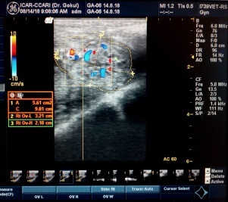 |  | Digital colour doppler ultrasound imaging technology in reproductive management of livestock | Standardized, Trans-abdominal and trans-rectal methods for scanning and imaging reproductive organs for diagnosing pregnancies, reproductive problems, monitor and assess the blood flow through internal organs using digital Color Doppler ultrasound imaging technique | Very useful in assessing ovarian perfusion and functional status of reproductive system | -----------
44 | 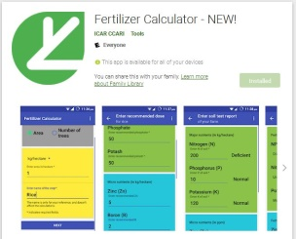 |  | Fertilizer calculator – New! | It is an android-based mobile app to prescribe soil-test based fertilizer recommendations for different crops in Goa state. | Avoiding misuse, abuse and overuse of fertilizers | The total number of installs by the users are > 7000  Link:https://play.google.com/store/apps/details?id=in.res.ccari.fertcalc
45 | 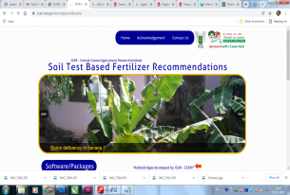 |  | Soil health management web portal | It is an online web application using base data of about 20,000 analyzed soil samples. It generates information on village and taluka wise soil fertility status of all sampled village and taluka of Goa for important annual and perennial crops | Use of balance fertilizers | Received 75000 views. Reduced fertilizer cost up to 13.0%, with a 24.0-37.5% increase in paddy and coconut yield. Generated income of Rs. 67.2 crores with 33% adoption by the users  Link: https://ccari.icar.gov.in/soilgoa/index.php
46 | 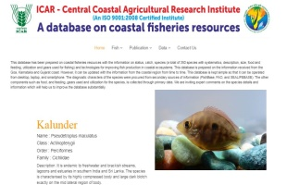 |  | ICAR-CCARI Fish database | Provides information on status, catch, species (a total of 300 species with systematic, description, size, food and feeding, utilization and gears used for fishing) and technology options for improving fish production in coastal ecosystems | The database acts as a decision support system to the coastal fishermen. | The total number of views/visitors to the data base are ≈10000/annum  Link: https://kvknorthgoa.icar.gov.in/fishdb/
47 | 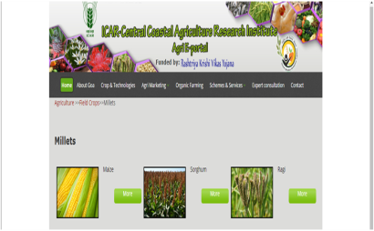 | 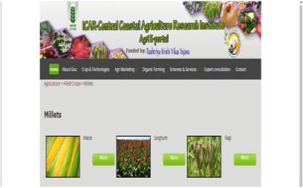 | Comprehensive e- Agriculture Portal for Information and Knowledge sharing in Goa | The portal houses advanced technologies in agriculture, horticulture, animal and fishery sciences. It also has the list of various inputs for improving the farming and rearing the animals. The weather data of six different talukas of Goa are also attached for use. | It inspires to the farmers and planners for the sustainable use of natural resources. | The total number of views/visitors to the web portals are ≈17000  Link: https://www.agrigoaexpert.res.in/icar
48 | 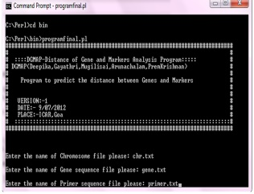 | 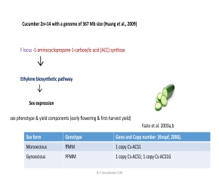 | Bioinformatics software to map the primer sequences | DG-MAP - map the primer sequences on whole genome sequences, RAPD and SSR markers and distance between the priming sites.  Validated using genome sequences of chromosome 1 of cucumber and F locus. Predicted the known and existing markers closely linked to F locus
49 |  |  | Web application- Buffalo breeding Expert | Developed for buffalo breeding, herd management, reliable calving date and ideal weaning date for various breeds of buffaloes. It includes an expert system on scientific buffalo farming, management practices and indigenous buffalo breeds suitable for coastal climate. |  | The total number of views/visitors to the webportal are 1500.  Link:https://kvknorthgoa.icar.gov.in/buffalo/form.php
50 | 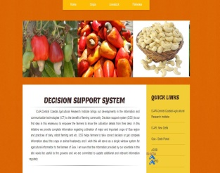 |  | Decision Support System (DSS) | Comprehensive information on scientific practices of cultivation of major and important crops, livestock and fisheries of the region were attached to decision tools to access the complete information on agricultural practices. |  | Total 25,51,934 views have been received.  Link: https://ccari.icar.gov.in/dss/index.html
51 |  |  | Crop, livestock, fish & microbial germplasm conserved and utilized | A total of 999 crop plants, 16 livestock, 45 fish species, 10 aquatic plants and 91 microbial germplasm were collected and conserved in the coastal region of India | The germplasm bank acts as a sheet for the future breeding and improvement programmes and promotes biodiversity

