**Changes on CAIS site 1-3-2022**

1. Add **LULC Map**s under Sr.no 4 **Land Use and Land Cover**

* LULC_1985
* LULC_1995
* LULC_2005

Create Maps on Class_Name

1. Add **Land Degradation** Map under Sr.no 5 **TERRAINE CHARACTERISTICS**

* Create a point map

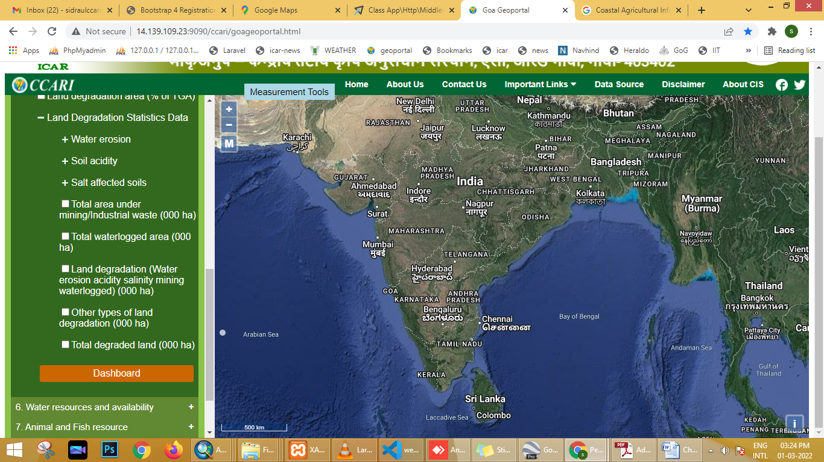 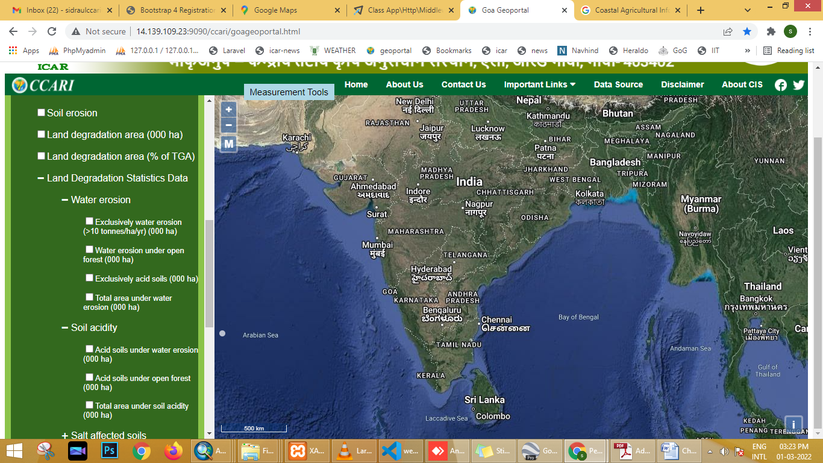

1. Add **Physiographic map** Under Sr.no 5 **TERRAINE CHARACTERISTICS**

Create map on N_F column

1. Add **Rivers** Under Sr.no 6 **Water Recourses and availability**

Create map on Rivers column

1. Add **Soils** maps under Sr.no 5 **TERRAINE CHARACTERISTICS**

Create map on Depth_d, drainage_d, surfacetexture_d, PCS_d, Salinity_d, Sodicity_d column

1. Hide **Wasteland Map** under Sr.no 5 **TERRAINE CHARACTERISTICS -> Land Dgradation**
2. Restrict Zooming of map at a particular scale.
3. CIS name needs to be changed to CAIS – **Coastal Agricultural Information System**